

Snow Sport Helmets made in the USA!

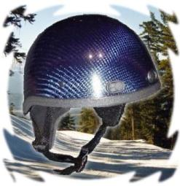

Mention "David P. Smith" to receive 20% off!

We are new, so we may not be stocked in your favorite snowboard/ski shop yet...

Use your Brain. Wear a Head Trip.

carbonfiberhelmets.com

David P. Smith, Sales & Marketing Guy 6127 Anno Ave. Orlando, FL 32809

info@carbonfiberhelmets.com (No it doesn’t snow in FL… we just make ‘em there!)

mobile: 206-399-4597 customer service: 800-300-9813 or 407-859-6153

head trip (hed' trip') n. Slang. 1. An exhilarating intellectual experience.

