For Sale by Owner
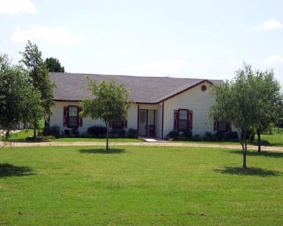10 Acres

Enjoy the cool breeze & view the 10 acres of luscious pastures from the covered back porch of this charming country home. Study, plus large family room for entertaining. The oversized two-car garage provides extra storage. When that breezes ceases, jump into your inground fiberglass swimming pool! 3% TO BUYER AGENTS - MLS# 628969
Property Type: | Single Family | Price: | $177,500
Square Footage: | 1985 | School District: | Waller
Area of Town: | Northwest | Bedrooms: | 3 w/ study
Bathrooms: | 2 | Barn: | 40x 50
Age of Home: | 6 Years Old | Garages/Carports: | 2

Sheila & Bart Ullrich
14702 Guy Rd
Waller, TX 77484
Home Phone: 936-931-3409
(281) 798-7509 (Sheila’s Mobile)
Alternate Phone: 281-782-9920
(Bart’s Mobile)
Email: Sheila@palomaec.com

