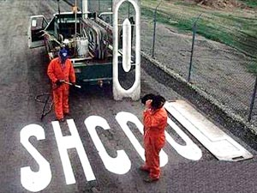

We be edumacated…



Enough said…

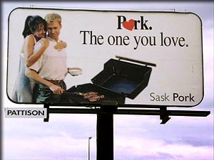

The “other” white meat.

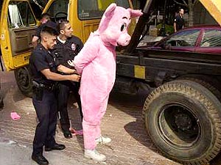
Irony at its finest.

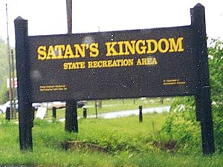
Leave your soul at the front gate, please.



Going Postal?

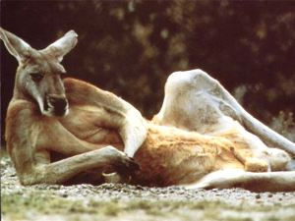
SINGLE, BROWN, KANGAROO, VERY MALE, SEEKS SINGLE, FEMALE KANGAROO TO HOP AROUND, MAKE KANGAROO BABIES AND SHARE GREEN BUSHES. HOBBIES INCLUDE HOPPING, CHEWING ON GREEN STUFF AND HOPPING. AGE NOT IMPORTANT. MUST BE A KANGAROO, ENJOY HOPPING AND GREEN STUFF. SERIOUS INQUIRIES ONLY.


I don’t even know what to say for this one.

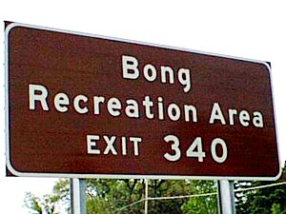

A fun, family vacation spot.

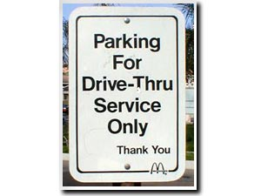

???

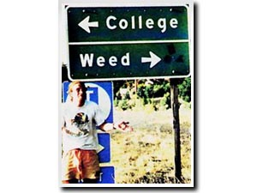

Major dilemma.

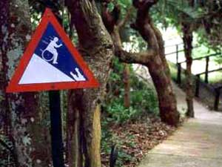
“CAUTION: HANDICAPPED MAN EATING CROCODILE AT BOTTOM OF HILL”

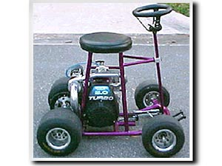

Turbo barstool, VERY cool.

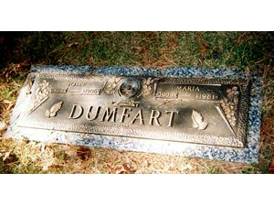

Some times a name change is the best idea…



If you say so!



I think I’ll keep driving!



Little extreme, I think! (and what about the women?)

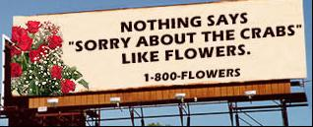

Somehow I don’t think that will work!


Now there’s a movie you don’t see everyday!

