Enron Research-Technical Analysis
Natural Gas Market
April 26, 2000
By Tricia Tlapek ext. 36615

Support-NGM  3.115-3.12  3.09  3.06  3.045-3.055 gap  3.02 | Resistance-NGM  3.14-3.15  3.175  3.19  3.23

For the 4/26 session, with sustained trades above 3.15, NGM is set to challenge 3.175, 3.19 and 3.23.

With sustained trades below 3.12, NGM is set to re-test the 3.06 level. Below 3.06, is 3.055-3.045 gap. Below gap is support of 3.02.

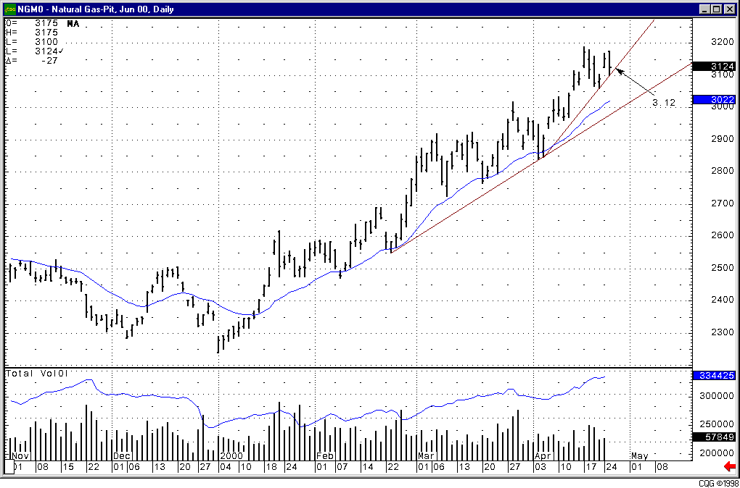Daily NGM

