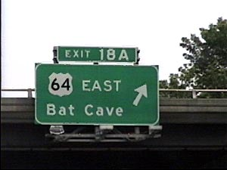
Sushh, it’s a secret…


OZZY, OZZY, OZZY, OZZY!!!

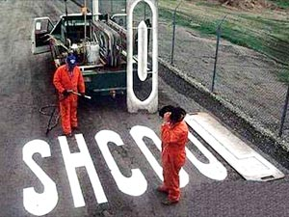
We be edumacated…

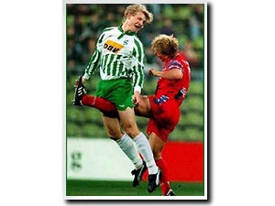
Umm, ouch!

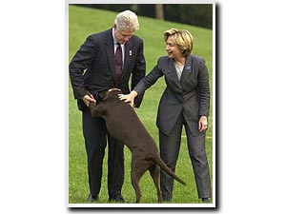
The President for some reason changes his dog’s name to Monica.


Nuff said..

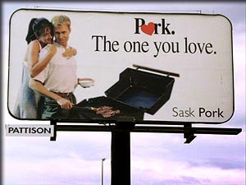
The “other” white meat..

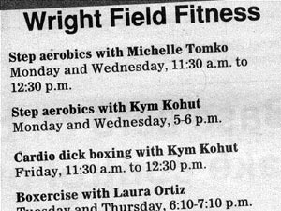
Typo?

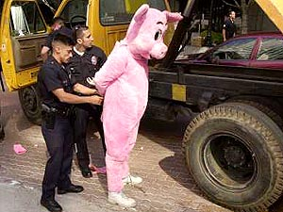
Irony at it’s finest.

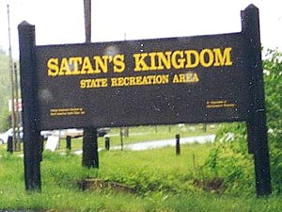
Leave your soul at the front gate please.

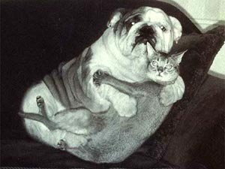
“Cats and dogs sleeping together, total ANARCHY!!”


Sushh, it’s a secret… #2


F*&# You Gov. Bush

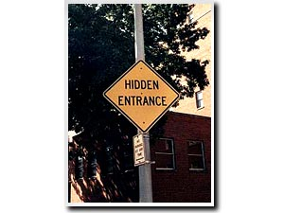
Sushh, it’s a secret… #3


This one is in Phoenix AZ, no lie!

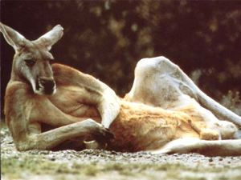
SINGLE, BROWN, KANGAROO, VERY MALE, SEEKS SINGLE, FEMALE KANGAROO TO HOP AROUND, MAKE KANGAROO BABIES AND SHARE GREEN BUSHES. HOBBIES INCLUDE HOPPING, CHEWING ON GREEN STUFF AND HOPPING. AGE NOT IMPORTANT. MUST BE A KANGAROO, ENJOY HOPPING AND GREEN STUFF. SERIOUS INQUIRIES ONLY.

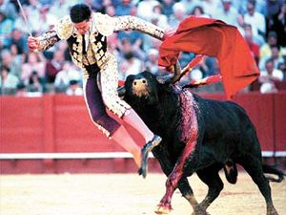
Umm, oucho!!


I don’t even know what to say for this one..


St. Mary Catherine discovers the wonderful world of online porn…

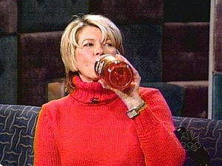
Juicin 40’s with Martha.

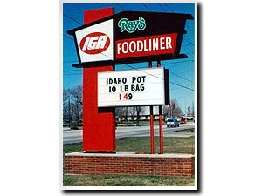
Idaho state legislature puttin the street dealers outta bidness.

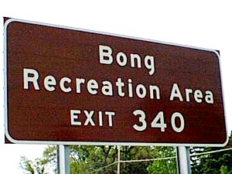
Amazingly, Bob and Dave never made it to their original destination,,, wherever it was.


???


Have another beer dude, tomorrow you won’t find it nearly as funny.


Jerry Springer reaches an all time low.

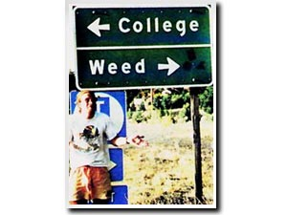
Major dilemma.

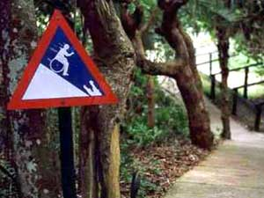
“CAUTION: HANDICAPPED MAN ABOUT TO BE EATEN BY CROCODILE AT BOTTOM OF HILL”

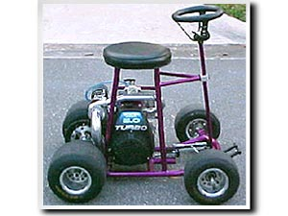
Turbo barstool, VERY cool.

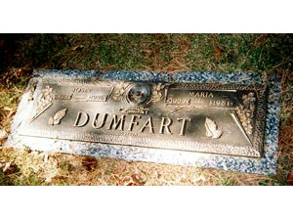
Sometimes a name change is the best idea…

