Objectives

Allow brokers to transact on behalf of their customers on EnronOnline (EOL), in exchange for a yearly license fee. The brokerage firm will be permitted to transact on behalf of 15-20 pre-determined customers, on a set of pre-determined product types. Each brokerage firm will be assigned a credit limit (based on the margin posted by them) and they may execute as many trades as their credit limit, and the customer on whose behalf they tare transacting will permit.

Functional Overview

- A brokerage firm will receive a transaction ID upon payment of the license fee. The ID received by them must be tagged as broker and set to expire at the end of the license period. We should have the ability to extend the expiry date easily should the license be renewed.
- A brokerage firm will have a master user who can then set up sub-users within the firm.
- A brokerage firm will be able to transact only on behalf of a limited number of users (specified in the contract). The counterparty list could be different for different brokerage firms depending on the individual agreements. The system should therefore allow us to maintain lists of counterparties for different brokers.
- The brokerage firm will be able to transact only on a specified set of products.
- Brokerage firms will not have access to Content in the quotes page.
- Users of a brokerage firm will log in from the home page into the quotes screen. (Need to determine if wording changes on usage of the word free is required.) On log in they will see a quotes page with only the MyQuotes section.
- In order to transact users at the brokerage firm will click on the bid or offer price. This will bring up a submission screen exactly the same as the current submission screen.

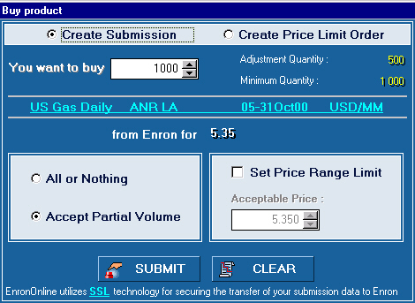

- Clicking Submit should bring up another screen, which prompts the user to select the counterparty on whose behalf the transaction is being made from a drop down list. The screen would look something as follows

- System should not allow a submission that has no counterparty selection.
- The system should check the following before executing a transaction request
- If the price and volume are still available.
- If the counterparty for whom the transaction is made has sufficient credit.
- If the brokerage firm transacting has sufficient credit.
- In the case of failed transactions, the Enron trader should not be able to see the name of the counterparty.
- When a transaction takes place the system should change the credit of both the counterparty and the brokerage firm by the appropriate amount. The transaction should be bridged to back office systems as having been executed by the counterparty and not the brokerage firm.
- When transactions are bridged to the back office system they should have a flag that identifies them as having been transacted on behalf of the counterparty by the brokerage firm so that mid-office personnel know that they have to confirmed with both the counterparty and the brokerage firm.
- On successful assignment of the transaction at the end of the day by the brokerage firm, the brokerage firms credit limit will be restored to the original amount (manual process to be defined).
- Today’s Transactions, Positions and Transaction search should all display the name of the counterparty for whom the transaction is made, in addition to all the information displayed currently.
- Transactions done by a brokerage firm for a counterparty should not be visible to the counterparty themselves and they should not be able to pull it up via transaction search.

