

FOREWORD

The following is an abbreviated look at the travels of the 36th Infantry Division better known as the “T-Patch”. The desire was to follow the career of Ervin I. McCain, T-Sgt, during World War II, but without personal accounts, that detail cannot be accurately described. Therefore, the hope is that what is depicted here is a summation of what he and his buddies in his outfit faced as far as training, travel, and finally engaging the enemy. Of course, no written account or movie or documentary could ever reveal the true pressures, fear, desire, commitment, dangers, and eventual determination to persevere under the difficult circumstances that he faced. Hopefully, you will be able to get a better understanding of where he was and when he was there and that in the future, more detail of his actual career can be added to this summary.

ERVIN I. MCCAIN, T-SGT


Ervin Ivy McCain was a Technical Sergeant (a Non-Commissioned Officer) during World War II. He served in the Headquarters Battery Battalion of the 133d Field Artillery Regiment under the 61st Field Artillery Brigade as a part of the 36th Infantry Division. This division was made up mostly of Texans but during training and later after deployment, young men from all over the country were added to the division. After training in the U.S. the division became a part of the ETO (European Theater Operations) Army Group in Western Europe under the command of General Dwight D. Eisenhower. It was assigned to the 5th Army and the VI Corps.

It is unknown what platoon, squad, and finally fire team that he was assigned to; however, T-Sgt. McCain was most likely the leader of his squad and firing team. The job of the 133d Field Artillery Battalion was to fire, maintain, and move 105mm Howitzers in support of the infantry groups in the 36th. Without personal recounts, it is also unknown what his exact assignment was, but it is likely that due to casualties and replacements, T-Sgt. McCain became well versed in many aspects of the 133d. Most likely he was responsible at one time or another for leadership, maintenance, driving, communications, reconnaissance, fire control, and small arms combat against the enemy. His groups relentless firing of the 105 Howitzers helped to destroy and soften enemy strongholds to help protect American troops and to lead to the eventual surrender, withdrawal, or destruction of the German Army in Italy, France, Austria, and Germany.

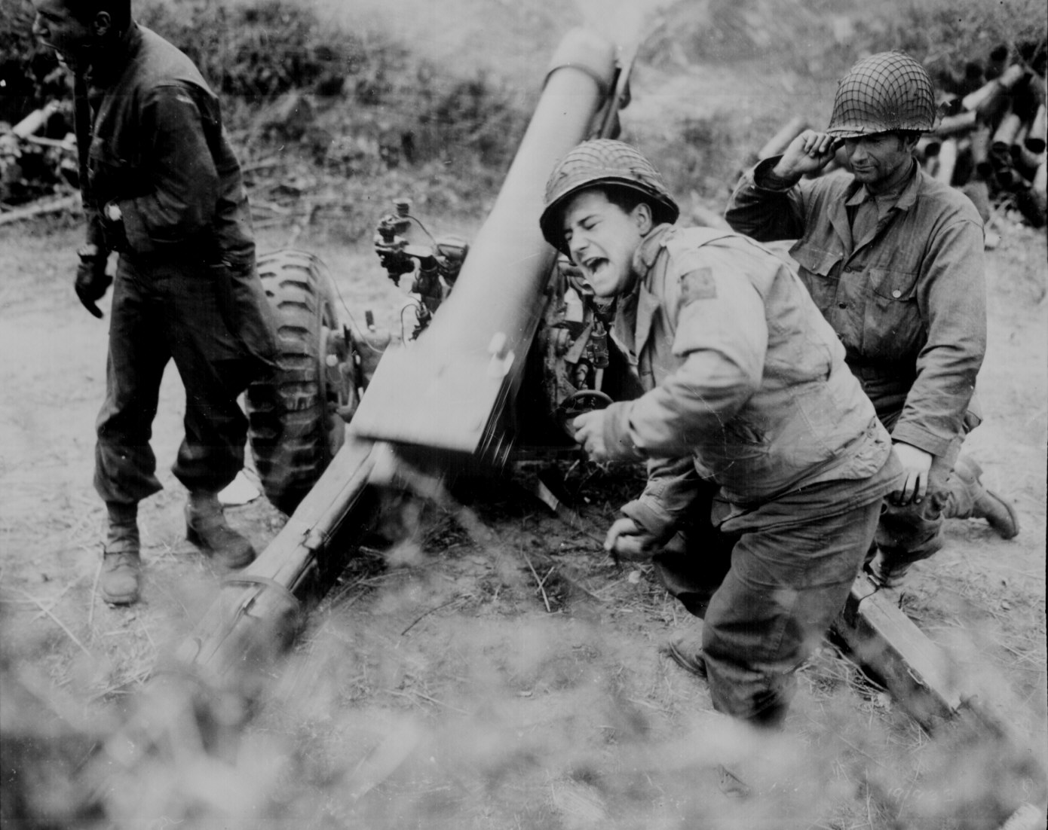

ORGANIZATION AND TRAINING

The 133d was called to federal service as part of the 36th Infantry on 25 November 1940 and arrived at Camp Bowie, Brownwood, Texas on 11 January 1941. The 36th was sent to Camp Blanding, Florida in February of 1942 and was readied for an early overseas shipment. Orders changed and the 36th was send to the Carolinas for exercises during the summer of 1942.

The T-Patchers left the warm Carolinas and moved north to Camp Edwards on Cape Cod, Massachusetts. The men lived in tent cities as they practiced amphibious assaults and launched mock invasions on Martha’s Vineyard. The division was cold tested that winter on the Cape as temperatures that winter dropped to 20 degrees below zero.

