Again the firing of the howitzers by the 133d FA and other Field Artillery units allowed the infantry men and engineers to cross the river. It took 4 days to cross a river that you could throw a stone across and again American losses were large. The Rapido crossing would be considered the T-Patchers lone failure due to poor planning and indecisiveness. After clearing the river and taking up positions in the valley just inland from the coastal plain, the 36th Division hunkered down for the rest of the winter allowing replacements to be trained and inserted where needed.

ROME

In May of 1944, the T-Patchers began moving towards Rome as addition Allied divisions attacked up the coastal plain and from more inland areas towards Rome. Operation Diadem was underway. Warm weather replaced the cold winter in May and the Americans used this as a boost of enthusiasm to push to areas just south of Rome in early June.
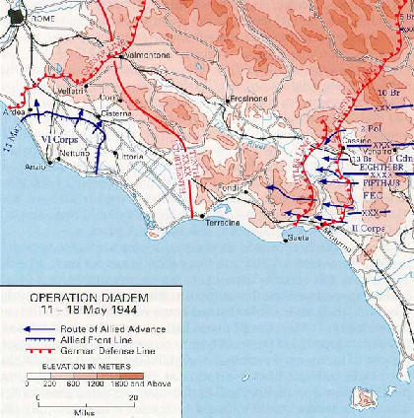

The advance on Rome found little resistance by the Germans and the 36th Division drove onto the streets of Rome June 4, 1944. The Germans gave up the city without a fight as they hurried north into northernmost Italy and back towards Germany. The 36th Division spent the next few weeks chasing Germans some 200 miles north of the capital city without ever really engaging the enemy. The Italian campaign had been successful. In 10 months, the Americans were able to capture Rome and to liberate the southern half of the country.

The following is taken directly from The Texas Army:

Though the Germans were the real foe, sandy beaches, seas of wintry mud, and seemingly endless mountains as well as open plain, did their part in molding the 36th into a powerful and tempered instrument of war. Selected to lead the American part of the Allied invasion of Italy, it took the Salerno beachhead in September 1943, beat off German counter-attacks, and force the enemy to withdraw to the mountains. The town of San Pietro next fell to the division, allowing egress past Mignano Gap into the approached to Cassino, the Rapido River and the Liri Valley. Crushed at the Rapido crossing through the intransigence and bad judgment of higher command, the division recovered by May, cracking the German line at Velletri and opening the door to Rome. Three final weeks of combat were spend pursuing the retreating enemy 200 miles north of the capital.

Fate had dictated that the battles fought by the Texas Division be among the most crucial of the Italian Campaign. From these long months of combat the 36th emerged as perhaps the finest American infantry division in the United States Army.

But this was not the end of the fighting for the T-Patchers. They would be called into duty once again in Southern France.

THE INVASION OF SOUTHERN FRANCE

During the months of June and July while portions of the 36th Division were chasing Germans through northern Italy, the remainder of the division were readying themselves for yet another treacherous mission. This mission would be another dangerous amphibious assault along the Riviera in Southern France. So on the beaches of Western Italy not far from Rome, the 36th recuperated and trained for their next daunting task. The following picture is of portions of the 36th Division readying to load transport ships to cross the Northern Mediterranean Sea from Italy to Southern France.

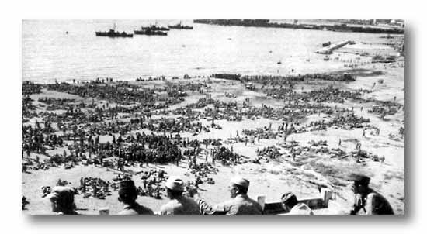

The infamous invasion of France by the Allied Army at Normandy had occurred several months earlier. And those valiant troops were now fighting through the hedgerows of Northern France. The time had come for an invasion into Southern France to start pushing the Germans out of Southern France. The objective was for the two invasion forces to liberate France and meet at the German border to push the Germans back into their homeland.

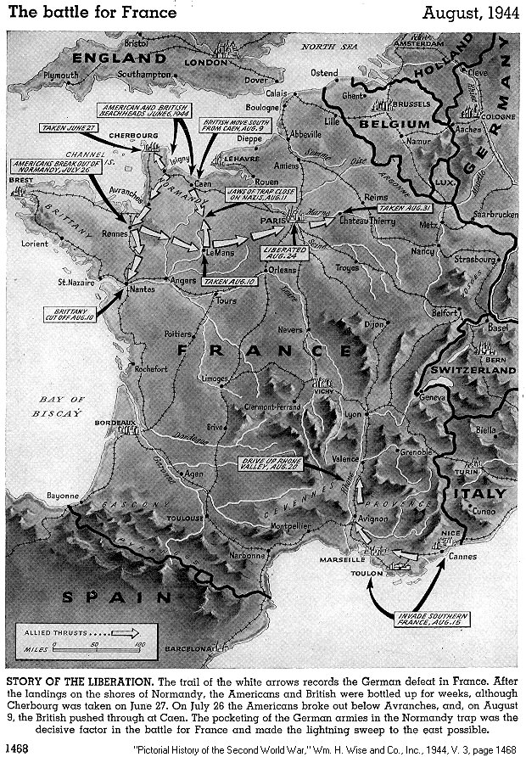

So on August 14-15, 1944, the 36th Division landed in Southern France along the Riviera between Cannes and St. Raphael.

