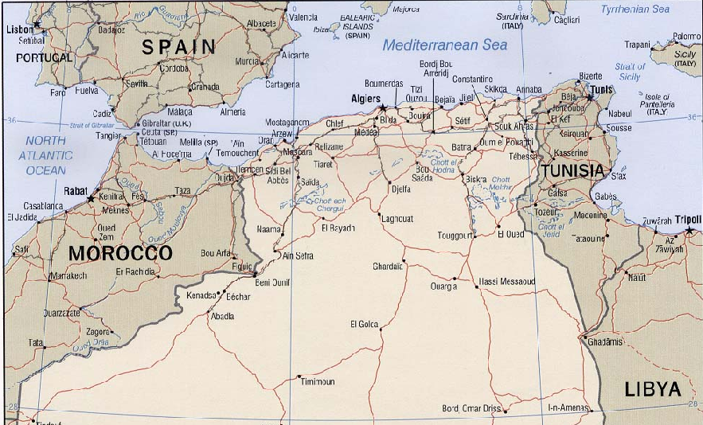

Then after the fall of Sicily in the summer of 1943, the T-Patchers were called into duty to engage the enemy by landing on the beaches of Salerno, Italy.

GOING TO WAR

OPERATION AVALANCHE

Operation Avalanche was the codename for the invasion of Italy by the Allied Forces. The Italians had shortly before surrendered and the Nazis had taken control of the country. Thus the enemy in Italy was entirely German as the Italian troops were on their way home or made prisoners themselves.

The plan was for an amphibious assault led by the 36th Division to land south of the port city of Salerno on the west coast at the southern end of “the boot”. Nearly ten months prior to D-Day and the Allied invasion at Normandy, this would mark the first time that American troops had set foot on the European Continent since the war began in the late 1930’s.

So the 36th Division sailed on transport ships from Oran, Algeria, across the Mediterranean Sea to the coast of Italy on September 9, 1943. The invasion site of Salerno was chosen due to a harbor large and deep enough to handle U.S. Naval ships and also due to the relatively flat coastal plain that extended some twenty miles inland from the coast. Surrounding Salerno to the north and east were large mountains that would have made an invasion in those areas very risky and not nearly as effective.

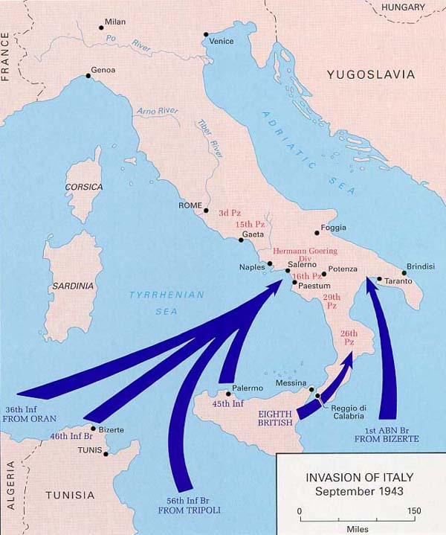

The 36th landed on beachheads designated Red, Green, Yellow, and Blue under intense fire from the enemy. U.S. warships aided the invasion by bombarding inland locations. The 133d Field Artillery (133d FA) was one of the first regiments to make it ashore in Italy. It immediately commenced firing on Germany positions as the assault moved inland to capture strategic railway and highway areas.

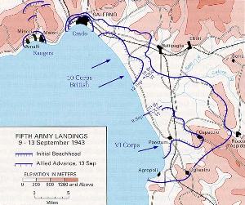

The 36th Division outnumbered the Germans at and along the beach, but 20,000 German reinforcements quickly moved towards Salerno and the beaches within hours of the initial invasion. It is said that heavy fire from the 133d FA and the 151st FA helped stymie this counterattack by the Germans saving many American lives and keeping the Germans from pushing the 36th back into the Mediterranean. Over the next several days, the Allied assault would capture and control Salerno and many of the smaller townships in the area allowing the U.S. Army to begin moving heavy supplies onshore.

The next move for the T-Patchers was to move inland over the mountains and capture Altavilla and Persano. These were strategic cities along major Italian highways that would cut the German transport lines in half and trap thousands of Germans in the southern tip of Italy. One of the only things more difficult than an amphibious landing is an assault into and through mountainous terrain where the enemy is well placed. The 36th took more casualties trying to capture Altavilla and Persano than on the initial landing a few days before. But on September 19th, the Germans withdrew and the 36th reported that the area had been cleared of Germans.

The total landing strength for the 36th Division was 13,915 officers, warrant officers and enlisted men. Personnel losses from September 9-19 totaled 126 officers, 1 warrant officer, and 1,920 enlisted men.

