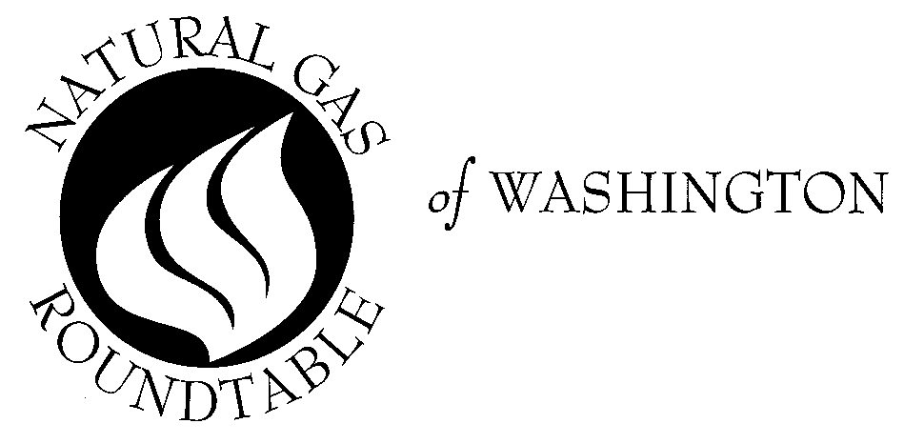February 12, 2002

LUNCHEON SPEAKER
NORA MEAD BROWNELL
Commissioner
Federal Energy Regulatory Commission

DATE: THURSDAY, FEBRUARY 21, 2002 TIME: Reception: 12:00 noon Luncheon: 12:30 p.m.
PLACE: University Club
1135 16th Street, NW
Washington, DC

We are very pleased to have Nora Mead Brownell, Commissioner, Federal Energy Regulatory Commission, as our guest speaker on Thursday, February 21. She will provide us with an update of the FERC regulatory agenda.

Commissioner Brownell was nominated by George W. Bush to serve on the FERC on
April 30, 2001. She was confirmed by the United States Senate on May 25, 2001.

Prior to joining FERC, Ms. Brownell served as a member of the Pennsylvania Public Utility Commission . During her tenure at the PUC, Ms. Brownell took an active role in the rollout of electric choice in Pennsylvania. In addition to her work in establishing the framework for one of the most successful retail electric markets in the country, Ms Brownell was a leader in the administration of Pennsylvania’s Electric Choice Consumer Education Program.

For reservations, please call me at 202-824-7121 or e-mail (sswann@aga.org) by noon, Tuesday, February 19. Just a reminder that we will need to bill you for lunch if you make a reservation and cannot attend. Also if you have a special dietary requirement, please let me know at the time you make your reservation.

Please Note: The 2001 luncheon fee is $23.00 per person for government and $32.00 per person for non-government and $42 for non-members of the Natural Gas Roundtable to be paid at the door.

Please mark your calendar for future 2002 luncheon dates: Thursday, March 21; Thursday, April 25; Thursday, May 16; Thursday, June 20; Thursday, July 18; no lunch August; Thursday, Sept. 19; Thursday, Oct. 17; Thursday, Nov. 21; and Tuesday, December 17.

Sincerely,

Susan Swann, Coordinator

