Figure 19 - Falcon Base Case Price Sensitivity vs. Net Present Value and Rate of Return.

Falcon Area Potential

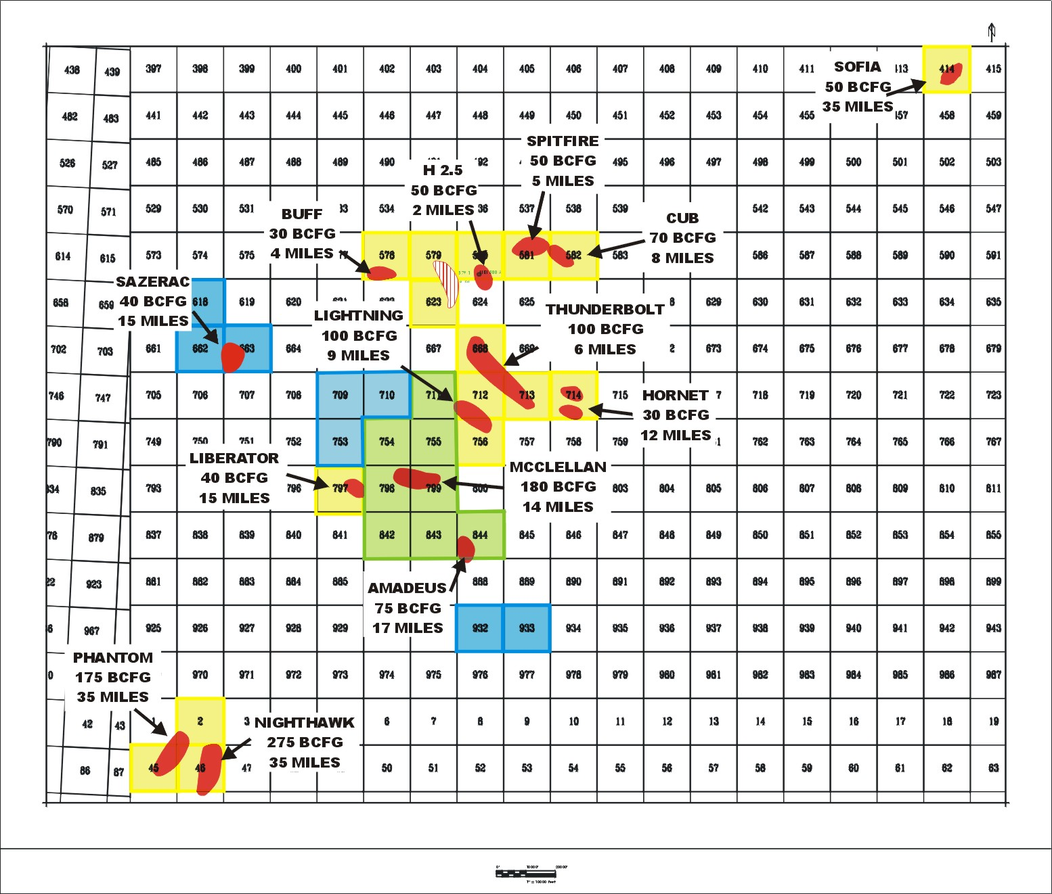

Figure 20 - Falcon Area Potential.

Falcon Area Potential

Figure 21 - Falcon Area Potential.

Falcon Economic Analysis

