Figure 7 - Falcon Production Forecast – Net Gas Production vs. Time.

Figure 8 - Falcon Production Forecast – Net MMBOE vs. Time.

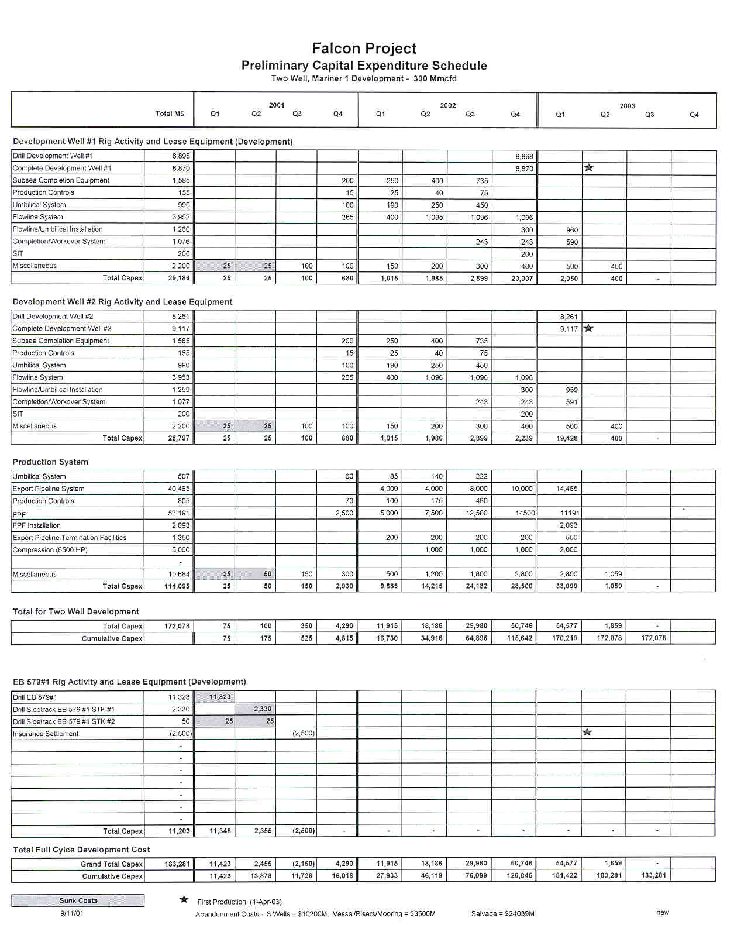

Figure 9 - Falcon Capital Expenditure Schedule.

Figure 10A - Falcon Monthly Operating Costs.

Figure 10B - Falcon Monthly Operating

Figure 11 - Falcon Cash Position Curve

Figure 12 - Falcon Project Reserve Summary

Falcon Economic Summary

Development Type: Two Well Subsea

Gross Reserves:
Gas (Bcf) 194
Condensate (MBbl) 581

Gross Capital: ($MM) 157

MEI Working Int. (%) 50
MMS Royalty (%) 0

Initial Gross Production Rate:
Gas (Mmcfd) 166
Condensate (BPD) 500

Initial Production Date: 12-31-02

Product Pricing 2003:
Gas ($/MMBTU) 3.25
Condensate ($/Bbl) 21.00

Economics net to MEI 50% Working Interest
IRR (%) 105
NPV-10 ($MM) 142
VAI-10 (%) 2.88
Finding Cost ($/NBOE) 5.06
Payout (from sanction)
(years) 2.2

Figure 13 - Falcon Project Economic Summary

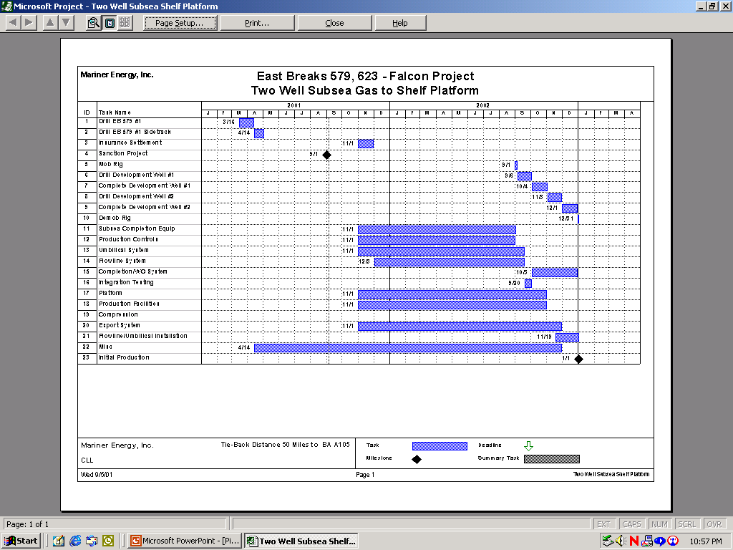

Figure 14 - Falcon Project Schedule.

Figure 15 - Falcon Reserve Sensitivity.
Figure 16 - Falcon Reserve Sensitivity.

Figure 17 - Falcon Capex Sensitivity.

Figure 18 - Falcon Capex Sensitivity.

