TO: Mariner Board of Directors September 12, 2001
FROM: A. D. Keel
SUBJECT: Falcon Project – East Breaks 579, 580, 623
Sanction Document

Executive Summary and Recommendation

It is recommended that the Mariner Board of Directors sanction the subsea development of the Falcon Field. The Falcon Project is located in 3400’ of water in East Breaks Blocks 579, 580 and 623 (Figure 1). Mariner, as operator for the Joint Venture Partnership, holds a 50% working interest ownership in the project. The blocks contain a commercial gas discovery in the H3.0 sand (Figures 2 and 3) with an estimated 194 Bcf of recoverable reserves which has been delineated by two wells and by reprocessed 3D seismic.

The H3.0 sand will be developed with two subsea wells tied back 30 miles to a platform
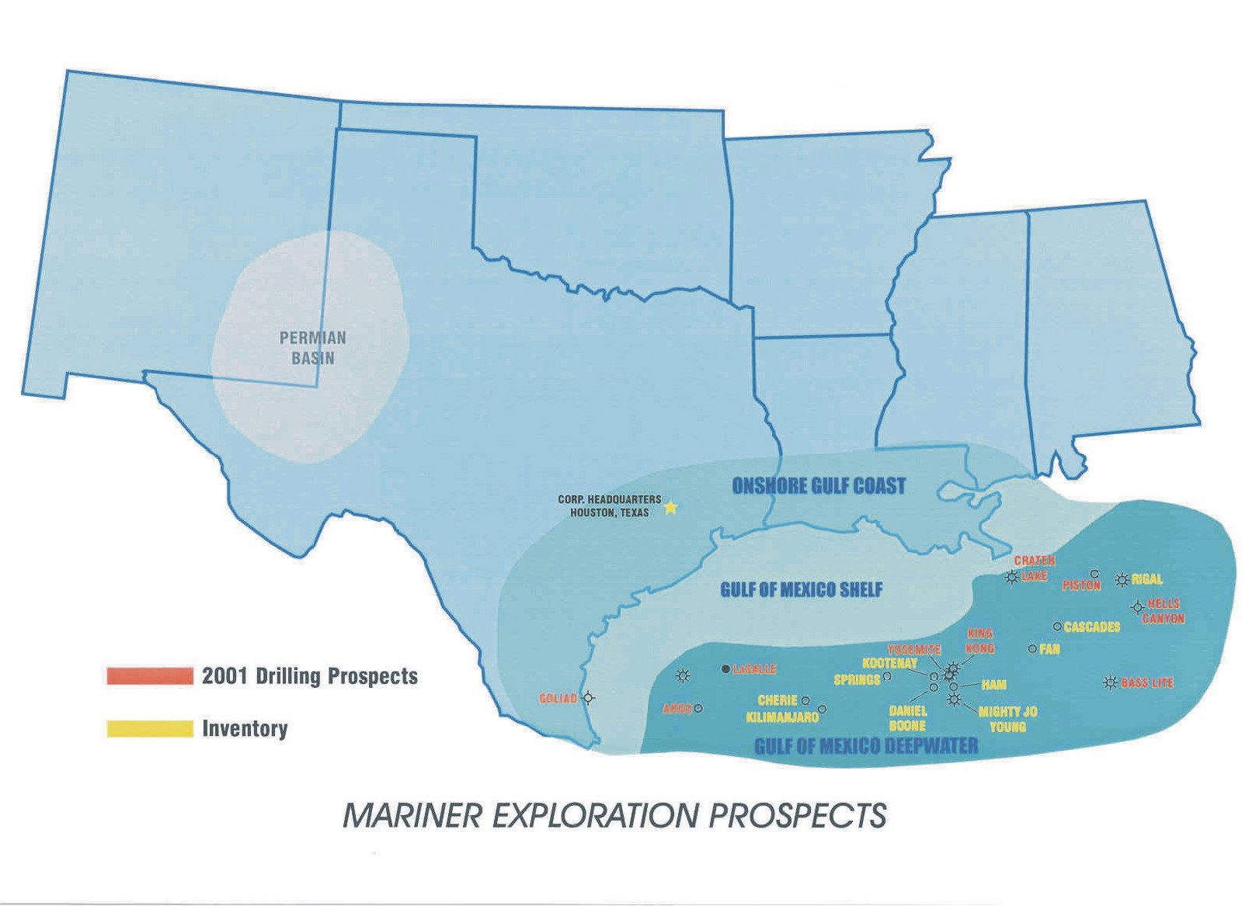
Falcon

Figure 1 - Falcon Project location in the Gulf of Mexico Area.

and process facility to be installed on the shelf edge. The platform will be installed in approximately 400 feet of water in the Mustang Island A103 Block (Figure 4). Gas will be exported through a 20-mile pipeline to be tied into the CTGS pipeline system in Brazos Area Block A105. Total net capital required for the two well development on a cost forward basis is $78.4 million. Sunk costs are $4.6 million net for leasehold, the drilling of the original hole, drilling of the downdip sidetrack and project costs associated with seabed surveying, project management and engineering. The wells are expected to begin production in late December of 2002 at a combined initial rate of 166 Mmcfd net of downtime.
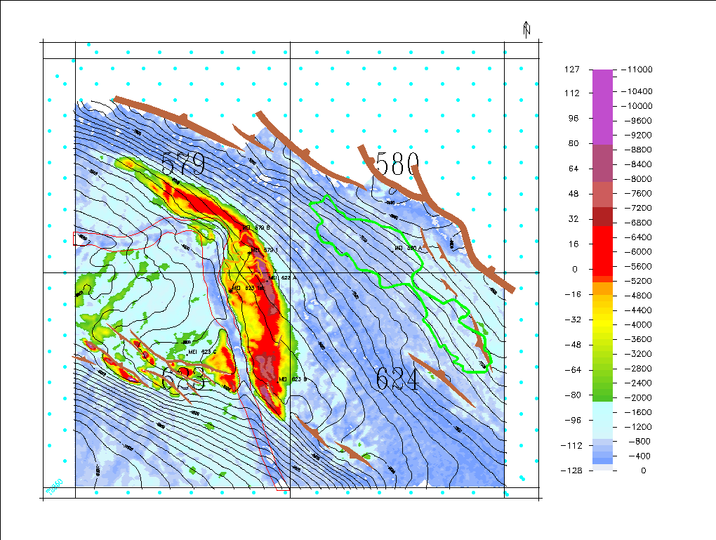
H3.0
H2.5
Splay
Xline 2875

Figure 2 - H3.0 Max Trough Amplitude Map (20-40 degree Angle Volume) including outline of “Splay” in orange and H2.5 in green.

Upside potential includes the development of the “Splay” sand found above the fields’ main accumulation and the drilling of the H2.5 sand in Block 580 (Figure 2). The “Splay” sand was penetrated by both the original hole and the sidetrack and is estimated to contain 10 Bcf of recoverable gas. The H2.5 sand accumulation on Block 580 has not been tested and is estimated to contain 30-50 Bcf of recoverable gas. Within 20 miles of

the proposed Falcon development, more than 10 leads and prospects with reserve potential in excess of 700 Bcf have been identified (Figures 19 and 20). Included in this reserve potential are 9 Falcon Area blocks on which Mariner was high bidder at the recent OCS Lease Sale. Additionally, Mariner and its partner have drill-to-earn options on 16 blocks via a Texaco and TFE farmout proposal. The process facility capacity will therefore be designed for expandability from 175 Mmcfd to 300 Mmcfd.

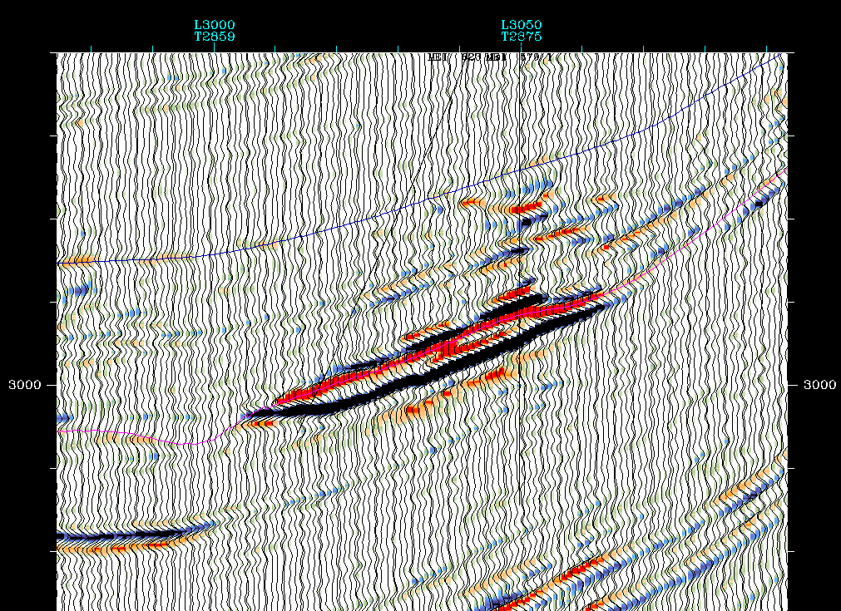
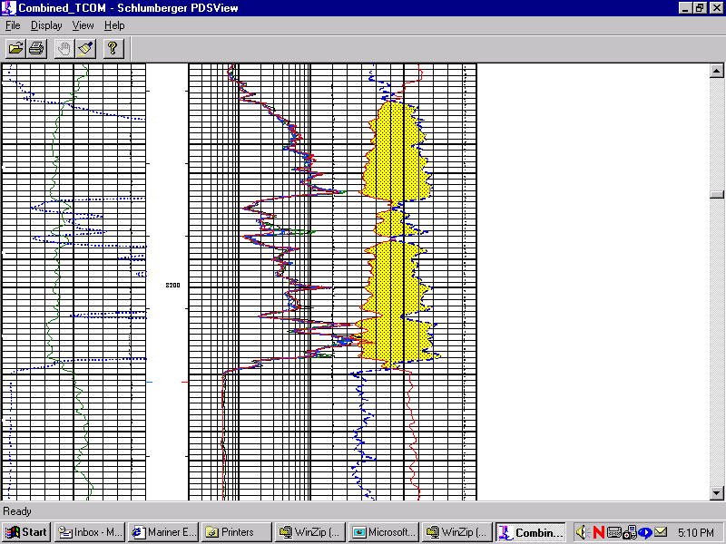
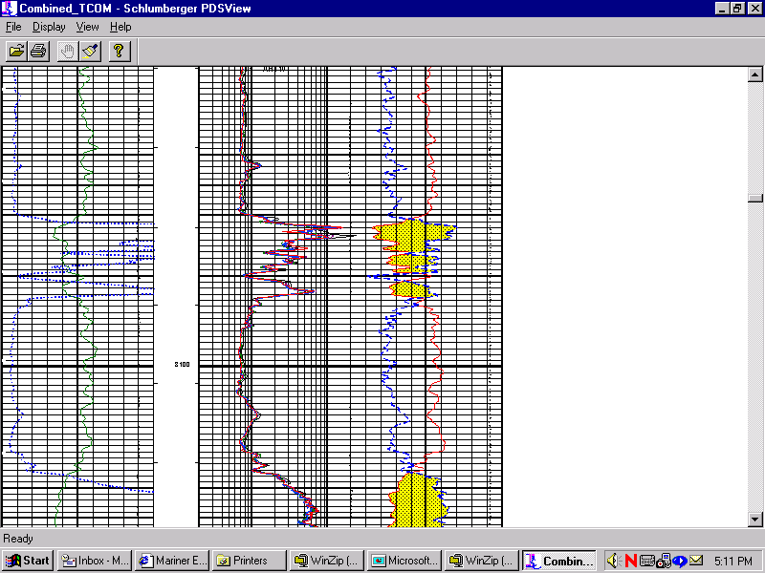
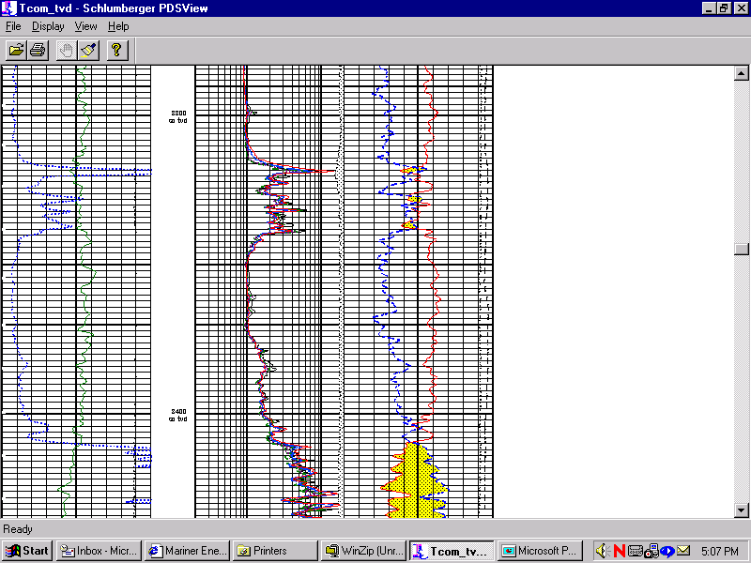
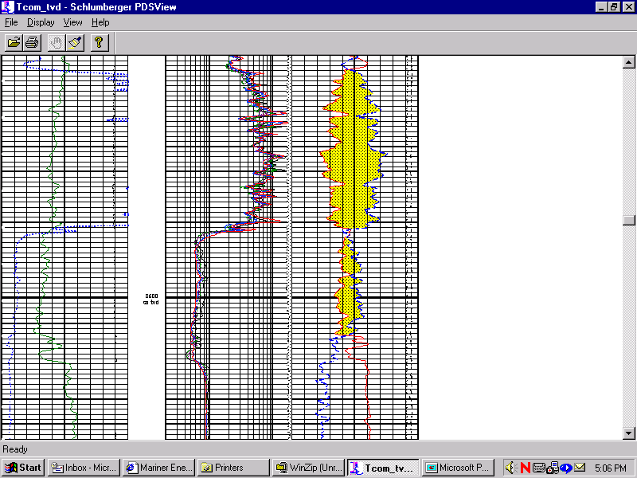
NE
SW
EB 579 #1
EB 623 #1 Stk
Splay
H-3
Splay
H-3

Figure 3 - Crossline 2875 of H3.0 Max Trough Amplitude Map (0-20 degree Angle Volume)

Most likely economics for the Falcon Project development are summarized in Figure 13. Gas pricing for these analysis starts at $3.25/Mmbtu Henry Hub for 2003 and is maintained flat for four years with a 2% annual escalation beginning in 2007. The Falcon subsea development project pays out in just over two years from project sanction, yielding an IRR over 100%, VAI-10 of 2.88 and a finding cost of $5.06/Boe. The project will contribute an estimated 5.0 Mmboe of production and $95.0 million in EBITDA in year 2003.

Based on the strong economics and the upside potential, we recommend your approval of the sanctioning of the Falcon Project effective September 12, 2000.

Project Background

Mariner and Oryx, with a 50% working interest each, acquired East Breaks Blocks 580 and 623 in OCS Lease Sale 168 in August of 1997 for a total gross expenditure of $4,424 M. Mariner then acquired Texaco’s 100% working interest in East Breaks 579 and Kerr McGee’s (formerly Oryx) 50% working interest in property trades. Subsequent to the trades Mariner assigned 5% interest to Noble and sold 45% interest to Pioneer Natural Resources for a net leasehold reimbursement of $1.8 million. The leases are free of royalties for the first 87.6 MMBOE in accordance with MMS guidelines.

Following acquisition of 3D data and significant seismic reprocessing, the plans for testing of the prospect were finalized. In late 2000 the Falcon prospect was tested through a promoted deal structure where Pioneer Natural Resources paid 90% of the cost of the initial test well before casing point to earn a 45% working interest in the three block area and Mariner paid 10% before casing point. Working interests after casing point of the EB 579 #1 well are Mariner (operator) 50%, Pioneer 45% and Noble 5%.
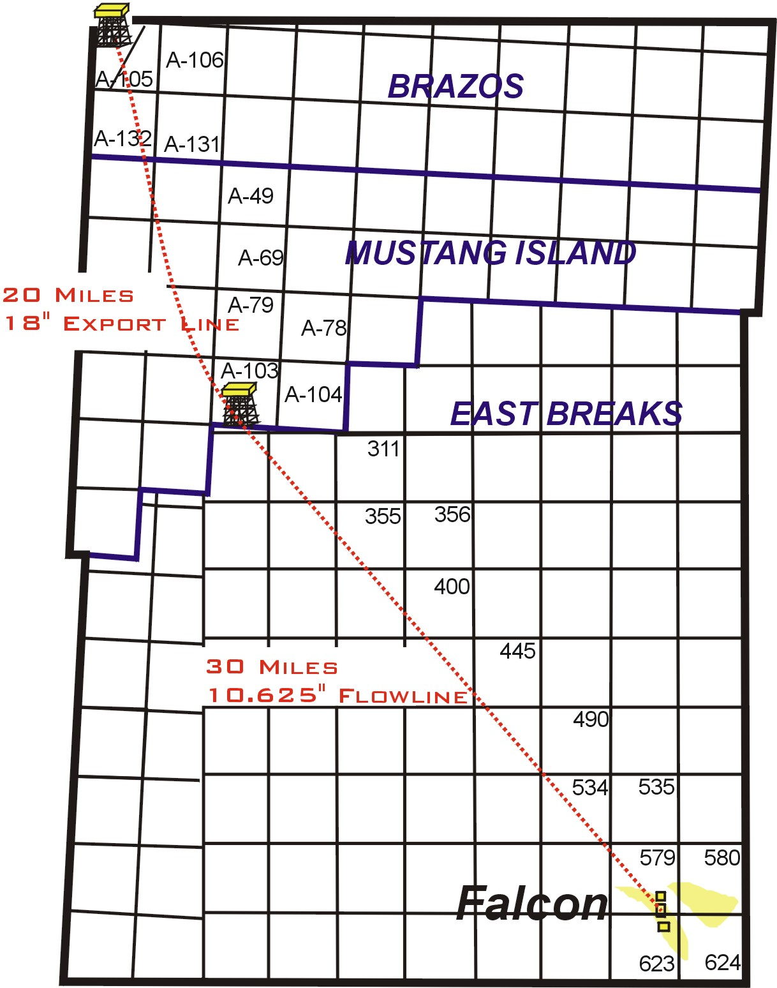

Figure 4 – Falcon Project flowline and export line routes.
The EB 579 #1 well was spud in March of 2001. Following a successful test of the middle Miocene section at a depth of approximately 8100’ TVD, the well was immediately sidetracked (EB 623 #1 Stk.) to a downdip structural position to establish the extent of the discovery. The sidetrack found a similar sand section along with a predicted gas/water contact confirming the commerciality of the accumulation. The well was temporarily abandoned pending further evaluation.

During the drilling of the well extensive logging, bottomhole pressure and fluid sampling occurred. Analysis of the data began in parallel with proprietary prestack processing and simultaneous inversion work by Jason. Using the results of these studies, both geological and reservoir simulations were undertaken in order to determine recoverable reserve volumes and establish a development plan. Ryder Scott, Mariner’s reserve auditors, assisted in the preparation of the reservoir model and the determination of the number of development wells required for the most efficient recovery of field gas reserves. The studies concluded that two wells would effectively deplete recoverable gas and condensate reserves.

Several development alternatives were considered for the Falcon project due to lack of infrastructure in the area. Plans for development included a subsea tieback, Spar, mini-TLP, conversion of a semi-submersible and the application of a Mariner generated FPF concept. Costs and schedules were prepared for each of the alternatives. Initial costs and predicted online dates eliminated all but the subsea tieback and Mariner FPF options. Significant engineering effort was expended in furthering these concepts. Economics were run on the basis of a “stand alone” project and one that could be easily expanded to include the tie-in of equity or third party projects within the Falcon area. Although project economics played a significant role in the development alternative selection process, intangible items such as cost and expense variability, expandability of the system, use of proven technology, cost, schedule, and operating risks, date of first production and uptime were also considered in the decision process. In conclusion, a two well subsea development is recommended.

Subsurface

Reserves discovered to date by the EB 579#1 well and the EB623#1 Stk. are in stratigraphic traps containing high quality sands (Figures 2, 3 & 5). The main pay interval, the H3.0 sand, is interpreted to be a Middle Miocene “Basin Floor Fan”, which onlaps the basin edge forming a stratigraphic trap. A post-depositional shale filled channel cuts into the H3.0 sand body, creating an additional stratigraphic barrier along portions of the downdip extent of the gas accumulation. Dry gas (98.4% methane) is the principal hydrocarbon phase present. There is evidence of aquifer support from both well information, including a gas-water contact at 8413’, and seismic data that exhibits flatspots and amplitude conformance to depth structure. The aquifer is estimated to be 10x in relation to hydrocarbon pore volume. Reservoir quality is excellent (see reservoir parameters in Figure 12). The hydrocarbon accumulation produces a significant seismic amplitude anomaly, which forms the basis of the areal extent and thickness estimates. The reservoir area and gross pay thickness are calibrated by well control and 3D seismic data from original, reprocessed and inversion products.

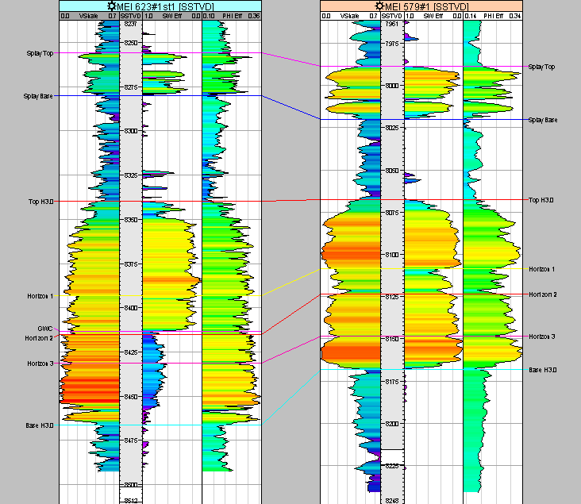
91’/101’
60’/66’TVT
GWC

Figure 5 - Falcon TVDSS cross-section.

Reserves

A Monte Carlo reserve distribution was created in Crystal Ball by varying eight input parameters. Estimated P50 of recoverable gas for the H3.0 Horizon is 194 Bcf (Figure 6). Downside recoverable gas is 155 Bcf, and upside recoverable gas is 244 Bcf. Ryder Scott, Mariner’s reserve auditors, estimates recoverable reserves of 133 Bcf proved and 41 Bcf probable.

Facilities

Process facilities and living quarters will be installed on a platform that will be fabricated and installed in Mustang Island Block A103 in 400’ of water. Dedicated equipment capable of handling 175 Mmcfd will be added to the platform to receive, separate, process and meter Falcon production. The dehydrated gas will be sold into a planned 18” departing gas export line and commingled with the produced condensate.
Gas Reserves
% Bcf
0%100.4
10%154.6
20%166.1
30%175.9
40%184.8
50%193.6
60%204.2
70%212.8
80%225.2
90%244.3
100%336.4

Figure 6 - Falcon H3.0 Monte Carlo reserve distribution.

Produced gas will be sold into the Central Texas Gathering System at a 16” tie-in point in the 30” transmission line in Brazos Area A105. Net gas production and cumulative net gas produced for the P50 reserves of 194 Bcf vs. time are shown in Figure 7. Equivalent MMBOE volumes are shown in Figure 8. Compression will be required and installed approximately two years after the commencement of production.

The subsea system will include: a four-well subsea manifold, one 10” flowline, a multiplex control system and a control umbilical capable of handling four subsea wells. A dedicated chemical injection system will be utilized for corrosion and hydrate inhibition. Methanol storage, electrical power, instrument air, fire water system and safety equipment will be installed on the platform to support the process and living quarters.

Mariner is currently in discussions with Williams and El Paso for the potential installation of the export system, platform and facilities. The goal is a positive impact on the net present value of the project through the possible transfer of ownership of a portion of the infrastructure to the transmission company.

Economics

The Falcon project economics assume that two wells will develop the H3.0 sand and be tied back into a subsea manifold for transport through a single 10” gathering line to a platform installed in Mustang Island Block A103. Estimated gross “most likely” cost forward for this development alternative is $156.7 million ($78.4 million net). Future capital required for the Falcon “stand alone” development is summarized in Figure 9. Each of the two wells is expected to flow gas at initial rates of 83 Mmcfd net of downtime. Operating costs are estimated to be $274,000/month for the platform and $52,000/month/well including interventions, workovers and unscheduled repairs (Figure 10A & B). Gas pricing for this analysis starts at $3.25/Mmbtu Henry Hub for 2003 and is maintained flat for four years with a 2% annual escalation beginning in 2007. Condensate price is held constant at $21.00/Bbl for 2003 and 2004, drops to $20.00/Bbl in 2005 and 2006 and escalated 2% annually thereafter.

Subsea development, including subsea facilities, conventional platform, process facilities and the export pipeline system, of the Falcon Project pays out in just over two years from project sanction as shown in the cash position curve in Figure 11. Economics yield an IRR over 100%, VAI-10 of 2.88 and a finding cost of $5.06/BOE. An estimated 5.0 MMBOE of production and $95.0 million in EBITDA are estimated in year 2003. The project schedule for subsea development is shown in Figure 14 and depicts an online date of late December 2002.

The economics show that the project will generate a PV-10 of $142 million net to Mariner. Figures 15 and 16 illustrate the project sensitivity to reserves. A reduction in project reserves from a most likely level of 194 Bcf to 100 Bcf reduces the IRR to 65%, well above the economic threshold. Reduction of reserves to the Ryder Scott proved volume for the H3.0 of 133 Bcf results in an estimated IRR of 85% and a PV-10 of $80 million. Figures 17 and 18 show the project sensitivity to cost overruns. A gross capital over-expenditure of 120% above the “most likely” cost of $156.7 million would lower the IRR to a level of 25%. Price sensitivity is shown in Figure 19. A $.50/Mmbtu reduction in price to a level of $2.75/Mmbtu reduces the IRR to 81% and the PV-10 to $107 million net to Mariner.

Upside Potential

Initial reservoir simulation work indicates the potential for a recovery percentage greater than the most likely estimate of 65% is possible due to limited aquifer support. Recovery could reach 75% or 224 Bcf.

An additional un-drilled anomaly, the H2.5, exhibits a seismic signature similar to that of the H3.0 and “Splay” reservoirs. The H2.5 anomaly on EB 580/624 is considered low risk (1:2) with a P50 reserve size of 30 Bcf. Development of the H2.5 is considered upside for this economic evaluation. The Falcon subsea system could accommodate the development of both the H3.0 and the H2.5.

The “Splay” reserves of 10 Bcf are presumed recoverable in late field life through the recompletion of one of the two proposed wells if the economic analysis at that time supports the capital expenditure.

Within 20 miles of the proposed Falcon development, more than 10 leads and prospects with reserve potential in excess of 700 Bcf have been identified (Figures 20 and 21). Included in this reserve potential are 9 Falcon Area blocks on which Mariner was high bidder at the recent OCS Lease Sale. Additionally, Mariner and its partner have drill-to-earn options on 16 blocks via a Texaco and TFE farmout proposal.

