Case Study:
El Paso Energy’s Acquisition of Coastal Corp.

Enron North America
Corp. Development
January, 2000
Table of Contents

TAB
Transaction Overview A
Overview of El Paso B
Overview of Coastal C
Combination Analysis D

Transaction Overview

Overview of El Paso

Overview of Coastal

Combination Analysis

Transaction Overview

Introduction
- On January 18, 2000 El Paso Energy Corporation (“El Paso”) and The Coastal Corporation (“Coastal”) announced a stock-for-stock merger, creating a company with an estimated pro forma enterprise value of $32 billion.
- El Paso enhances its several of its core businesses:
- Natural gas transmission (#1 with 17 Bcfd capacity on 58,000 miles of pipelines)
- Natural gas domestic reserves (#4 with 4.8 Tcfe of reserves)
- Natural gas gathering and processing (#2 with 14,800 miles gathering 5.5 Bcfd)
- Natural gas marketing (#3 with 10.2 Bcf/d)
- Power marketing (#3 with 90 MM Mwh)
- Power generation (12,000 net MW)
- The company will have significant refining capacity (4 refineries with 468,000 Bpd capacity). Future growth is expected to come primarily from power generation and fiber-optic communications businesses.

Transaction Overview

Introduction
- With El Paso trading at $37.25/share¹, its offer of 1.23 shares per Coastal share represented a 27.3% merger premium over Coastal’s $36.00/share. However, based on El Paso’s $33.25/share closing price 2 trading days after announcement², the offer represents only a 14% merger premium.
- The total value of the acquisition is approx. $16 billion, including $6 billion in assumed debt.
- Based on $200mm annual synergies, the transaction is projected to be accretive to El Paso’s 2000 earnings and 5% accretive 2001 and 2002 earnings.
- El Paso paid multiples of 10.5x, 8.6x and 7.2x CFPS for 1999, 2000E and 2001E, respectively⁵.
- The tax-free merger is expected to be completed during 4Q 2000 using pooling of interest accounting. The transaction is not subject to a collar but is subject to a $300mm mutual break-up fee.
- Management anticipates neither material asset dispositions nor significant regulatory (FTC, FERC, SEC) issues.

Overview of El Paso

Summary
- Recently completed acquisition of Sonat, Inc. creating the largest pipeline system in North America and dramatically increased El Paso’s oil and gas E&P exposure, adding 1.2 Tcfe of mostly Gulf of Mexico natural gas reserves.
- El Paso’s stock price has risen 22% during 1999 and has continued to trade at a premium to its comparables (15.7x 2000 EPS vs. 15.3x 2000E EPS for its comparables).
- Financial Data ($mm):
 | Years Ended 12/31 |  |  |  |  | As of 12/31/98⁴
Income Statement | 1998 | 1999E |  | Balance Sheet | Book |  | % | Market | %
Operating Revenues | $9,492 |  |  | Total Debt | $3,843 |  | 48.5% | $3,843 | 28.5%
EBITDA | 778 |  |  | Preferred Equity | 699 |  | 8.8% | 699 | 5.2%
Operating Income | (257) |  |  | Common Equity | 3,375 |  | 42.7% | 8,950 | 6.6%
Earnings Per Share | $(1.35) | 1.78 |  | Total Capitalization | $7,917 |  | 100% | $13,492 | 100%

Overview of El Paso

Overview of Pipeline Assets
Tennessee Gas Pipeline Company  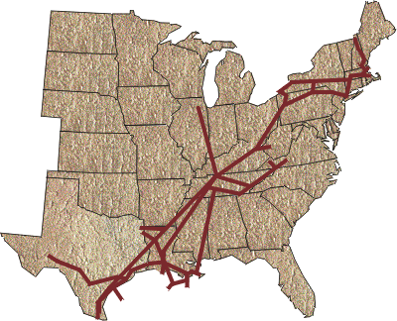 | El Paso Natural Gas Company  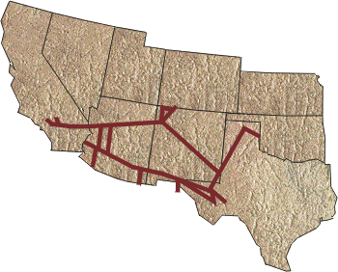
Sonat Natural Gas Company  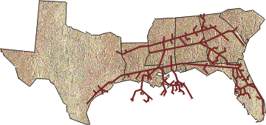 | El Paso Field Services Company  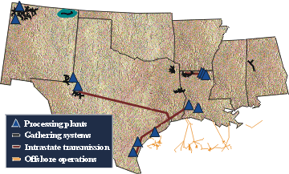

Overview of El Paso

Overview of Pipeline Assets
- The majority of El Paso’s earnings have historically come from its natural gas transmission business.

Overview of El Paso

El Paso Competitive Assessment
- The Coastal merger should address some of El Paso’s perceived weaknesses.

Overview of Coastal

Summary of Assets
- Transmission: ANR Pipeline Co. and Colorado Interstate Gas Co. transport 8 Bcfd over 18,000 miles of regulated natural gas pipelines, handling 13% of all gas consumed in the U.S.
- Exploration & Production: successful operations in South Texas, the Texas and Louisiana coastal plains, the Gulf of Mexico and Utah's Natural Buttes area (reserves =
- Refining & Marketing: Four refineries with a combined processing capacity of 468,000 Bpd
- Aruba (210,000 Bpd)  - Westville, N.J. (140,000 Bpd) | - Corpus Christi, TX (100,000 Bpd)  - Mobile, AL (18,000 Bpd)

- Coastal moves products to market through efficient transportation network, including almost 1,700 miles of wholly or partly owned crude oil and product pipelines located in Texas, with an average throughput of 230,000 bpd. 1,700 Coastal-branded outlets sell | 1,700 Coastal Mart-branded outlets in 45 States. 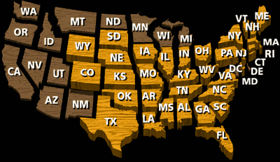
- Power: Coastal's electric power production company now operates plants in the United States, China, El Salvador and the Dominican Republic, and has projects in various stages of development in Pakistan, Nicaragua and Guatemala.
- Financial Data
 | Years Ended 12/31 |  |  |  |  | As of 9/30/98
Income Statement | 1998 | 1999E |  | Balance Sheet | Book |  | % | Market | %
Operating Revenues | $7,368 |  |  | Total Debt | $4,213 |  | 52.1% | $4,213 | 24.3%
EBITDE | 1,388 |  |  | Preferred Equity | 400 |  | 4.9% | 400 | 2.3%
Operating Income | 945 |  |  | Common Equity | 3,476 |  | 43.0% | 12,748 | 73.4%
Earnings Per Share | $2.03 | $2.75 |  | Total Capitalization | $8,089 |  | 100.0% | $17,361 | 100.0%

Overview of Coastal

Map of Coastal’s Assets

Coastal Corporatation
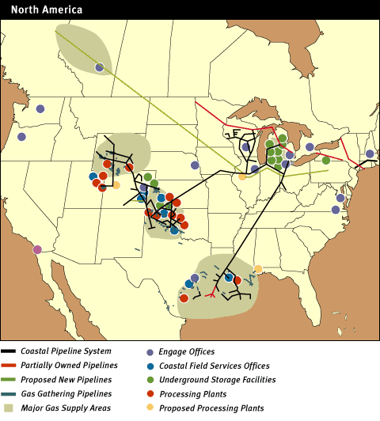

Overview of Coastal

Historical Financial Data
- The majority of Coastal’s earnings have historically come from its natural gas operations.

Overview of Coastal

Coastal Competitive Assessment
- As can be seen in the tables below, Coastal has certain competitive weaknesses that most likely made the decision to merge with El Paso more tenable.

Combination Analysis

Business Mix Comparison (2000E Operating Income)
Coal &
Other
$58
Power $119
Transmission
$4
Midstream
$75
E&P $348
Refining $140
Marketing
$172
4%
9%
35%
5%
25%
10%
12%

Coastal
Midstream
$151
Transmission
$827
Merchant
Energy $136
Production
$210
Power/Int'l
$103
11%
10 %
15 %
7%
58%
El Paso
Coal &
Other
$58
Power/ Int'l
$222
Refining $140
Marketing
$172
E&P $558
Merchant
Energy $136
Midstream
$226
15%
9%
37%
11%
9%
15%
4%
Pro Forma Combined
Total: $1,390⁽¹⁾
Total: $1,427⁽¹⁾
Total: $2,817⁽¹⁾⁽²⁾

Combination Analysis
Ranking of Electric and Gas Companies by Equity Market Value
- The combination creates a company with larger equity market value than Duke Energy, Southern Company or Williams Companies

Combination Analysis

Largest Pipeline System in North America
- By acquiring Coastal, El Paso adds further to its position as the largest pipeline network in North America with a 56,600 miles system transporting over 20 Bcf per day.
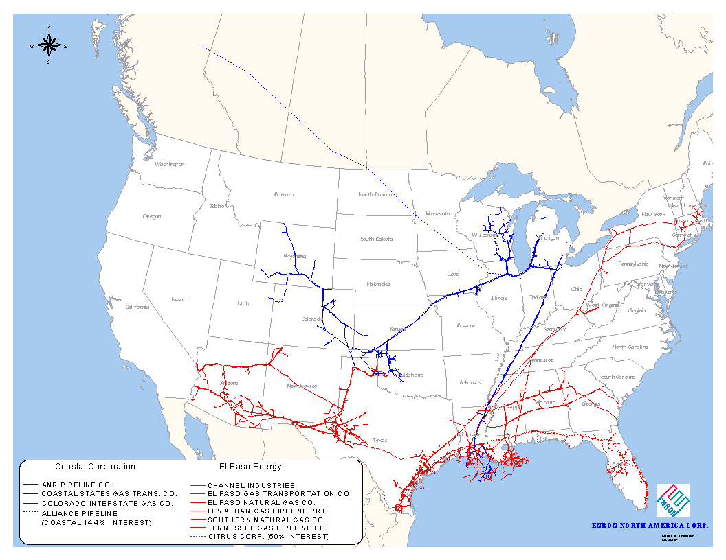

Combination Analysis

Rankings among “Natural Gas Majors”

Combination Analysis

Combination Analysis – Operational Statistics
 |  | 1999E (unless otherwise denoted)
 | El Paso |  | Coastal | Combined
Pipeline System:
Regulated Pipelines (miles) | 38,600 |  | 18,000 | 56,600
Interstate Transported (Bcf/d) | 12.7 |  | 8.0 | 20.7
Exploration & Production:
Production (Mmcfe/d) | 660 |  | 510 | 1,170
Reserves (Tcfe) | 1.4 |  | 3.4 | 4.8
Gathering and Processing:
Miles of Gathering | 11,000 |  | 3,800 | 14,800
Throughput (1998, Bcf/d) | 4.5 |  | 1.0 | 5.5
Processing Plants | 16 |  | 10 | 26
Marketing:
Natural Gas Volumes (Bcf/d) | 6.7 |  | 3.5 | 10.2
Power (MM MWh) | 79.4 |  | 10.5 | 89.9
Refining Capacity
MBpd | 0 |  | 468 | 468
Power Generation:
Capacity (MW) | 12,000 |  | 2,000 | 14,000

Combination Analysis

Combination Analysis – Financial Statistics
 |  | 1999 Estimated
 | El Paso |  | Coastal | Combined
Income Statement:
Revenues | 10,600 |  | 7,600 | 18,200
EBIT | 1100 |  | 990 | 2090
EBITDA | 1700 |  | 1500 | 3200
Net Income | 420 |  | 500 | 920
Balance Sheet:
Total Assets ($ billion) | 16.8 |  | 14.7 | 31.5
Shares outstanding | 230 |  | 214 | 499

Combination Analysis
The price of El Paso’s and Coastal’s common stock during the past several years has been similar

Performance since 1/1/97 Performance since 1/19/99

- Document Profile
- Author: Jeff Bartlett
- Subject/Comments:
- Document: o:\stfin\from_jmb\corpdev\epg_cgp_study.doc
- Users:

01/18/00 JMB

As of January 14, 2000, the day prior to announcement of the transaction. 2 Based on exchange ratio of 1.23 shares of El Paso for each share of Coastal. 3 Premium over Coastal’s closing price as of January 14, 2000. 4 As of January 19, 2000. 5 2000 and 2001 projections based upon Merrill Lynch research report dated January 18, 2000.
Source: CSFB comparable trading analysis dated 1/9/00. Comparables include Coastal, Columbia Energy Group, Equitable Resources, Kinder Morgan and Questar.
Pro forma Sonat merger. Source: merger proxy dated April 30, 1999.
Source: Merrill Lynch research report dated January 18, 2000. 4 Pro forma for merger of El Paso/Sonat (9/30/99 information not available, as merger closed during October, 1999).
(1) El Paso's results for 1996 through 1998 are not restated for El Paso's merger with Sonat and reflect El Paso on a stand-alone basis. Estimated results for 1999 are restated for the Sonat merger.
Merrill Lynch research report dated January 6, 2000.
As of January 14, 2000.
As of December 31, 1998.
Coastal’s net volumes marketed by Engage during 1998 (Coastal owns 50% of this JV with WestCoast Energy).
Source: Press Release from Coastal web site.

