 | 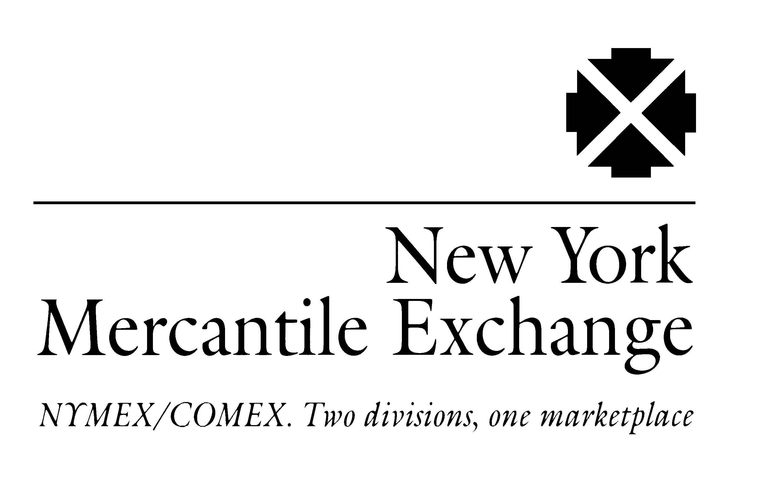
EXCHANGE ANNOUNCES FIRST SLATE OF PRODUCTS FOR enymex^{sm}
NEW YORK, NY, December 7, 2000 -- The New York Mercantile Exchange, Inc., board of directors last night approved a range of energy products for listing on enymexsm, the Exchange's internet-based trading system, intended to be launched during the second quarter of 2001.
Exchange Chairman Daniel Rappaport said, "These products were designed to replicate the most actively traded over-the-counter energy instruments, introducing the added benefits of clearing services; a neutral, centralized marketplace; and a highly sophisticated technological platform. While there may be additional products developed for introduction at launch, including more internationally based contracts, and there will certainly be more shortly thereafter, these contracts were selected as natural adjuncts to our established markets because of their close relationships to these liquid benchmarks."
The contracts include:
A West Texas Intermediate crude oil calendar swap contract
A Henry Hub natural gas swap contract based on the final settlement price for the Exchange's futures contract
Spread calendar swap contracts based on the differential between Platts (a division of The McGraw-Hill Companies) quoted prices for Gulf Coast unleaded 87 gasoline and the Exchange light, sweet crude oil and New York Harbor unleaded gasoline futures contracts
Spread calendar swap contracts based on the differentials between the Platts quoted price for Gulf Coast Pipeline No. 2 heating oil and the Exchange light sweet crude oil and New York Harbor heating oil futures
Basis swap contracts based on the differential between the final settlement price for the Henry Hub natural gas futures contract and Inside FERC's Gas Market Report quoted indexes for Henry Hub; El Paso San Juan Basin; Houston Ship Channel; and Transco Zone 6
Basis swap contracts based on the differential between the Exchange Henry Hub natural gas futures contract and the Canadian Gas Price Reporter Alberta spot month price (based on AECO C/NIT) -more-
Basis swap contracts based on the differential between the Exchange Henry Hub natural gas futures price and the Natural Gas Intelligence quoted index prices for Chicago City Gate and the southern California border
Louisiana Light Sweet and West Texas Sour crude oil contracts
A Dubai crude oil calendar swap
Terms and conditions include a unit size of 1,000 barrels for each of the crude oil and petroleum product/crude oil spread contract; 42,000 gallons for each heating oil and gasoline contract; and 5,000 million British thermal units (mmBtus) for each natural gas contract. Prices will quoted in U.S. dollars and cents per barrel, gallon or mmBtu. Other specifications are:
West Texas Intermediate crude oil calendar swap
Termination of Trading: The last business day of the month prior to the contract month.
Delivery: Financial, based on the average of the settlement price of the first nearby light, sweet crude oil futures contract throughout the contract month (example: the July 2001 contract will be based upon the average of the settlement prices for the August 2001 futures contract during July 2001 until it ceases trading and the settlement prices for the September 2001 contract for the remainder of the month)
Minimum Price Fluctuation: One cent per barrel
Henry Hub natural gas swap
Termination of Trading: The third business day prior to the contract month.
Delivery: Financial, based on the final settlement price of the Exchange Henry Hub natural gas futures contract for the corresponding month
Minimum Price Fluctuation: $0.001 per mmBtu
U.S. Gulf Coast unleaded 87 gasoline crack spread calendar swap
Termination of Trading: The last business day of the month prior to the contract month.
Delivery: Financial, based on the average of the Platts U.S. Gulf Coast unleaded 87 gasoline mean minus the settlement price of the first nearby light, sweet crude oil futures contract throughout the contract month
Minimum Price Fluctuation: One cent per barrel

Unleaded 87 gasoline up-down calendar swap
Termination of Trading: The last business day of the month prior to the contract month.
Delivery: Financial, based on the average of the Platts U.S. Gulf Coast unleaded 87 gasoline mean minus the settlement price of the first nearby Exchange New York Harbor unleaded gasoline futures contract throughout the contract month
Minimum Price Fluctuation: $0.0001 per gallon
U.S. Gulf Coast No 2 heating oil crack spread calendar swap
Termination of Trading: The last business day of the month prior to the contract month.
Delivery: Financial, based on the average of the Platts U.S. Gulf Coast pipeline No. 2 heating oil mean minus the settlement price of the first nearby light, sweet crude oil futures contract throughout the contract month
Minimum Price Fluctuation: One cent per barrel
No. 2 heating oil up-down calendar swap
Termination of Trading: The last business day of the month prior to the contract month.
Delivery: Financial, based on the average of the Platts U.S. Gulf Coast No. 2 pipeline mean minus the settlement price of the first nearby Exchange New York Harbor No. 2 heating oil futures contract throughout the contract month
Minimum Price Fluctuation: $0.0001 per gallon
Henry Hub natural gas basis swap
Termination of Trading: The last business day prior to the contract month.
Delivery: Financial, based on the Inside FERC Gas Market Report Henry Hub index price minus the final settlement price of the Exchange Henry Hub natural gas futures contract for the corresponding month
Minimum Price Fluctuation: $0.001 per mmBtu
San Juan natural gas basis swap
Termination of Trading: The last business day prior to the contract month.
Delivery: Financial, based on the Inside FERC Gas Market Report El Paso San Juan Basin index price minus the final settlement price of the Exchange Henry Hub natural gas futures contract for the corresponding month
Minimum Price Fluctuation: $0.001 per mmBtu
Houston Ship Channel natural gas basis swap
Termination of Trading: The last business day prior to the contract month.
Delivery: Financial, based on the Inside FERC Gas Market Report Houston Ship Channel index price minus the final settlement price of the Exchange Henry Hub natural gas futures contract for the corresponding month
Minimum Price Fluctuation: $0.001 per mmBtu
Transco Zone 6 natural gas basis swap
Termination of Trading: The last business day prior to the contract month.
Delivery: Financial, based on the Inside FERC Gas Market Report Transco Zone 6 index price minus the final settlement price of the Exchange Henry Hub natural gas futures contract for the corresponding month
Minimum Price Fluctuation: $0.001 per mmBtu
AECO/NIT natural gas basis swap
Termination of Trading: The last business day prior to the contract month.
Delivery: Financial, based on the Canadian Gas Price Reporter Alberta spot month price for AECO C/NIT price minus the final settlement price of the Exchange Henry Hub natural gas futures contract for the corresponding month
Minimum Price Fluctuation: $0.001 per mmBtu
Chicago natural gas basis swap
Termination of Trading: The last business day prior to the contract month.
Delivery: Financial, based on the bid week price quoted for the Chicago Citygate, under the Midwest heading in the Natural Gas Intelligence bid week survey, minus the final settlement price of the Exchange Henry Hub natural gas futures contract for the corresponding month
Minimum Price Fluctuation: $0.001 per mmBtu
Socal natural gas basis swap
Termination of Trading: The last business day prior to the contract month.
Delivery: Financial, based on the bid week price quoted for the Southern California border average, under the California heading in the Natural Gas Intelligence bid week survey, minus the final settlement price of the Exchange Henry Hub natural gas futures contract for the corresponding month
Minimum Price Fluctuation: $0.001 per mmBtu
Louisiana Light Sweet crude oil futures
Termination of Trading: Third business day prior to the 25th calendar day of the month preceding the contract month. If the 25th calendar is a non-business day, trading terminates on the third day prior to the last preceding business day.
Delivery: Physical in St. James, Louisiana
Minimum Price Fluctuation: One cent
West Texas Sour crude oil futures
Termination of Trading: Third business day prior to the 25th calendar day. If the 25th calendar is a non-business day, trading terminates on the third day prior to the last preceding business day.
Delivery: Physical in Midland, Texas
Minimum Price Fluctuation: One cent per barrel
Dubai crude oil calendar swap
Termination of Trading: The last business day of the month prior to the contract month.
Delivery: Financial, based on the average of the Platts Dubai frontline mean
Minimum Price Fluctuation: One cent per barrel
enymexsm is intended to become the premier system for trading and clearing forward commodities. The Exchange is the largest physical commodity exchange in the world, trading nearly 110 million energy and metals futures and options contracts last year, worth approximately $3.3 trillion.
==================================================================== Forward Looking and Cautionary Statements
The New York Mercantile Exchange, Inc., has attempted, wherever possible, to make statements in good faith by using words such as anticipate, believes, expects, and words and terms of similar substance in connection with any discussion of its present and future operations within the industry. Any forward-looking statements made by, or on behalf of the Exchange, involve a number of risks, trends, uncertainties, and other factors which may cause actual results to differ materially, including; the Exchange's receipt of the necessary Commodity Futures Trading Commission approval; timely performance and cooperative effort of exchange and technology partners; and changes in financial or business conditions at the Exchange.

