As a result of increased security measures, the legacy dial-up strategy has been eliminated. Everyone will have to be approved for access going forward – even if you had it in the past.
You will need to request (via the e-Request system) the new dial-up software. The new dial-up solution is called "eConnect". Here are the instructions on how to get updated. If you have already submitted the request please skip Step 1.

Step 1 - Request Software:
- Go to itcentral.enron.com.
- Go to the e-Request section.
- Log in with your normal user id and password.
- Click on "Update Account Access".
- Type in your name (or the person that needs the software).
- Click on appropriate priority: Normal or High (I recommend High)
- Click OK.
- Click on "Applications".
- In the blank field enter "VPN" and press search.
- econnect-VPN will appear, click "Add"
- Select Tier level.
- Click "Add to request".
- Click "Continue"
- Enter your manager's name if requested.
- Enter your VP's name if requested.
- Click "OK"
- Click "Submit".

Once this has been approved, then the next step is to download the software. If your request needs to be approved by a Manager and/or VP, then they will need to approve it before the request can be processed by Information Risk Management (IRM). Once you have received approval from your Manager and/or VP, then the process to be approved may take several days, depending on the work load for IRM. You may track the progress of your e-Request in itcentral.enron.com. If you requested the software yourself, you will receive an email when the request has been completed.

Step 2 - Get the Software
There are two ways to get the eConnect software, please choose appropriate location:

Dial-up (From home machines)
- Create a dial-up networking entry* for this number: 713-440-4221. Also follow steps below on modifications that you will need to configure within the Dial-up Networking Entry.
- Under the Security tab, select Advanced (custom settings)
- Click Settings...
- Under Data encryption select 'Require encryption (disconnect if server declines)' from the pull-down list
- Ensure only Allow these protocols & MS-CHAP v2 is selected
- Under the Networking tab
- Under 'Type of server I am calling:', Select 'PPP: Windows 95/98/NT/2000, Internet'
- Click Settings
- Ensure only 'Enable software compression' is checked under PPP Settings
- Click OK
- Under the Options tab
- Ensure 'Include Windows logon domain' is checked under Dialing options
- Click OK
2. Using this new connection, dial-up and log in with your regular network credentials into the CORP domain.
3. Once connected, open Internet Explorer.
4. Go to itcentral.enron.com.
5. Click on "Projects", then "eConnect". PLEASE READ THIS PAGE THOROUGHLY. It will give you more detail and information.
6. Click on the "Pre-Requisites" page to find out what all you need to have installed on your computer. If you are unsure of what you have or don’t have, then contact the support for your computer if it is not an Enron asset.
7. Go back to the main eConnect page and find the listing for "Downloading the client" and click on it.
- Choose which connection you need and download it.
- Disconnect from the internet once you have finished downloading it and execute the file you just downloaded.

If IPASS is not available use this Dial up connection to connect to Enron’s Network (You do not need to run the VPN connection if you are using this dial in solution)

* For instructions on installing and using Dial-up Networking, please visit the following website: http://support.microsoft.com/default.aspx?scid=kb;EN-US;q285189

Users in the Office (connected to the network)

Go to http://itcentral.enron.com/Data/Projects/eConnect/ to download the client software.

Once the software is installed, you will see an eConnect icon on your desktop. You will use this to get connected.

Step 3 - Use the Software
There are two ways to use eConnect, one with IPASS to dial up and eConnect on it's own.

Using IPASS
- Double-click the eConnect IPASS icon.
- IPASS will launch - connect normally with IPASS
- After IPASS has dialed, then the eConnect screen will appear. Log in normally.
- You will then be inside the firewall.

Using eConnect without IPASS
- Go to Start => Programs => eConnect => eConnect VPN Access
- Log on with your existing credentials.
- You will then be inside the firewall.

Other Considerations:

- You will not need to re-request access to Terminal Servers, all other access will remain the same.

- If you only require access to your email, then choose “Tier 1” in the e-request system.

- If you have any questions, problems, please contact the Resolution Center at 3-1411.

Appendix

Create a Dial-up Entry

Select Start – Settings – Network and Dial-up Connections – Make New Connection

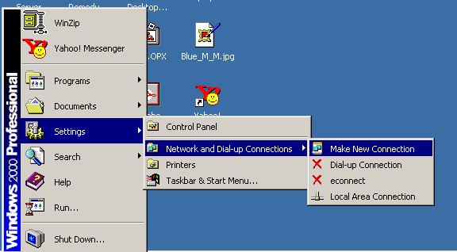

You will get the following screen

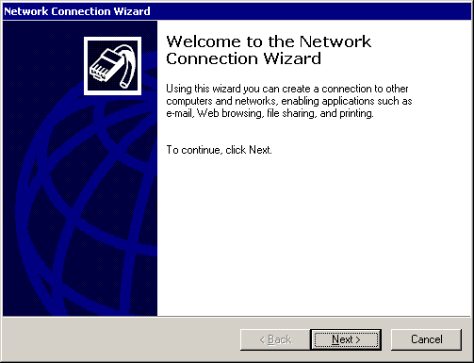

Select – Next
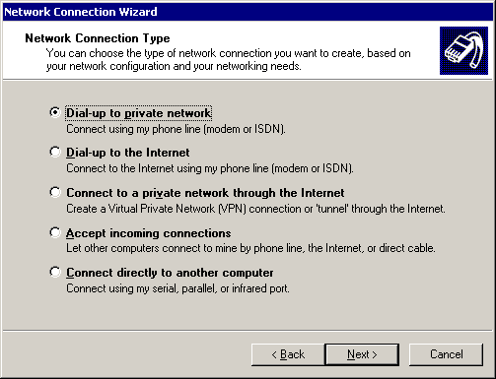

Select Dial-up to private network – select next

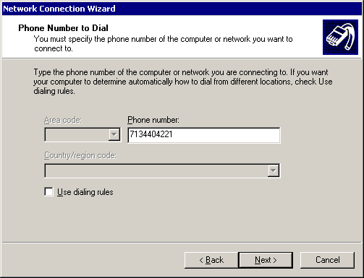

Enter in the phone number: 713-440-4221 and select next
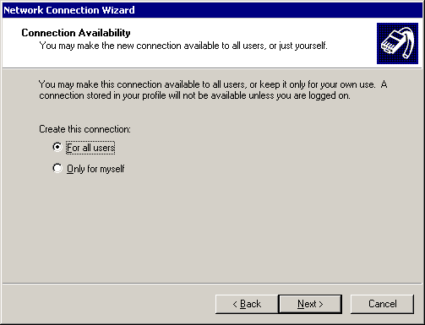

Select For all users and select next

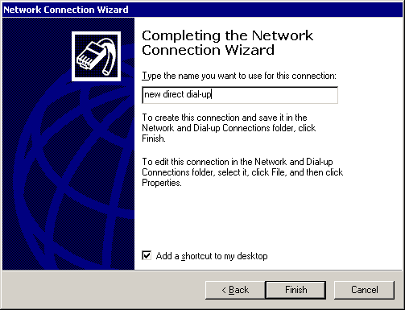

Enter a name, select add a shortcut to my desktop and select Finish

