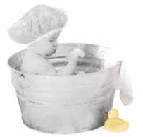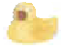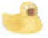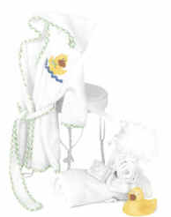
It’s a Baby Shower!
To hear a baby's laughter is to hear an angel sing...
and to hold a baby's hand is to feel the love they bring.
To see a baby's eyes twinkle softly like a star...
is a gift that comes from heaven, the most beautiful by far.

Scott and Lanette Earnest are about to welcome a new little addition to their household!

Please join us on Friday December 15th for a baby shower to celebrate.

Location: To be determined
Time: 2:00 PM - 3:30 PM

If you would like to contribute to a group gift,
please see Sue Foust or Mary Morris

Registered at Babies R’ Us

