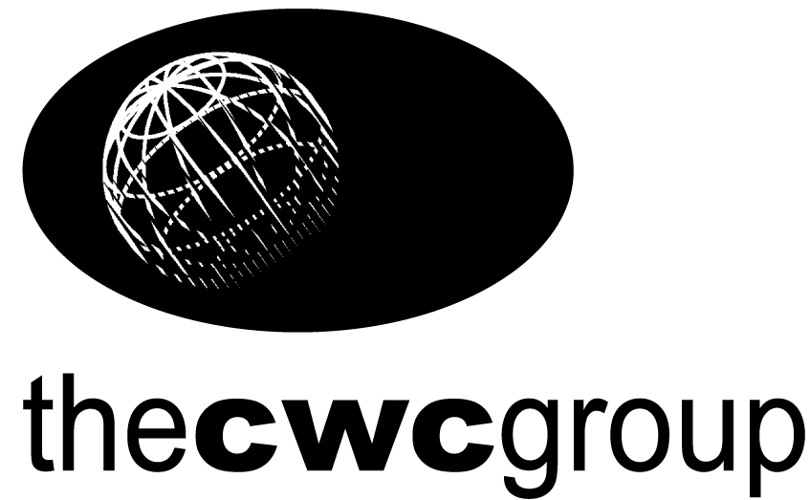

Liberalisation of Italy’s Energy Markets
23 and 24 October 2000

Westin Excelsior Hotel, Rome, Italy

-------------------------------------------------------------------------------------------------------

Day One – 23 October 2000

Moderators

Renato Urban, Vice President, ENI – Agip Division

Alirio A Parra, former Minister of Energy and Mines, Venezuela

08.30 Registration and Coffee

09.00 Session One
Changing Face of the Italian Energy Sector

Opening Keynote Address
HE Dr Enrico Letta, Minister of Industry, Italy

Speaker to be confirmed, Ministry of Industry, Italy

Questions and Answers

10.15 Coffee

10.45 Session Two

Regulation and Financing
- ensuring fair opportunities for new market entrants
- implications for the regulator
- European Union directives
- cross-border regulation: prospects for regulation
- project finance

Professor Sergio Garribba, Commissioner, Regulatory Authority of Electricity and Gas, Italy

Stuart Lawton, Vice President & Senior Analyst, Moody’s Italia SRL
The Effect of Italy's Liberalisation of the Energy Markets on Corporate Credit Quality

John McQuiston, Partner, PricewaterhouseCoopers

Questions and Answers

12.30 Lunch

14.00 Session Three
Opportunities for Investment in the Opening Gas Sector
- changing gas market: demand and supply
- ENI’s divestiture of gas
- Implications of the deregulation on international suppliers

Marcello Colitti, President, UNI; former Vice Chairman, AGIP

Sergio Palma, Agip Oil Company, North Africa

Questions and Answers

15.30 Coffee

16.00 Session Four
Opportunities for Investment in the Liberalising Power Sector

Legislation governing the opening up of European electricity markets
- Privatisation of Italy’s electricity entities
- Competition

Guillermo Bosch Estrada, Marketing, Trading and Tariffs Director,

Dalmine Energie

The Strategic Choices for a New Entrant in the New Italian Energy Market

Questions and Answers

17.30 End of Day One

*********************************************************************

Day Two – Tuesday 24 October 2000

Moderators

Renato Urban, Vice President, ENI – Agip Division

Alirio A Parra, former Minister of Energy and Mines, Venezuela

08.30 Coffee

09.00 Keynote Address

Gian-Maria Gros-Pietro, Chairman, ENI

ENI’s Future - Integrating Competition on International Markets

09.30 Session Five

Competitive Approaches for an Established Player

Massimo Orlandi, CEO, Energia SpA

Yvonne Barton, President, BG Italia

View point of an Established International Player

Riccardo Bortolotti, Amministratore Delegato, Enron Italia

11.00 Coffee

11.30 Fabio Leoncini, President, AIGET

The Role of Traders in the New Italian Market

Dr Mario Casoni, President, Confindustria

Business Competitiveness

Questions and Answers

12.30 Lunch and End of Conference

***********************************************************************************

