COM/RB1/acb DRAFT Item H-26a
6/28/2001

Decision ALTERNATE DRAFT DECISION OF COMR. BILAS (Mailed 6/15/2001)

BEFORE THE PUBLIC UTILITIES COMMISSION OF THE STATE OF CALIFORNIA

Application of Pacific Gas and Electric Company for verification, consolidation, and approval of costs and revenues in the transition revenue account. | Application 98-07-003  (Filed July 1, 1998)
In the Matter of The Revenue Adjustment Proceeding (RAP) application of San Diego Gas and Electric Company (U 902-E) for approval of 1) Consolidated changes in 1999 authorized revenue and revised rate components; 2) the CTC rate component and associated headroom calculations; 3) RGTCOMA balances; 4) PX credit computations; 5) disposition of various balancing/memorandum accounts; and 6) electric revenue allocation and rate design changes. | Application 98-07-006  (Filed July 1, 1998)
Application of Southern California Edison Company (U 338-E) to: 1) consolidate authorized rates and revenue requirements; 2) verify residual competition transition charge revenues; 3) review and dispose of amounts in various balancing and memorandum accounts; 4) verify regulatory balances transferred to the transition cost balancing account on January 1, 1998; and 5) propose rate recovery for Santa Catalina Island diesel fuel costs. | Application 98-07-026  (Filed July 1, 1998)

O P I N I O N

Pursuant to Rule 47 of the Rules of Practice and Procedure, Southern California Edison Company (SCE) requests review on an expedited basis and modification of Decision (D.) 99-06-058. Specifically, SCE requests authorization to temporarily suspend payment of Power Exchange (PX) energy credits to energy service providers (ESPs) and direct access customers until a solution to the current energy crisis and SCE’s current liquidity crisis has been achieved. SCE asserts that this temporary suspension is necessitated by the radical increase in the PX energy charge in recent months. SCE says the dramatically inflated market rates that it must pay for electricity for its customers and its current financial crisis, require expeditious action.
In the restructured electricity market in California, customers may subscribe to “bundled service” from the utility distribution company or “direct access” service from an ESP. Customers who purchase bundled service from the utility pay a PX energy charge to cover the utility’s power supply costs. For these bundled service customers, the customer’s total “bundled” bill (that is, a bill that includes charges for all utility services, including distribution and transmission charges), is capped at 1996 levels during the rate freeze period. In other words, if the PX energy charge and transmission and distribution charges exceed the frozen rates, the customer does not pay the full PX energy charge but instead pays the capped rate.
Customers who elect direct access service currently receive a credit on their bills in the form of a PX energy credit. This credit is intended to offset the energy costs included in the bundled rate. There is no current cap on the amount of the PX energy credit given to direct access customers, i.e., the credit is exactly equal to the PX energy charge.
Prior to D.99-06-058, all three utilities’ tariffs provided that when a direct access customer’s PX energy credit exceeded the amount of the otherwise applicable bundled bill, the customer’s total utility charges would be equal to zero. The customer would receive a “zero minimum bill” and the PX energy credit would be capped at the amount of transmission and distribution charges. Thus, the customer would not receive a negative bill (and would not receive a refund or credit), even if the PX energy charge exceeded the total bill. (D.99-06-058, at mimeo. 18-19.)
The Commission approved this provision in Resolution E-3510, finding that the zero minimum bill was essentially approved by D.97-08-056. (Id., p. 20.) In Application (A.) 98-07-026 (the 1998 RAP proceeding), the Western Power Trading Forum (WPTF) proposed eliminating the zero minimum bill, arguing that it was a disincentive to direct access. Pursuant to a compromise and stipulation between SCE, WPTF, and Enron, which was approved in D.99-06-058, the parties agreed to the elimination of the zero minimum bill provision of SCE’s tariffs so that direct access customers would start receiving credits for the entire negative amount of the bill. SCE interpreted the stipulation as requiring a cash payment when the credit exceeded the minimum bill.
SCE states that due to the recent extremely high energy (PX) prices in California, direct access customers have been receiving large payments of PX energy credits for the past several months. These credit payments have been provided both directly to the direct access customer and to the ESP (who is then required to pass on any credits owing to the direct access customer), depending on the method of billing used to serve the direct access customer. SCE states that due to its current financial condition, it simply cannot continue to sustain the payment of these PX energy credits. SCE suspended payment of any PX energy credits January 5, 2001. In January 2001, the PX ceased operations.
Accordingly, SCE seeks modification of D.99-06-058 to temporarily suspend all PX energy credits to ESPs and direct access customers. SCE proposes to continue to reflect the accumulated PX energy credits on the customer's bill, but will not send refund checks to these customers to the extent the total PX energy credits exceed other charges on the monthly bill. This temporary measure will enable SCE to concentrate its resources to continue to provide transmission and distribution services to all customers, rather than passing on credits to ESPs and their direct access customers.
Enron Corp. (Enron) opposes SCE’s petition. Enron states that suspension of the stipulation between SCE, WPTF, and Enron (approved in D.99-06-058) violates the stipulation. (The stipulation is Appendix A.) Further, Enron argues that SCE’s petition is so ambiguous that it is impossible to discern the extent to which SCE seeks to forego its obligation to pay PX energy credits. In this regard, SCE requests that the following language be added as a modifier to the Commission’s approval of the stipulation:
[F]rom the time period beginning January 5, 2001 and continuing until the date that a solution to the energy crisis is reached and Edison has recovered from its liquidity crisis, payments of PX Energy Credits to ESPs and direct access customers shall be suspended.
From this language, Enron believes it is not clear what SCE means by the term “suspended.” Is it SCE’s intent to track the PX energy credits owed to direct access customers from January 5, 2001 forward and to pay the accumulated debt at a future time, or is it SCE’s intent to restart payment of PX energy credits at a future time, but not to pay the debt which has accumulated in the interim period? Enron opposes any relief that disturbs the fundamental agreement expressed in the stipulation (i.e., SCE’s obligation to pay the totality of the PX energy credit) which was approved by the Commission.
Additionally, argues Enron, regardless of the form the requested suspension takes, SCE is seeking to have such suspension of its obligation to make payments of the PX energy credits in place for an indefinite, unknown period of time. Enron asks: Who decides that a solution to the energy crisis has been reached? Who determines that SCE has recovered from its liquidity crisis? Such subjective criteria for determining when payments to direct access customers and ESPs will recommence places direct access customers and ESPs last in line to be paid by SCE. Enron claims that ESPs cannot continue to shoulder this debt, which continues to grow, indefinitely. New West Energy Corporation makes much the same argument.

Discussion
We grant the petition as set forth below.
To understand the direct access issue, an example is appropriate. In simplified form: assume the bundled rate for electricity in SCE’s territory is 15¢/Kwh, which is separated into an electric energy charge of 5¢ and a transmission and distribution charge of 10¢. During the rate freeze, a bundled customer pays 15¢/Kwh regardless of an increase in the energy charge. The responsibility for the deficit is yet to be determined.
A direct access customer is one who buys electric energy from an entity other than a public utility (an ESP), and has that energy transported over the public utility’s transmission and distribution lines. If, in our example, the ESP energy charge fluctuated with the spot market, the direct access customer could win or lose. If the ESP charged the direct access customer 4¢/Kwh for energy the customer has benefitted. If, however, the cost of energy rises above 5¢/Kwh, then the customer would be better off remaining with the public utility. To encourage direct access, this Commission authorized an energy credit to the direct access customer so that it would not be harmed by an increase in the price of energy. This is embodied in the stipulation set forth in D.99-06-058. For example, the comparison is:
Bundled Rate
Electric Energy 5¢/Kwh
Transportation and
Distribution 10¢
Total bundled rate 15¢/Kwh

Assume electric energy
PX cost of 20¢/Kwh

Utility Customer Bill Direct Access Customer
Electric Energy 20¢/Kwh 20¢
T&D 10¢ 10¢
30¢/Kwh 30¢
Bundled rate -15¢
Deficit 15¢/Kwh

If there were no credit, the direct access customer would be better off staying with the utility. To encourage direct access, we authorized a credit of the price paid by the utility for electric energy to be offset against the bundled rate. If the credit is in excess of the bundled rate, including transmission and distribution, the excess is a credit to the direct access customer. In effect, transmission and distribution services are not paid for by the direct access customer, although the utility renders these services.
The direct access customer credit is determined:
Electric energy 20¢ Bundled rate (15¢)/Kwh
T&D 10¢ Credit 20¢/Kwh
Total 30¢ Net to direct
Access Customer 5¢/Kwh
Utility Deficit
T&D not received 10¢/Kwh
Credit to Direct
Access Customer 5¢
15¢/Kwh

Since the actual bill sent to the direct access customer by the utility is for transmission and distribution only (in our example) the bill would be 10¢/Kwh. Because the customer is entitled to a credit (utility cost of electric energy (20¢) less the bundled rate (15¢)), SCE credits him with the 5¢/Kwh balance. This 5¢ was usually paid in cash. Thus, the direct access customer pays 20¢/Kwh to its ESP and receives a 5¢/Kwh credit from the public utility – net 15¢/Kwh, the same as a bundled utility customer.
For direct access to succeed, the ESP must provide energy at a cost less than that of the PX. If the PX price is 20¢/Kwh, the ESP’s price should be less. If the ESP charges 18¢/Kwh, the direct access customer pays (in our example) 18¢ to the ESP and receives at 5¢ credit from the utility for a net payment of 13¢/Kwh. However, the utility has incurred costs of the 5¢/Kwh credit to the direct access customer. In effect, the utility is subsidizing direct access.
Recent events in the California electric market have caused a radical change in the area of direct access. First, the Governor’s Proclamation of January 17, 2001, found that an emergency exists in the electricity market in California threatening “the solvency of California’s major public utilities, ….” Second, on February 1, 2001, Assembly Bill (AB) 1X was signed into law which, among other things, requires that the Department of Water Resources (DWR) procure electricity on behalf of California utilities.
We note that in the stipulation between SCE, Enron, and WPTF, there is no mention of a cash refund to direct access customers - the reference is to a credit.
The operative portion of the stipulation states:
“Specifically, SCE agrees to delete the direct access zero minimum bill provision from its tariffs and bill direct access customers without this mechanism, provided that (1) SCE is only required to implement this change to its bills when its billing systems are otherwise capable of making this change (which is expected to occur on or before July 1, 1999); and (2) SCE will refund (without interest), in the form of a credit to the bill, any amounts which are charged to the Direct Access Customers, that otherwise would not be charged, solely due to imposition of the minimum bill for the time period beginning with the effective date of a decision approving elimination of the minimum bill, and ending with the date on which the billing change is made assuming that SCE’s billing system is unable to make this change by the time a decision is rendered in this proceeding. SCE expects that refunds of this nature would not be necessary due to billing system constraints beyond July 1, 1999.” (Emphasis added.)
We find no provision in the stipulation which would require SCE to make a cash payment in lieu of a credit. Although we interpret the stipulation narrowly, if given a broader interpretation requiring cash payments, we would still suspend the payment of cash in lieu of a credit. As proclaimed by the Governor, as found in Water Code § 8000, et seq., and as set forth in Pub. Util. Code § 330, especially § 330(g) (“Reliable electric service is of utmost importance to the safety, health, and welfare of the state’s citizenry and economy.” …) Our primary duty is to ensure reliable electric service. Utility cash, which is in short supply, should be conserved to provide reliable service. However, SCE must continue to track and accrue credits for direct access customers.
SCE informs us that there is currently due direct access customers as of mid-February 2001, credits in excess of $202 million. In the current energy crisis, SCE should not be preferring the direct access customer over other creditors by making cash payments to them.
Because of the current emergency, this order suspending payment of cash refunds to direct access customers should apply to PG&E and SCE. This order does not apply to SDG&E because its rate freeze has ended and a direct access credit is no longer required.
Today’s decision does not deal with the outstanding issues surrounding payments and credits remaining due to direct access customers or reformation of the stipulation approved in D.99-06-058. Both of these sets of issues should be addressed expeditiously. We believe that modification of D.99-06-058 is necessary due to the demise of the Power Exchange. Parties are directed to file comments in 20 days on a modification of D.99-06-058 to adopt a bottoms-up calculation for direct access customers. Reply comments may be filed within 5 days thereafter. Moving to a bottoms-up approach would require direct access customers to pay a rate that reflects only the non-generation cost elements of the utility’s frozen rate (i.e. transmission, distribution, public purpose program costs, nuclear decommissioning and CTC). Such an approach would eliminate the undercollection concerns and disputes over calculation of the credit under the top-down approach required by the stipulation and D.99-06-058. A bottoms-up approach would allow direct access customers to pay only for services provided to them, while being consistent with the rate freeze and PU Code Section 368(b).
Contrary to the proposed decision issued by the Administrative Law Judge and Assigned Commissioner, this draft alternate decision does not suspend direct access under Water Code Section 80110 as enacted by AB 1X. That section declares that “After the passage of such period of time after the effective date of this section as shall be determined by the commission, the right of retail end use customers to acquire service from other providers shall be suspended until the department [of water resources] no longer supplies power hereunder.” It appears that Water Code Section 80110 may only give the Commission discretion over the timing of the suspension, but not the terms of it. Attached to this draft alternate decision as Appendix B is a memorandum from the State Treasurer, the Department of Finance and the DWR (memo) expressing their concerns about the impact of a continuation of direct access on the saleability of the DWR Power Purchase Revenue Bonds authorized recently by the Legislature. Relying on the provisions of Water Code Section 80110, the memo opines that there are only two options for resolving the concerns—either the Commission must suspend direct access or the Legislature must act quickly to revise AB 1X to permit direct access to continue with conditions resolving their concerns. In the comments on this draft alternate decision, parties should address: 1) whether there is any way the Commission may act to accommodate those concerns besides suspension without violating Water Code Section 80110; 2) whether less onerous conditions can resolve the concerns and, if so, why and how; and 3) the impact of the conditions proposed in the memo on direct access and resolution of market dysfunction.

Comments
This alternate is being mailed 13 days prior to the Commission’s consideration of the ALJ’s proposed decision. A reduction of the applicable 14- day period for review and comment under Rules 77.6(d) and 77.7(b) is required in order for the Commission to consider this matter at its June 28, 2001 meeting. Pursuant to Rule 77.7(f)(9), public necessity requires this action, as the public interest in adopting a decision addressing direct access issues at that time in order to address matters relevant to the current energy crisis outweighs the public interest in having the full public review and comment period. Comments are due on June 25 and whenever possible should be served electronically on anw@cpuc.ca.gov. Reply comments may be filed by noon June 27, 2001. Parties in R.94-04-031 and I.94-04-032 may file comments to this draft alternate decision in this docket.
Findings of Fact
- An emergency exists in the electricity market in California.
- Direct access is a necessary component of restoration of functional electricity markets.
- There is no requirement for SCE to make cash refunds to direct access customers or ESPs in lieu of a bill credit, at this time.
- The Commission should consider modifying D.99-06-058 by adopting a bottoms-up calculation for direct access customers.
- The Commission should act expeditiously to address remaining concerns over issues surrounding credits and payments due to direct access customers.
- Pursuant to Water Code Section 80110, this Commission should determine when the right of retail end use customers to acquire service from other providers shall be suspended, but has discretion as to the timing of such a suspension .
- State officials have expressed concerns about the impacts of a continuation of direct access upon the saleability of state revenue bonds. The Commission should explore alternatives to suspension of direct access that may accommodate those concerns.
Conclusions of Law
- The petition of SCE should be granted.
- SCE should not make cash payments to direct access customers or ESPs to satisfy the PX credit, but should continue to track and accrue credits for such customers.
- The determinations we make today should apply to PG&E, SDG&E, as well as SCE.
- This order should be served on the parties to R.94-04-031 and I.94-04-032, who may file comments to the draft alternate decision in this docket.
- This order should be effective today so that our findings may be implemented expeditiously.

ORDER

IT IS ORDERED that:
- The petition of Southern California Edison Company (SCE) to modify Decision 99-06-058 is granted to the extent set forth in Ordering Paragraph 2.
- This order shall apply to Pacific Gas and Electric Company (PG&E) and San Diego Gas & Electric Company (SDG&E).
- SCE and PG&E shall not make any payments of cash to direct access customers or energy service providers to satisfy the customers’ Power Exchange credit balance, but shall continue to accrue and track such credits.
- Comments on the adoption of a bottoms-up calculation for direct access customers shall be filed in 20 days. Reply comments may be filed 5 days thereafter.
This order is effective today.
Dated , at San Francisco, California.

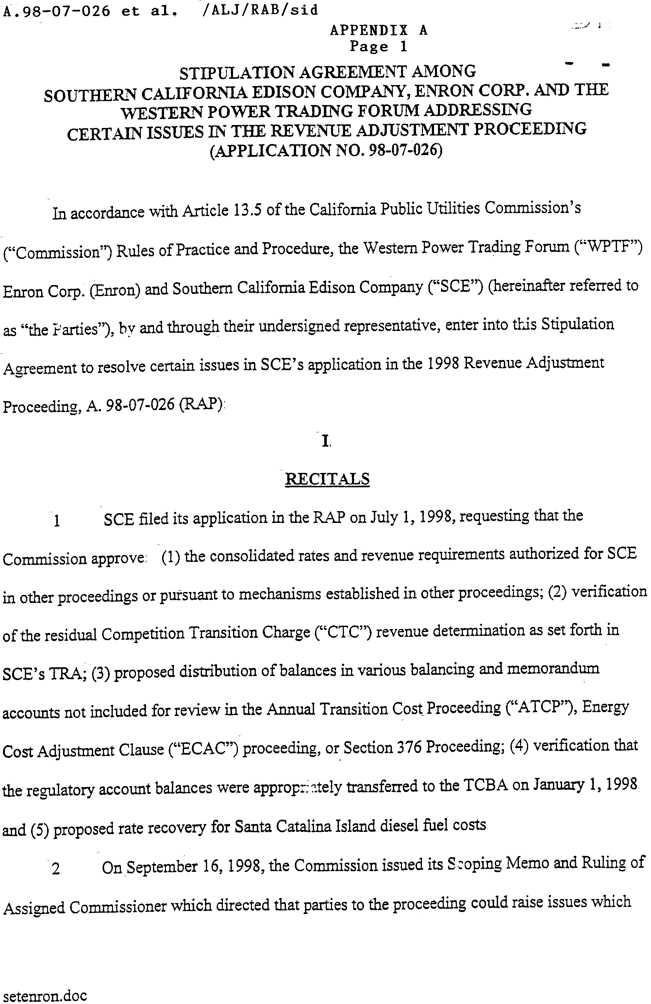
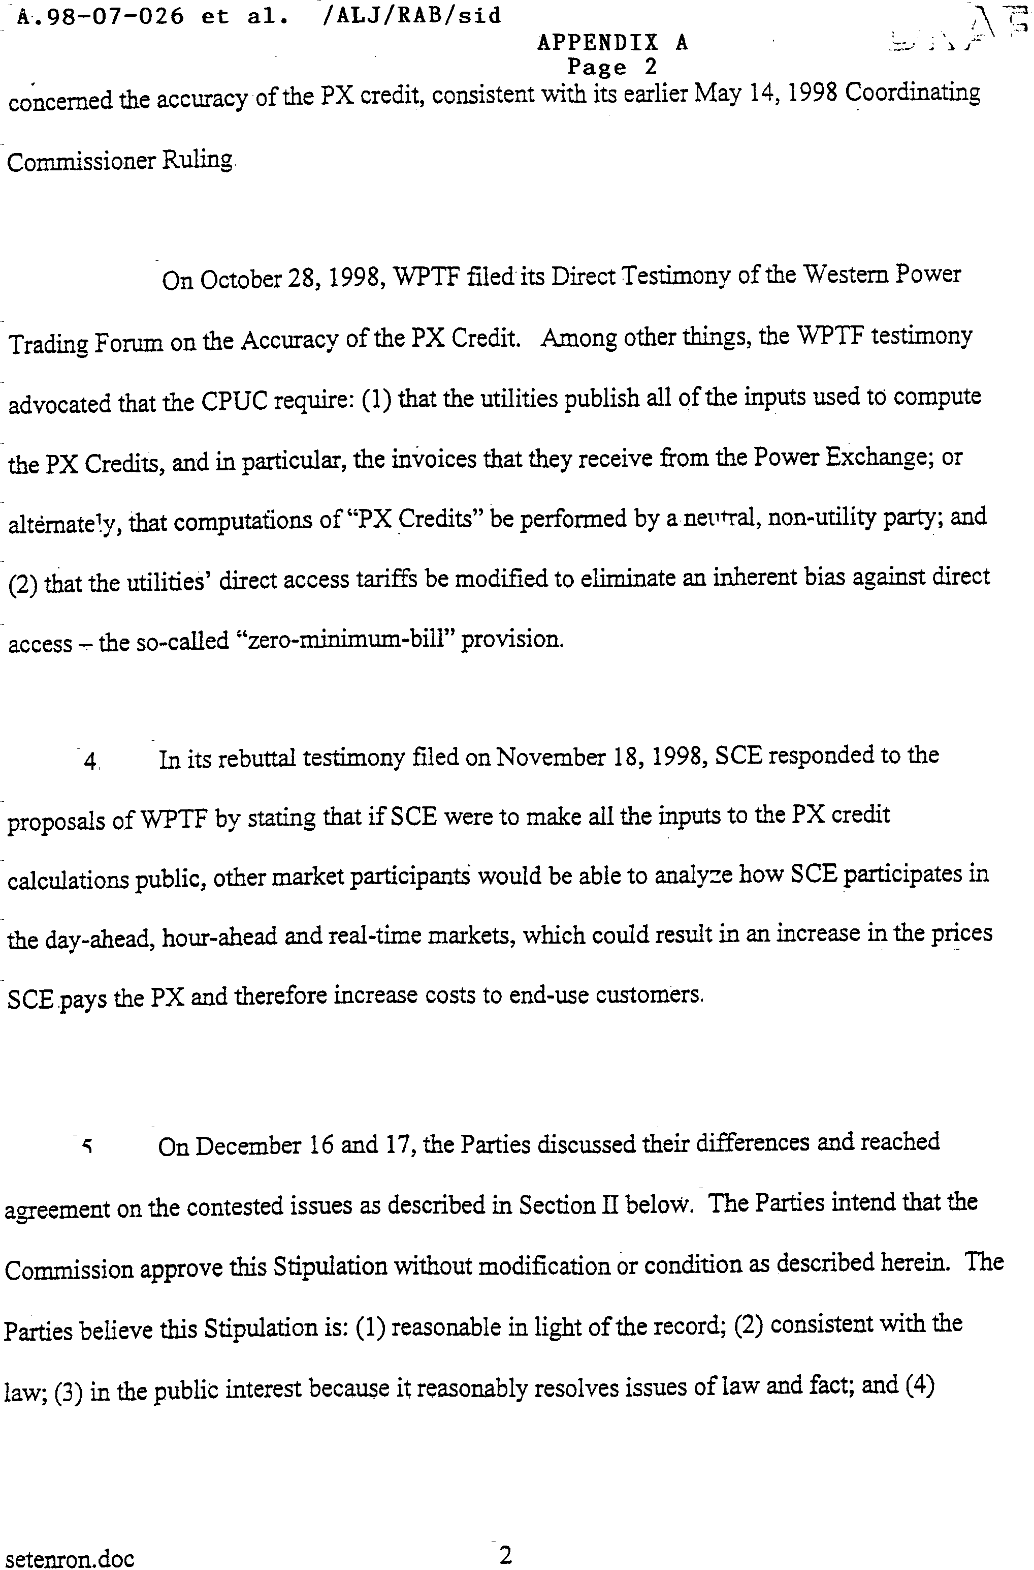
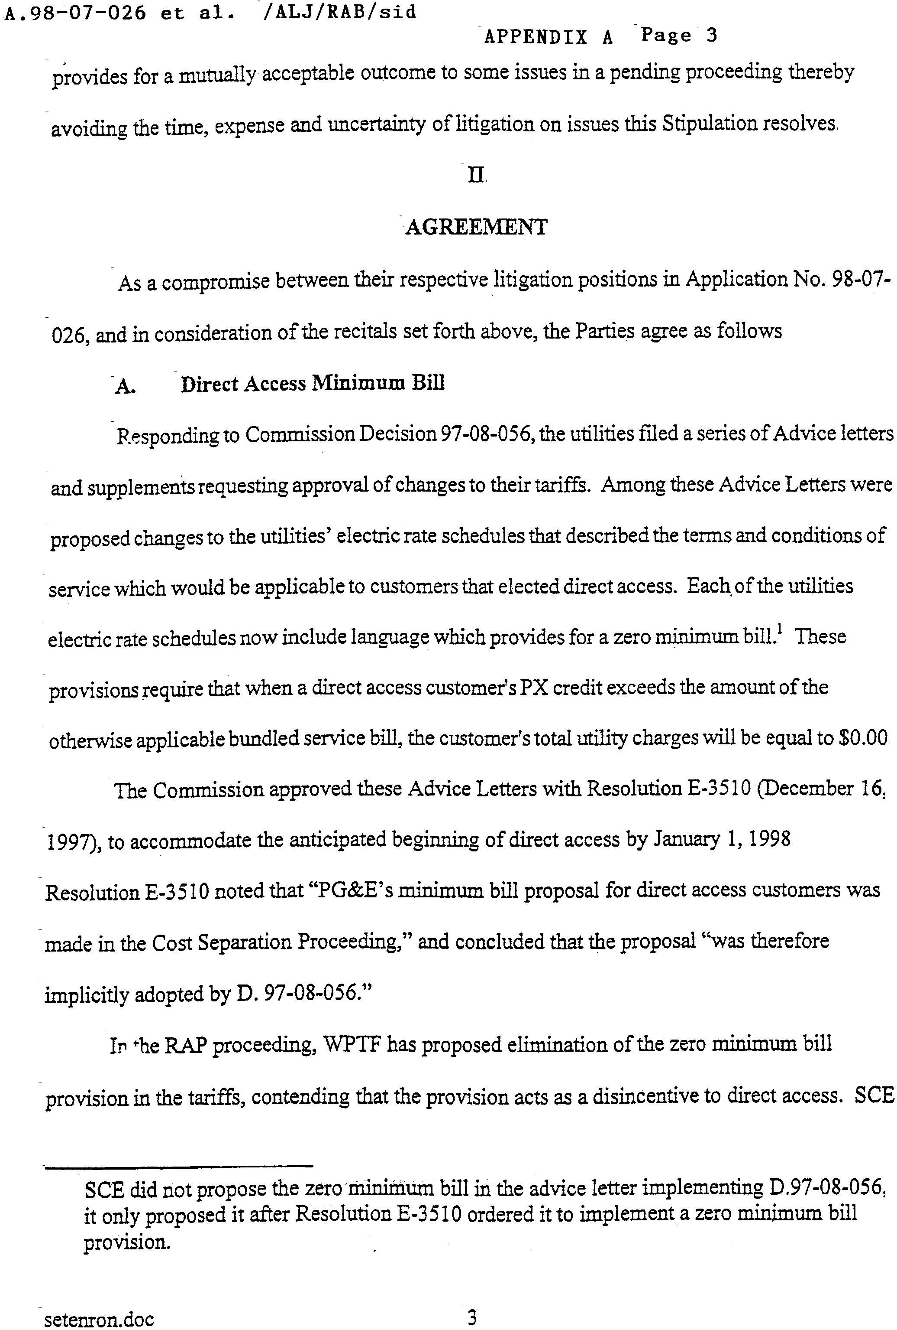
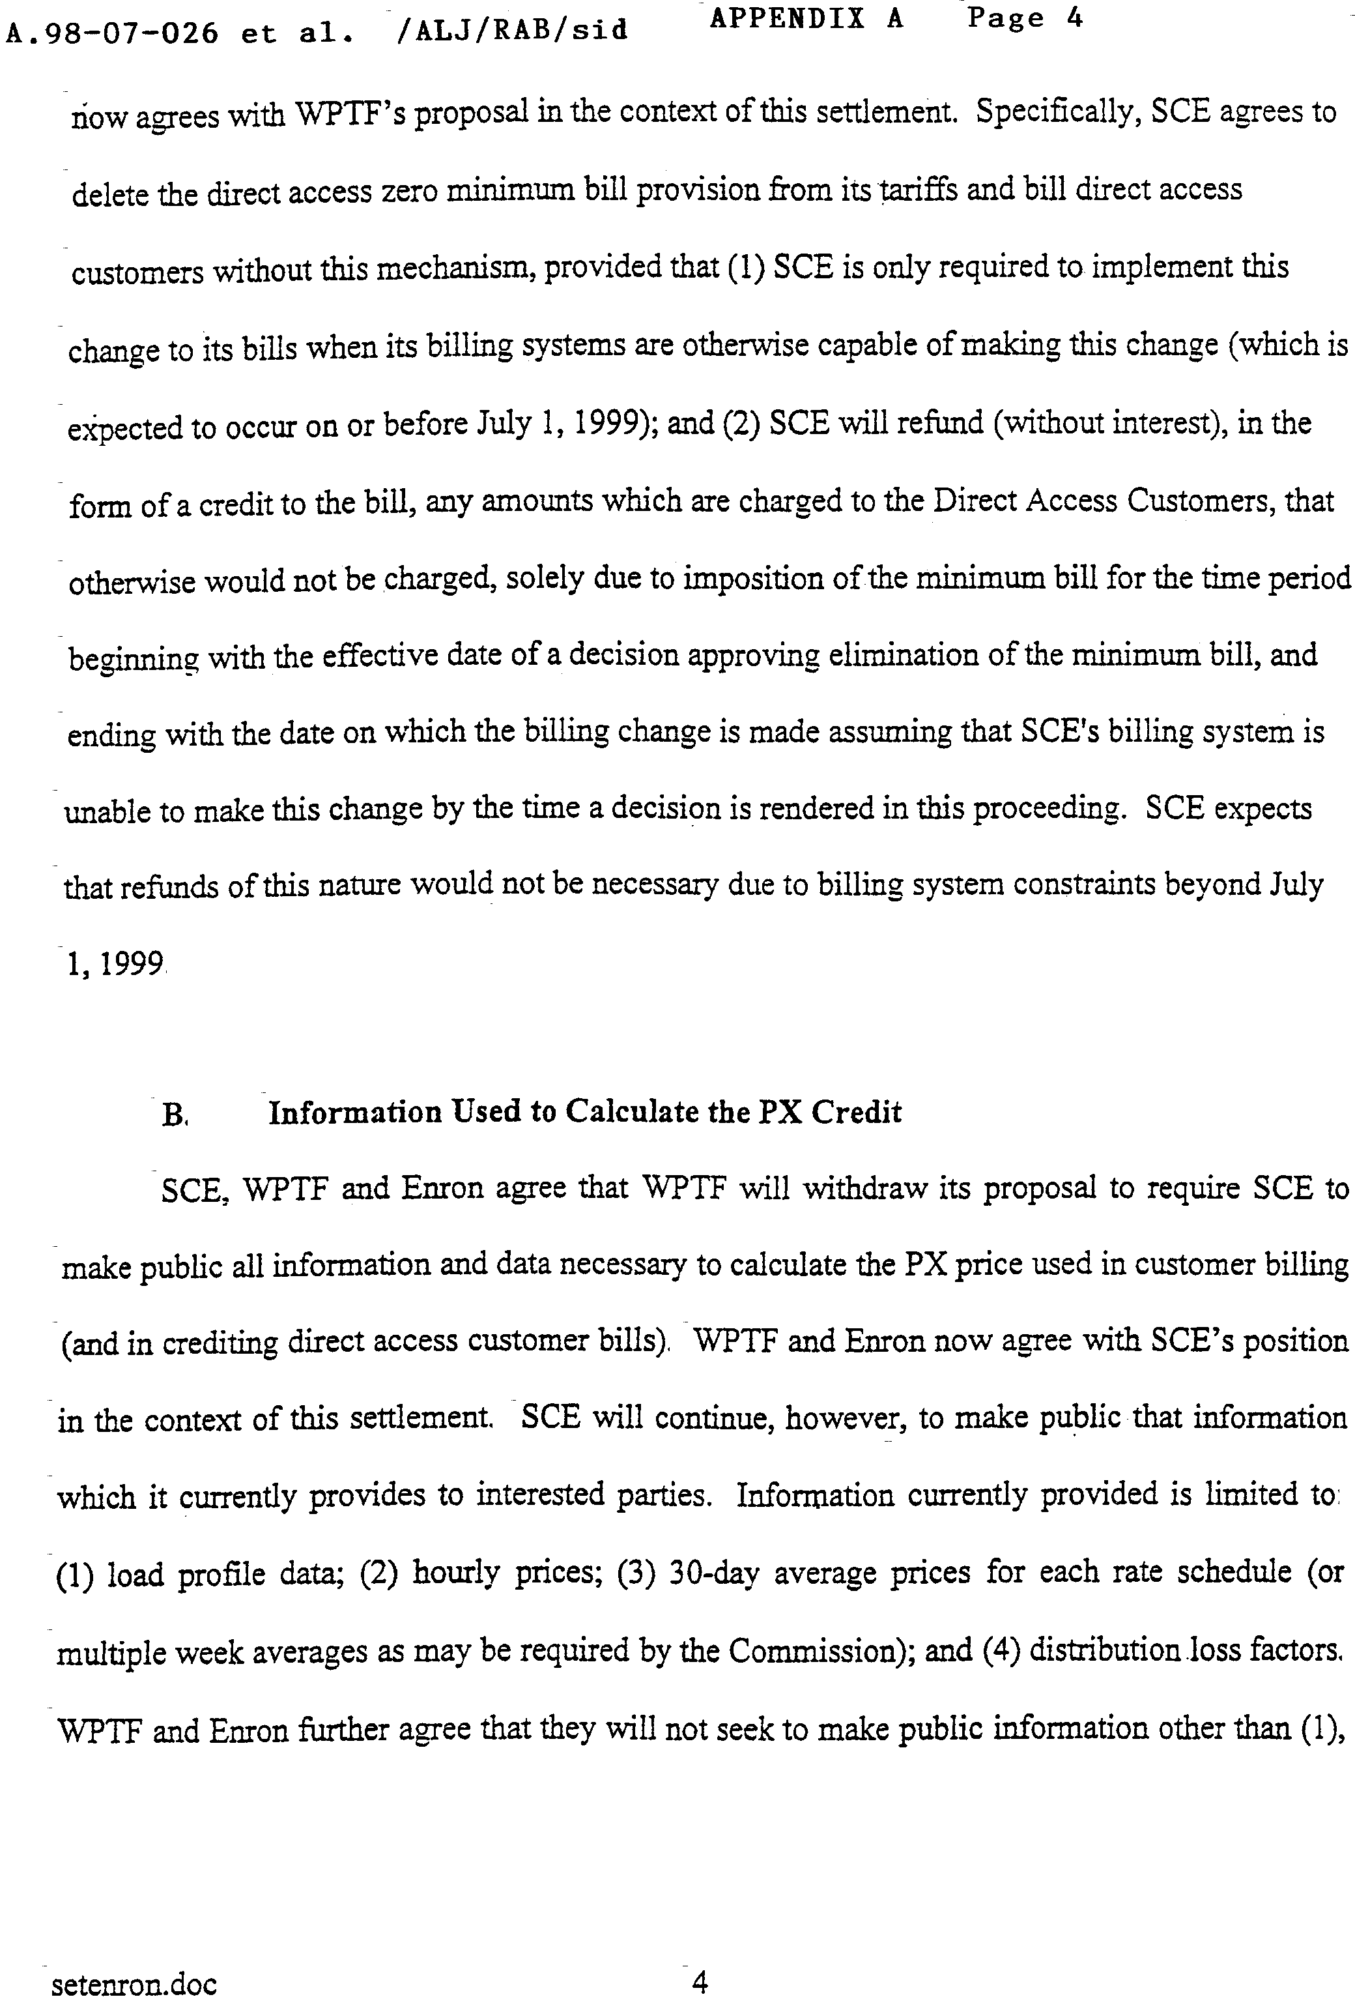
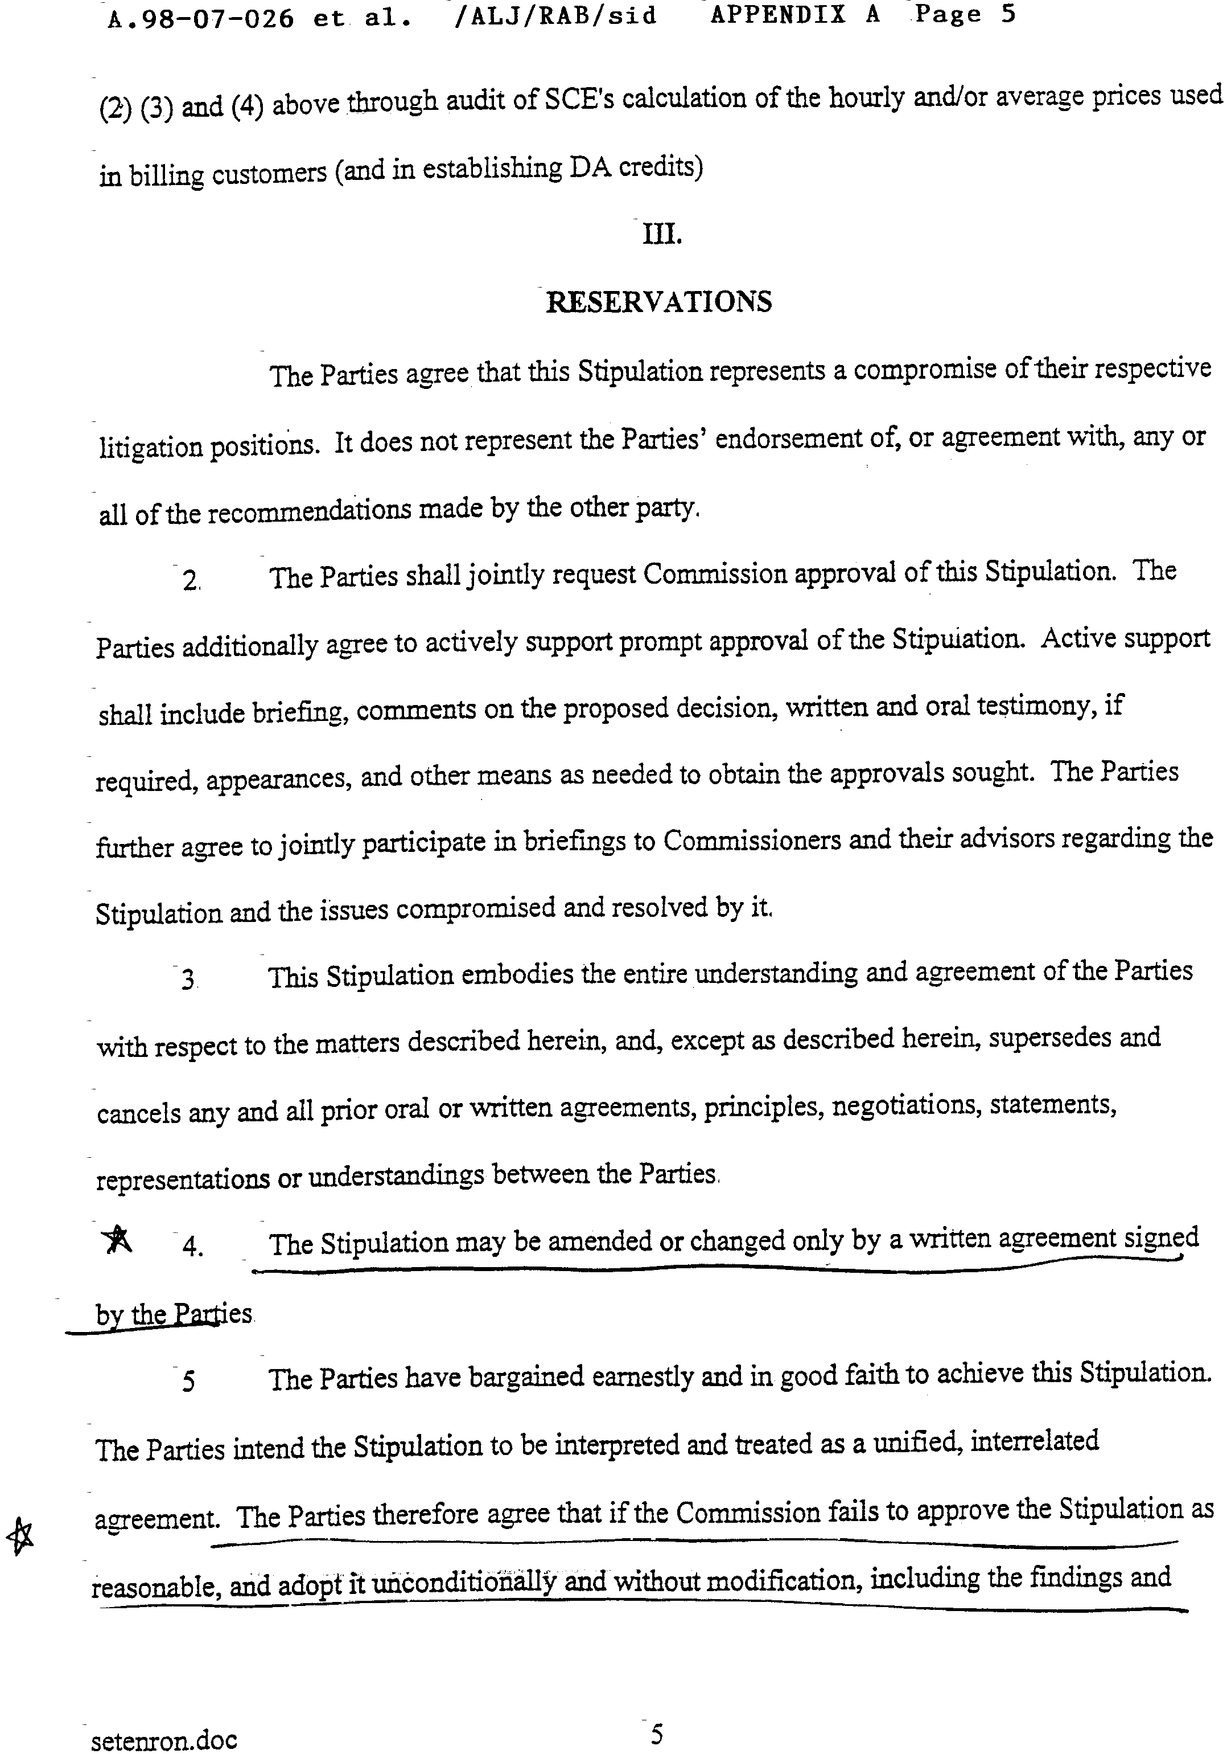
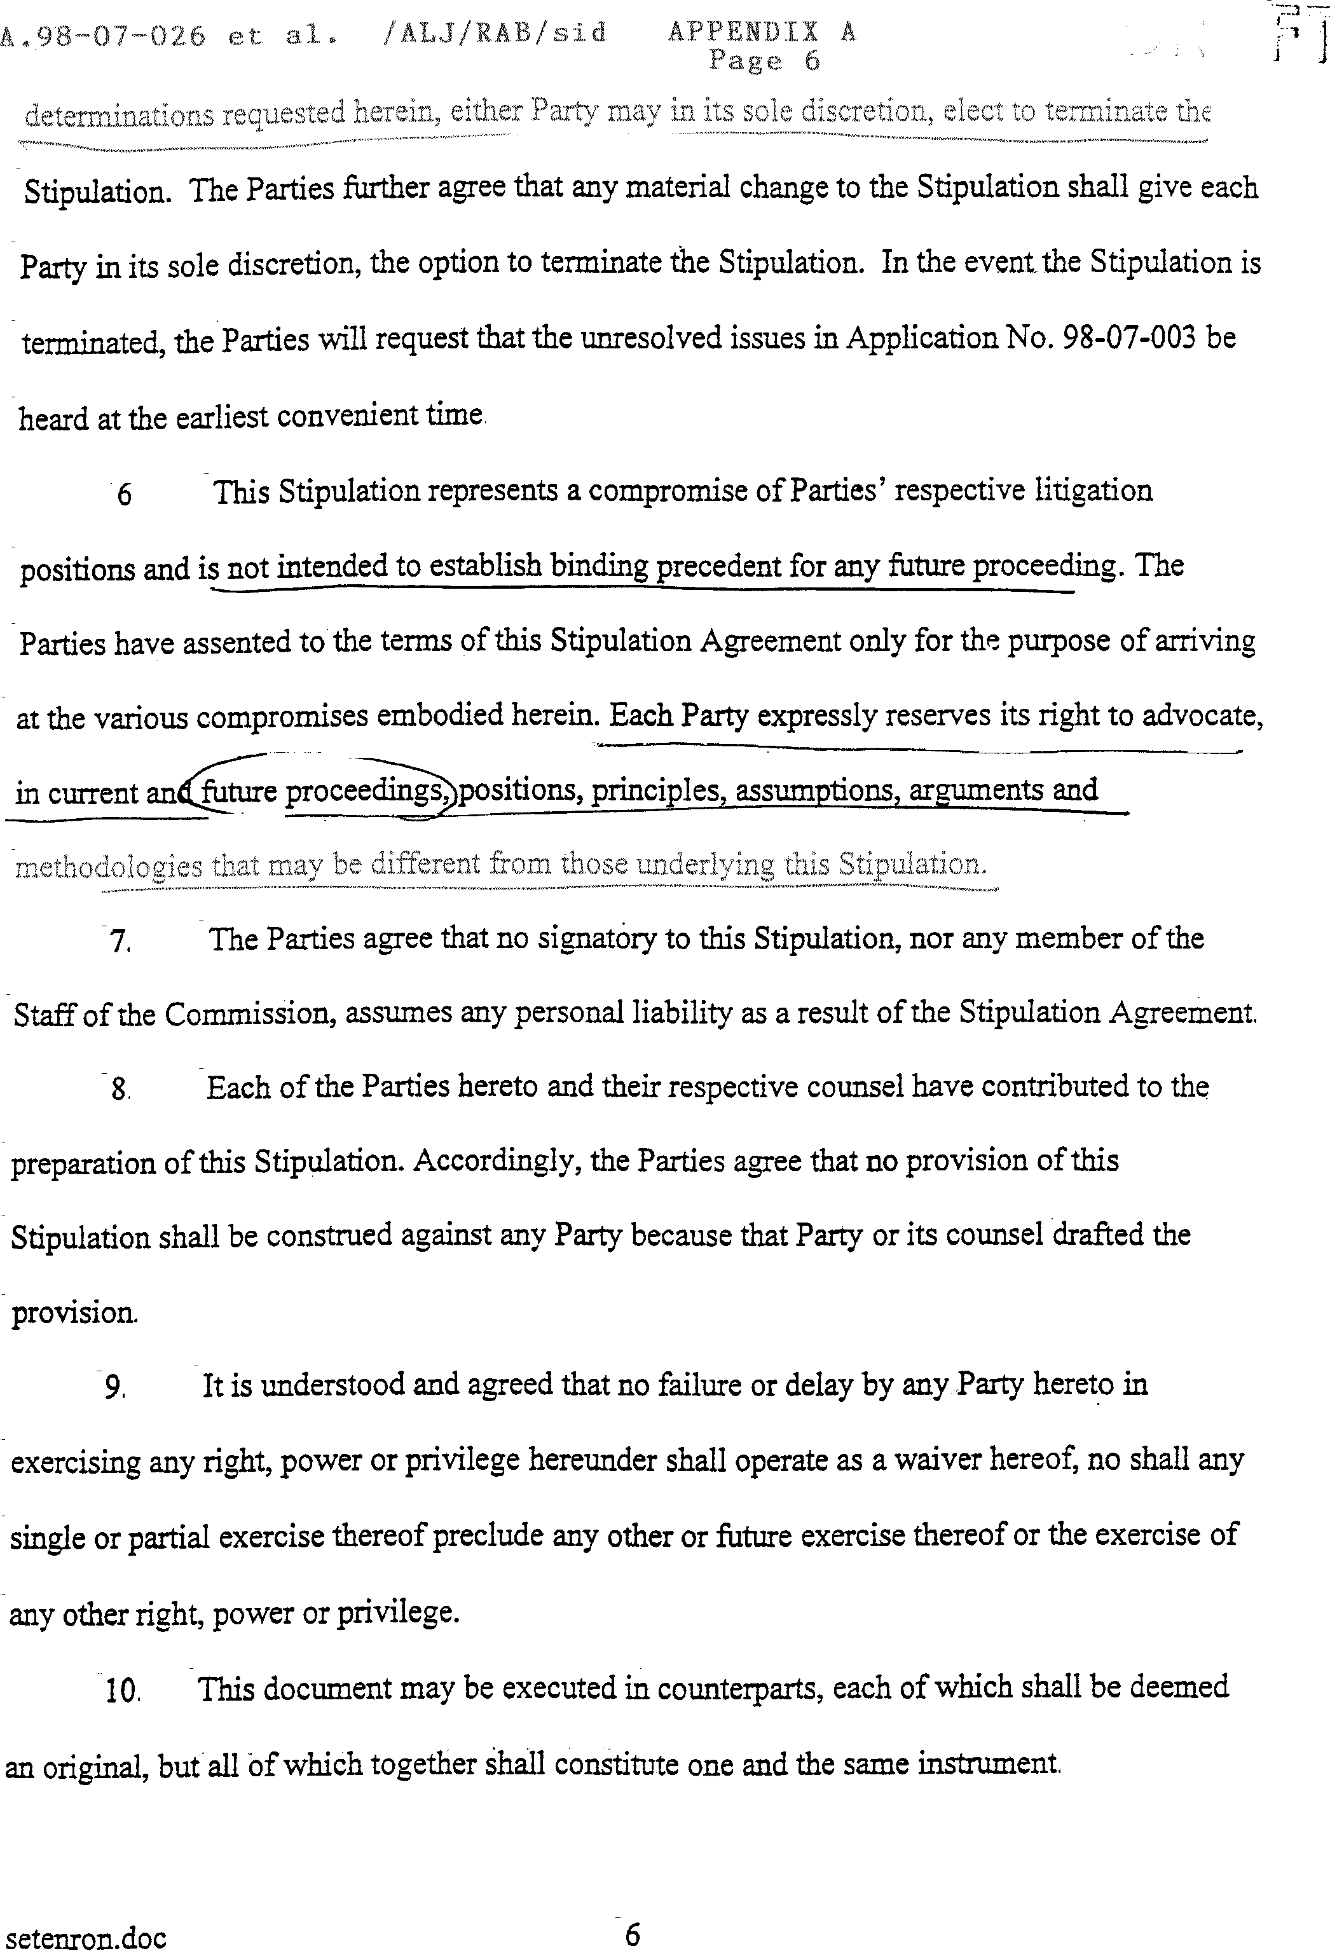
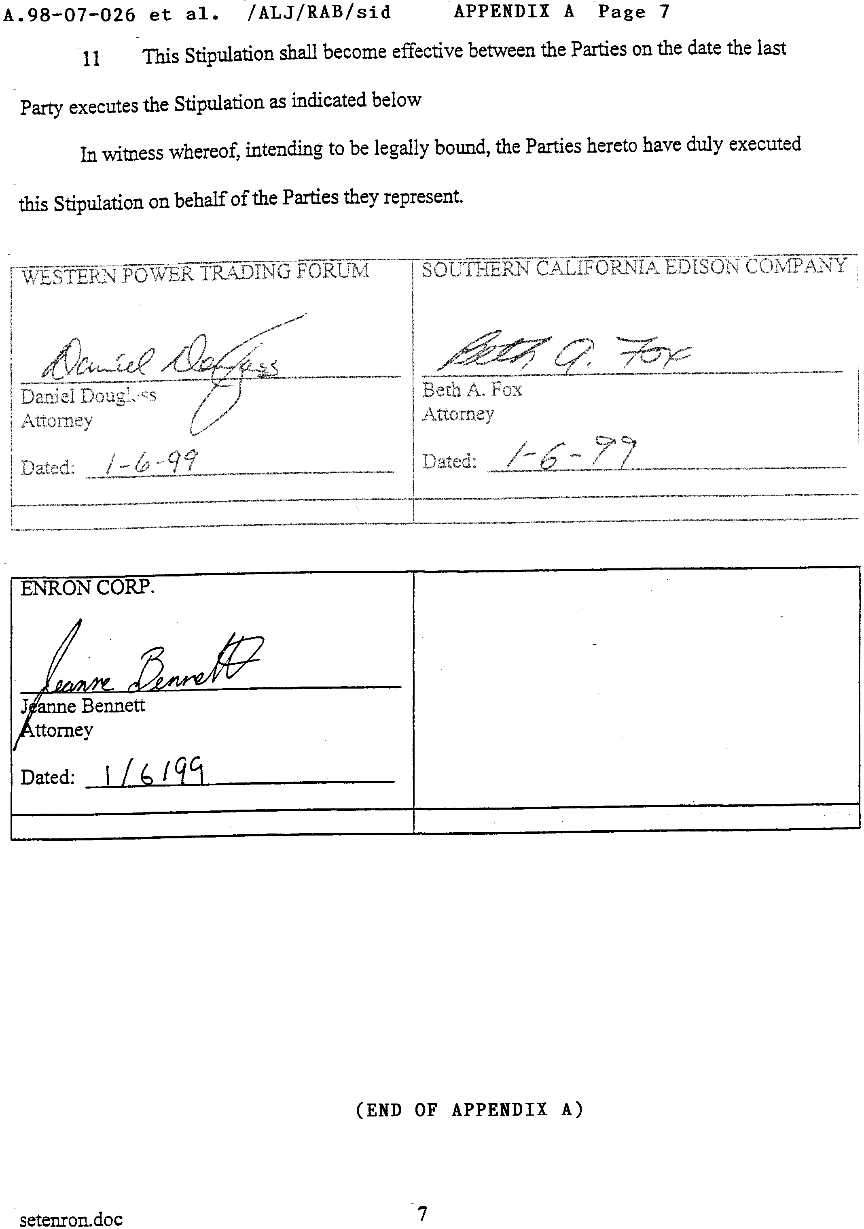
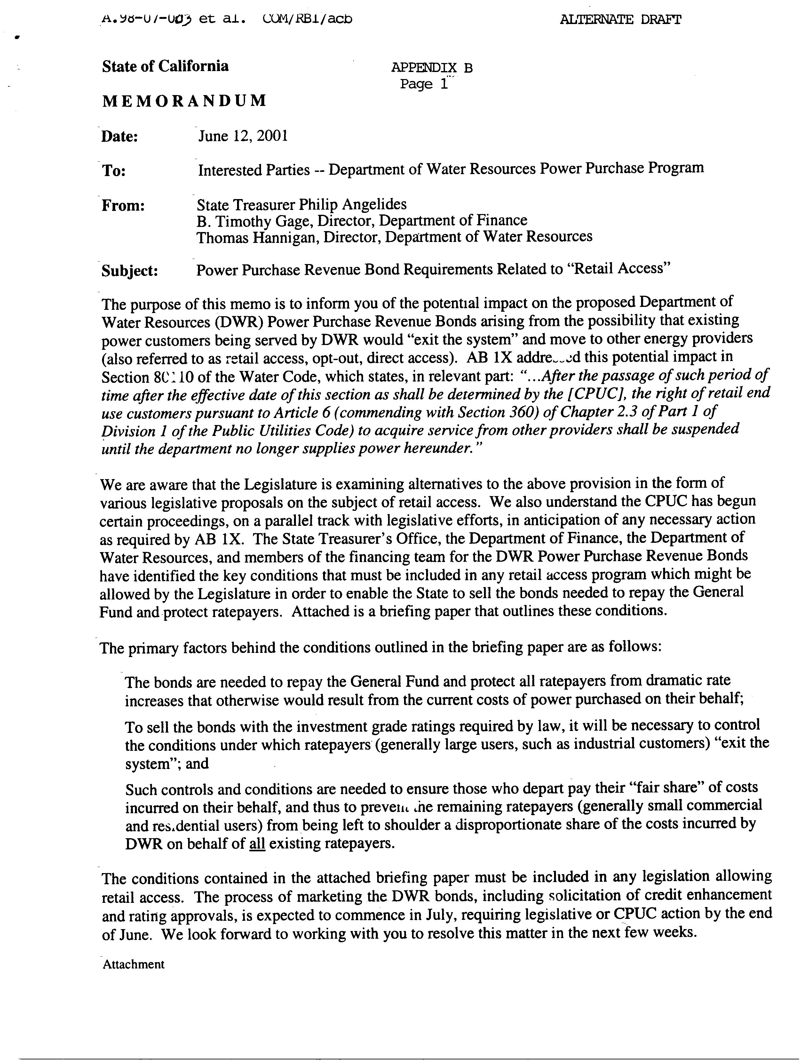
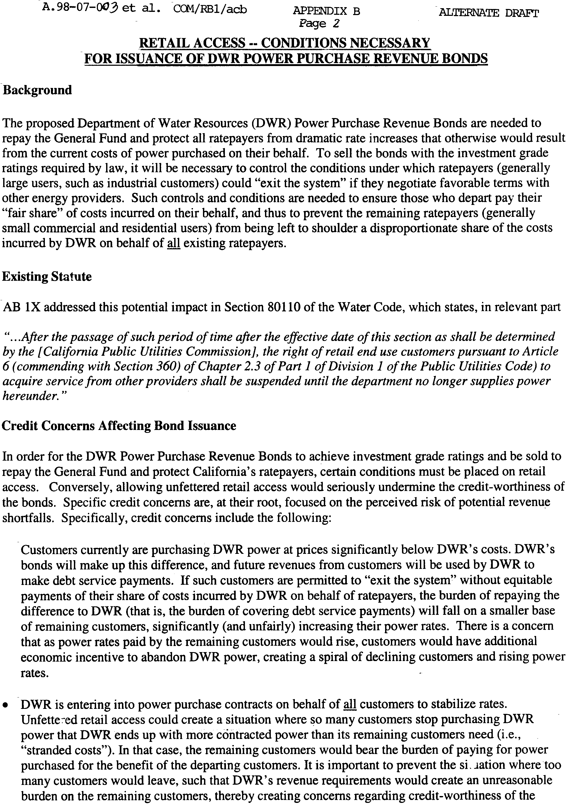
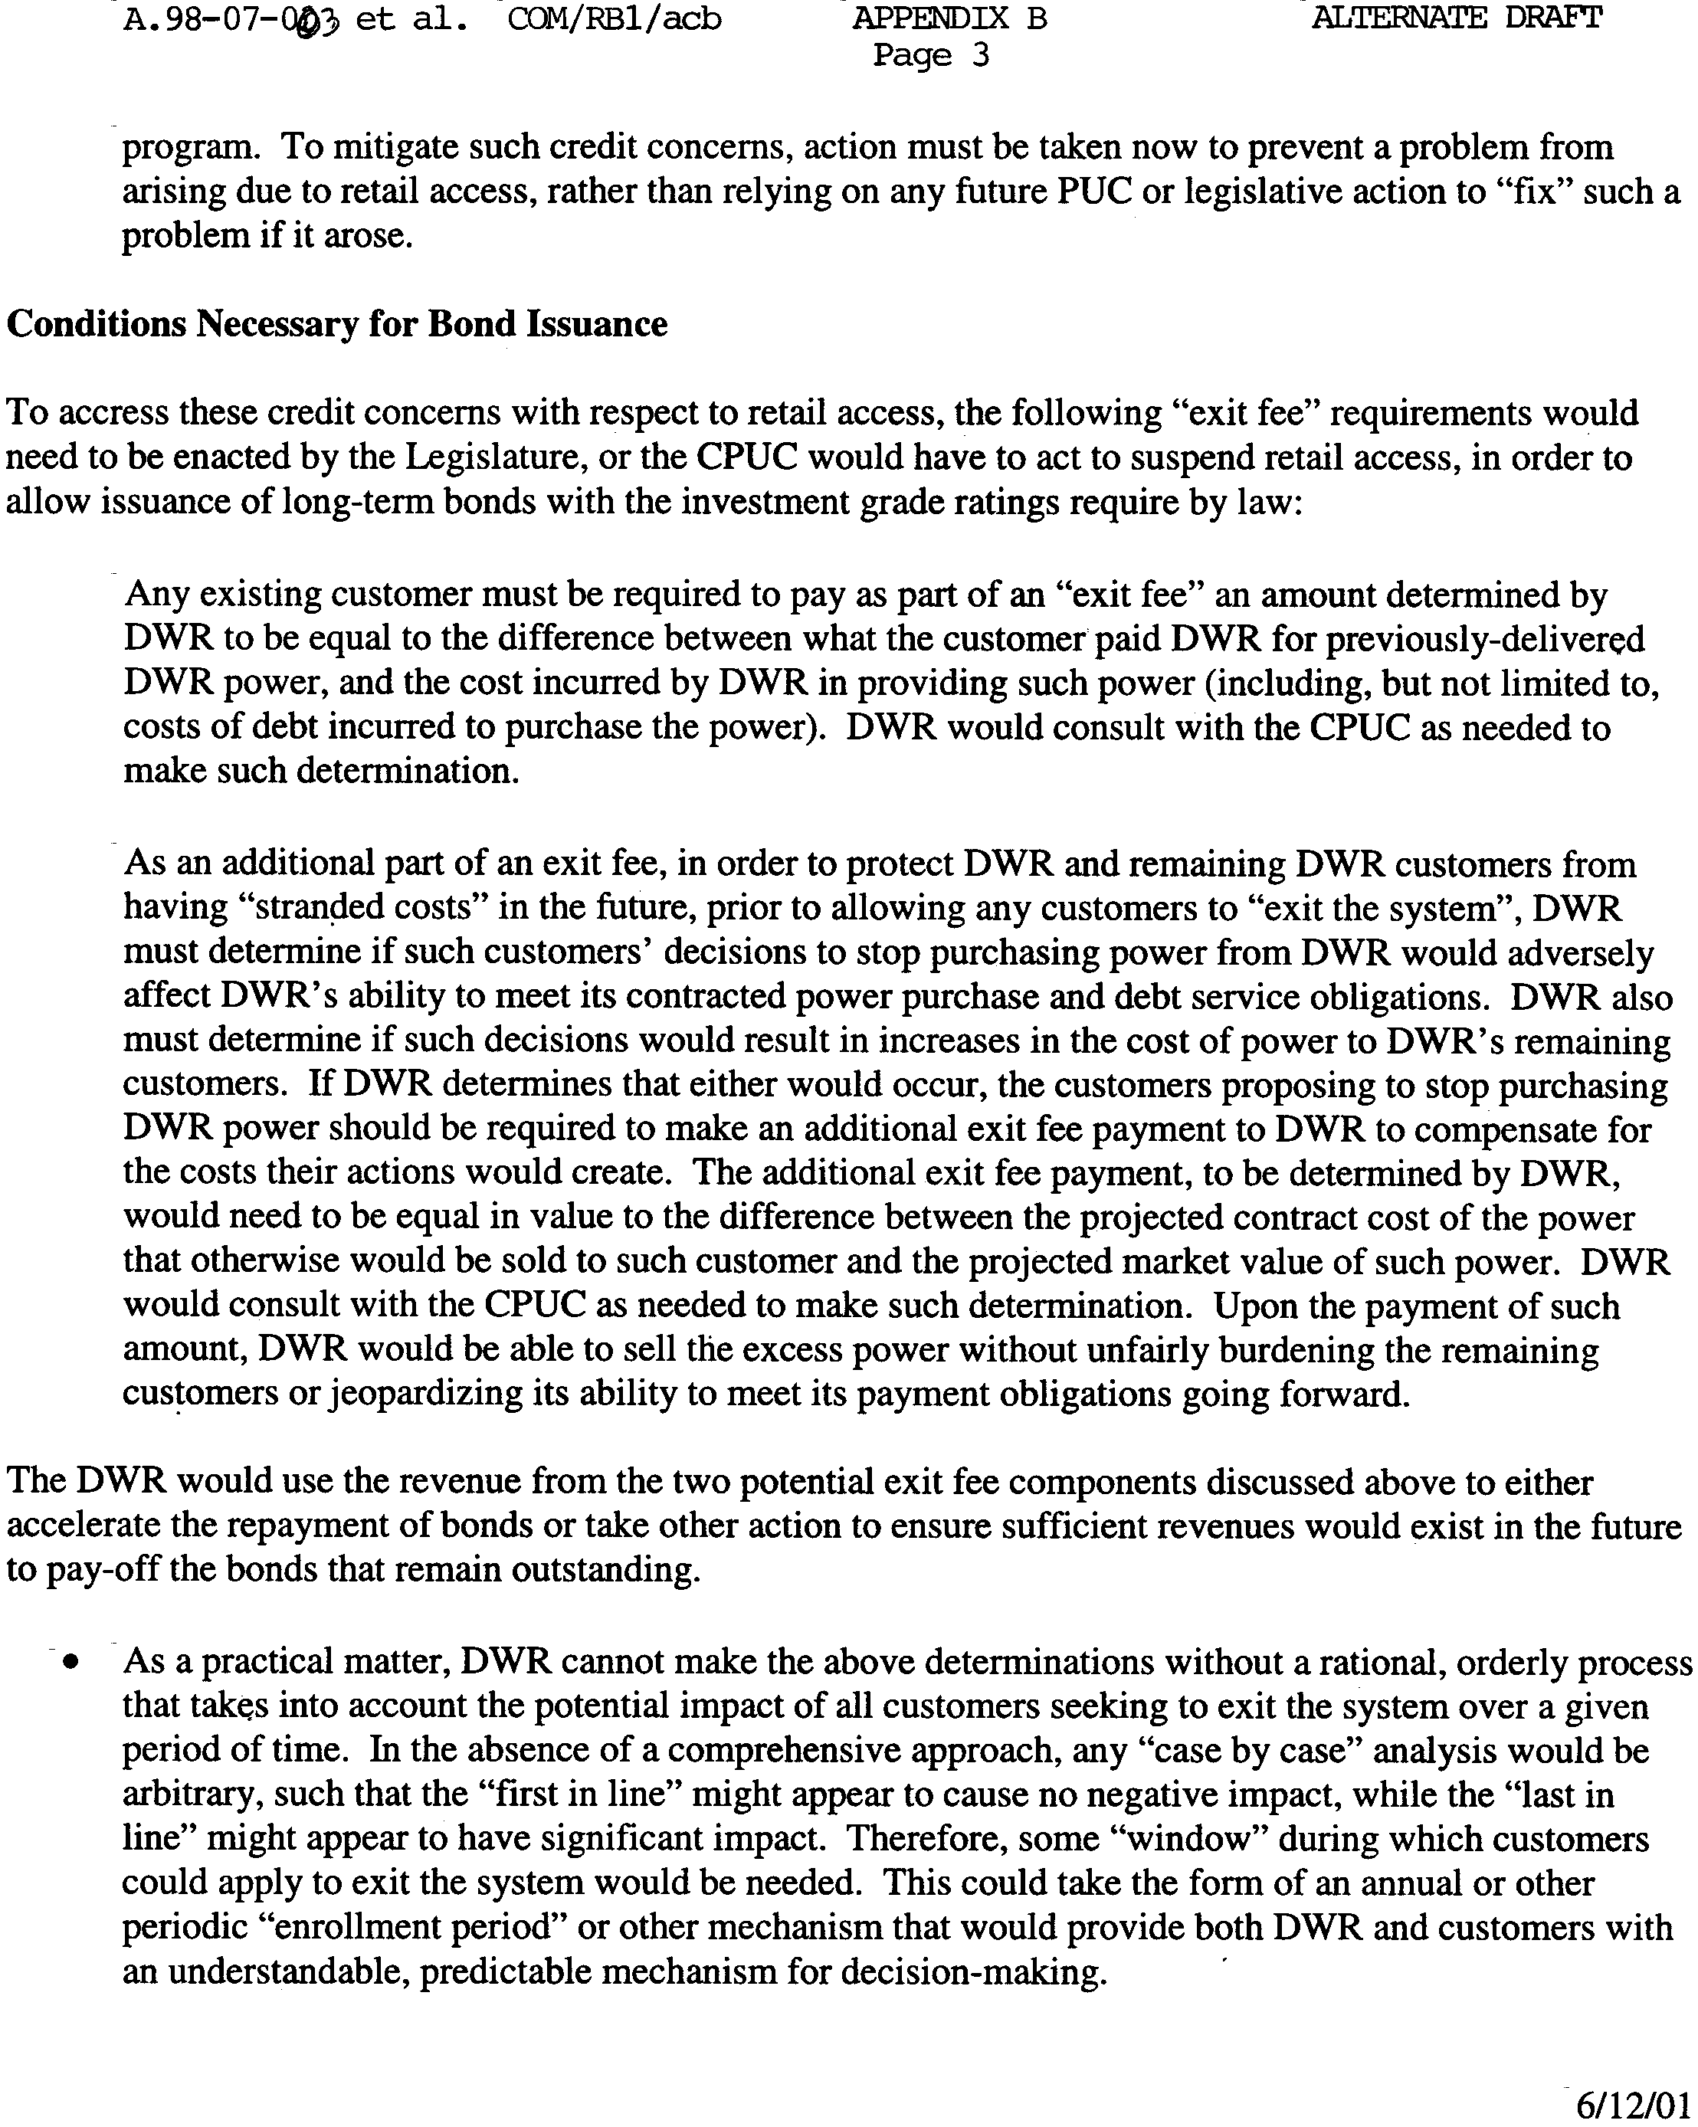

(End of Appendix B)

This frozen rate now is supplemented by the 1¢/kWh surcharge adopted in D.01-01-018, and the 3¢/kWh surcharge adopted in D.01-03-082.
PG&E and SDG&E entered into similar stipulations with WPTF and Enron.
For example, recent electricity prices have ranged from 25¢/kWh ($250 per MWh) to 50¢/kWh ($500 per MWh) compared to 8¢/kWh ($80 per MWh) in late October 2000. Since June 2000, SCE has made payments of PX energy credits in the amount of $157 million to direct access customers and ESPs.
SCE will notify ESPs and direct access customers through a bill message that refund checks will not be issued for PX energy credits.
The electric energy charge is the total frozen rate less distribution, transmission, public purpose programs, nuclear decommissioning, and trust transfer amounts.
D.99-06-058, at mimeo. 19.

