Associates
Breakfast and
FEP Task Force
Meeting
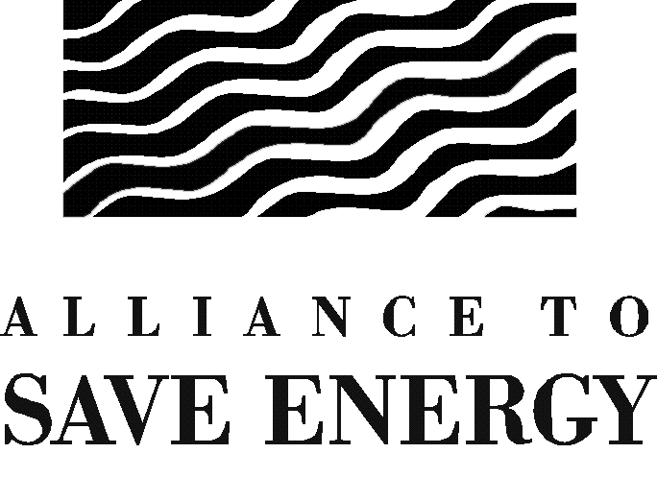

Congressional Energy Legislation:
A View from New Alliance Chair Byron Dorgan

Guest Speaker:

Senator Byron Dorgan

Thursday, February 7, 2002
8:00 – 9:30 a.m.

to be followed by the

Federal Energy Productivity (FEP) Task Force Meeting
10:00 – 12:00 noon
(All Associates are welcome to join us for this update on pending legislation and new initiatives in the Federal Energy Management Program)

2nd Floor Conference Room

Dewey-Ballantine

1775 Pennsylvania Avenue, NW
Washington, DC
(by Metro, take Farragut West, 18th Street Exit)

RSVP by January 31, 2002 to Lyra Dumdum at ldumdum@ase.org.

