Curve & Position Manager

This document describes how to use the new curve manager to mark and maintain
the power curves.

The first screen displayed when the application is launched is given below.

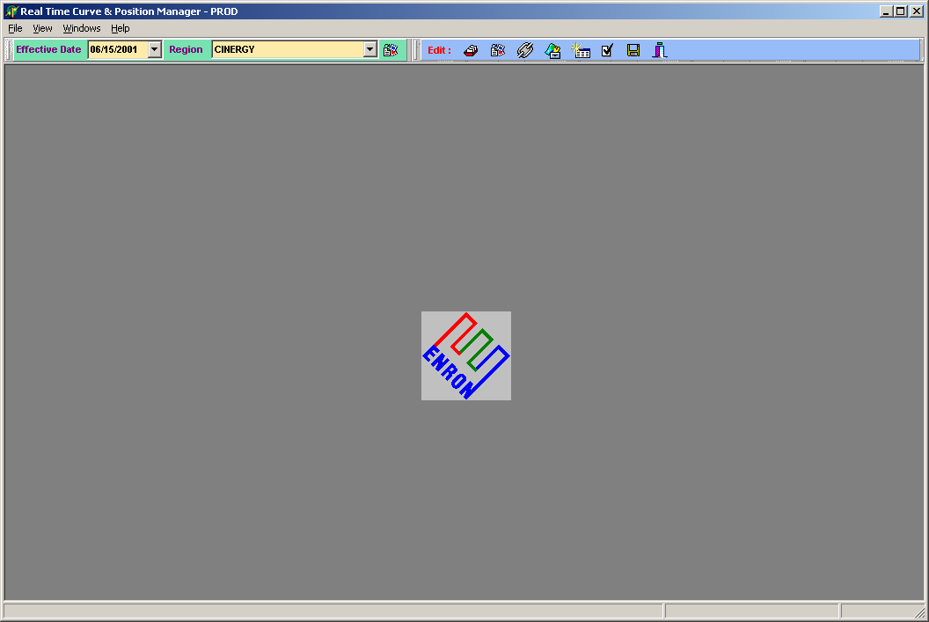

Viewing Curves

- Select the effective date.
- Select the region.
- Click the button to the right of region dropdown box which will bring up a
new screen. (Screen 2)
- The caption bar of the new screen should display the region and effective date selected in the previous steps.
- In the same way it is possible to open multiple regions, which will bring up multiple screens.
- West traders should select ‘West’ radio button, which is in the right corner of the screen.
- Click on the ‘Select Curves’ button, which will display the list of available curves for that region. (Screen 3)
- Select the curves and Click ‘OK’
- This will bring up the curves, which are selected. (Screen 4)
- The bottom of the screen will display the curren status of the request.

Screen 2

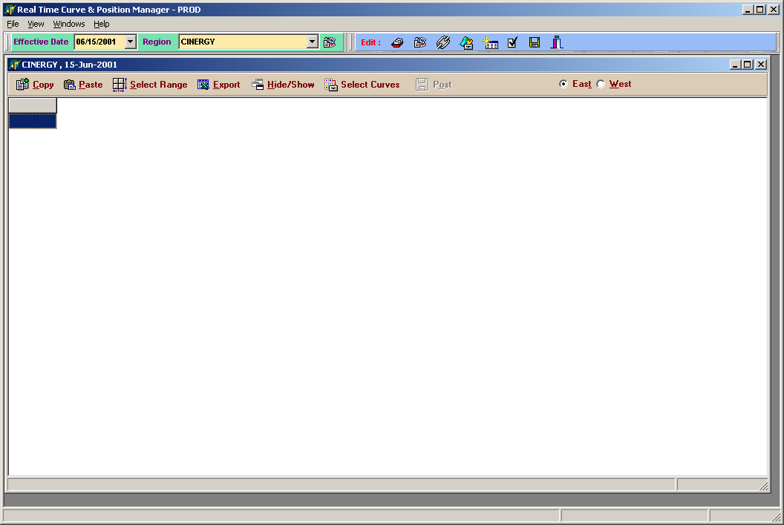

Screen 3

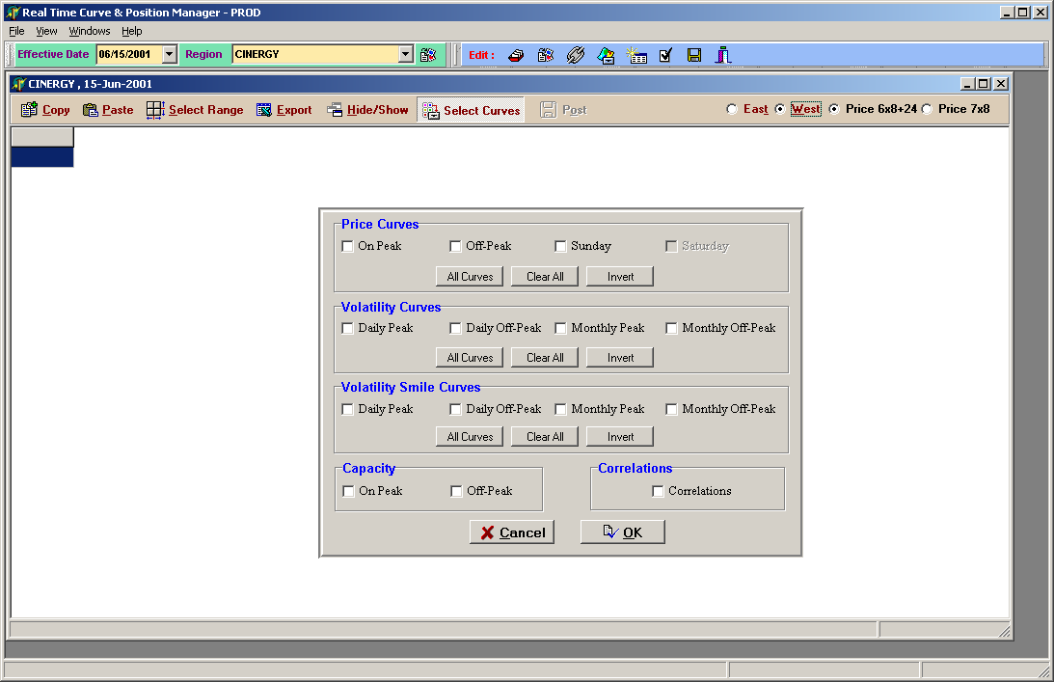

Screen 4

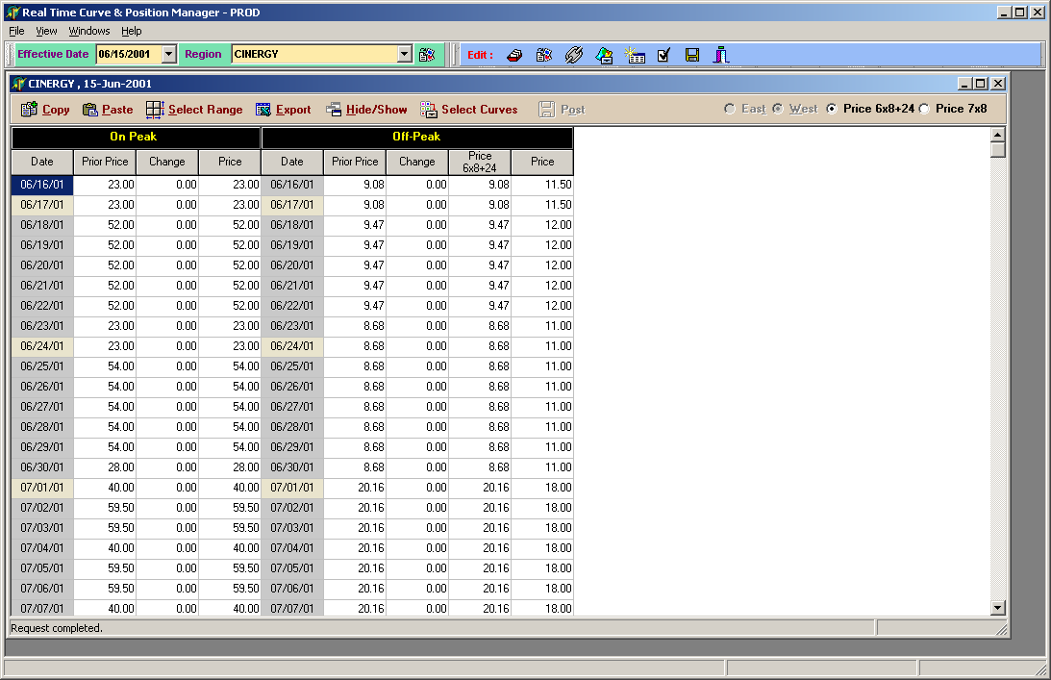

Editing Curves

- All the prior price columns are read only.
- There are two ways of editing a curve. The traders may either choose to mark the ‘change’ column, which is the offset from the prior days value, or they can mark the ‘Price’ column directly.
- For the off-peak curve the traders can choose the column, which they want to edit (6x8 or 7x8). Selecting the radio button on top of the screen, which should read ‘Price 6x8+24 and Price 7x8’, can do this. The traders are allowed to edit only one of those columns at any given moment. The other column will be made read only.
- Even though the short-term traders are marking the 6x8+24 prices in the excel sheet, Portcalc doesn’t differntiate between 6x8+24 and 7x8 price for the short-term portion of the curve. So it is very necessary for the short-term traders to mark the 7x8 column of the curve and NOT the 6x8 column.
- Only the front two months of the Sunday curve is editable. The rest of the values are calculated by the system and therefore is read only. The traders are required to mark the front months of the Sunday curve every day.
- All the edited value will be highlighted by a different color.
- The traders can save the changes they have made to the curve by clicking on the ‘Post’ button.

Editing Basis

There are a series of button on top of the main screen and one of them should display a hint ‘Curve Dependency’. Clicking on that will bring up the Curve Dependency screen.
(Screen 5)

Screen 5

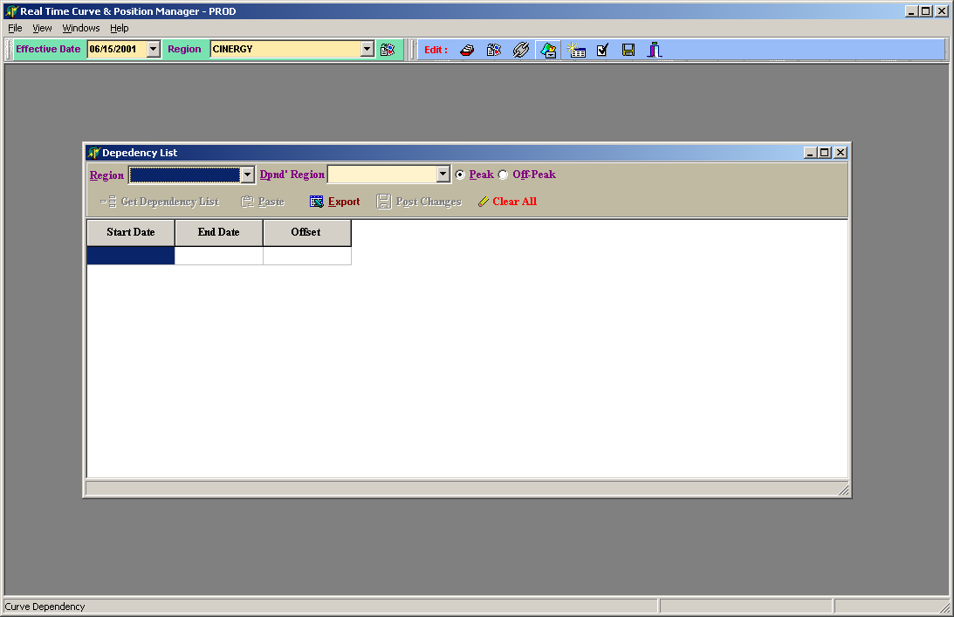

- Select the region from the ‘region’ dropdown box. Eg (WSCC-S)
- Select the basis region from the dependent region dropdown box. Eg (Mead)
- Click on the ‘Get Dependency List’ button.
- This will bring up all the offsets. (Screen 6)
- The traders might either choose to mark the offsets directly or cut and paste values from excel.
- Click on the ‘Post changes’ button to save the offsets

Screen 6

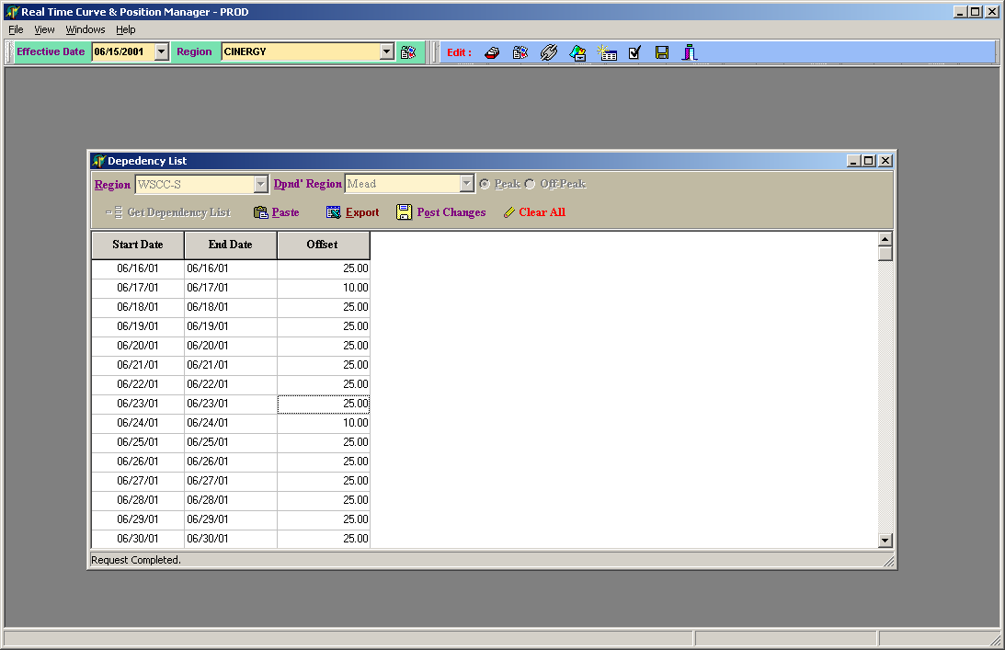

Final Posting

- At the end of the day when the traders are ready to make their curve official, the final posting has to be done before running portcalc. Only then portcalc will be able to grab the latest curves from the system.
- On top of the screen there should be a button which displays a hint ‘Regions for final Posting’.
- Clicking on it will bring up a new screen where final posting can be done. (Screen7)
- Click on the button ‘Get Region List’ will bring up the regions, which are to be posted, and which are already posted.
- Select the regions for which final post has to be done and click on ‘Do Final Post’.
- This action will make all the curves in the selected regions non-editable ie the traders will no longer will be able to mark their curves after final post.

Screen 7
