DATA SERVICE AGREEMENT

THIS DATA SERVICES AGREEMENT (this "Agreement") is made and entered into on this the ______________ day of June, 2001, by and between ENRON NET WORKS, LLC ("Enron"), a Delaware limited liability corporation, having its principal place of business at 1400 Smith Street, Houston, Texas 77002, and BLUMBERG LP ("Blumberg"), a _________________ corporation, having its principal place of business at 499 Park Avenue, New York, New York 10022.

WITTNESSETH

WHEREAS, Enron has developed a product which presents certain information and data in relation to transactions associated with the trading of certain energy products or other commodities (including derivatives products), which data is more particularly described in Schedule 1 hereto; and

WHEREAS, Blumberg, directly, and indirectly through its licensed and authorized affiliates, agents and distributors, prepares and transmits financial data to Subscribers by means of certain electronic information services; and

WHEREAS, Blumberg wishes to receive and provide the data received from Enron to its current and future Subscribers via its electronic information services and has agreed to do so in accordance with the provisions of this Agreement.

NOW, THEREFORE, for and inconsideration of the mutual promises and covenants contained herein, the receipt and sufficiency of which are hereby acknowledged by Enron and Blumberg, the parties hereby agree as follows:

- DEFINITIONS AND INTERPRETATION

  - The following definitions apply throughout this Agreement unless the context otherwise requires:
Authorized Distributors means the entities listed on Schedule 4 which are related entities to Blumberg, either by affiliation or otherwise, and who have been specifically licensed or authorized by the Blumberg Group to distribute the Data Information Service in one or more countries world-wide;
Blumberg Group means collectively Blumberg and its direct and indirect subsidiaries from time to time, including Blumberg, and its Authorized Distributors;
Blumberg Service means the services provided from time to time by Blumberg to Subscribers including the Data Information Service;
Business Day means a day when the New York Stock Exchange is open for business;
Commencement Date means the later of (i) date this Agreement is signed by both parties and (ii) __________________, 2001;
Content means data or information in any form, whether text, visual (still or moving) audio or any combination of the foregoing;
Damages means all and any losses, damages, costs, expense, fees (including reasonable attorney’s fees) and liabilities incurred by a party to this Agreement as a result of a breach, default or other violation of the terms of this Agreement by the other party;
Data Information Service means the service to consist of or consisting in the supply of the Enron Data to Subscribers by Blumberg;
Enron Data means the Content provided by Enron and agreed between the parties as described in Schedule 1, as updated or enhanced in accordance with this Agreement;
Fees means the sums, if any, to be paid by Blumberg to Enron in accordance with Section 9;

Intellectual Property Rights means patents, Trade Marks, copyrights, mask work rights, topography rights, database rights and design rights (whether or not any of them are registered and including applications for registration of any of them), moral rights, trade secrets, know how and rights of confidence; all rights of forms of protection of a similar nature or having similar or equivalent effect to any of them which may exist anywhere in the world now or in the future;
Launch Date means the date that Enron and Blumberg jointly agree to publicly launch the promotion, marketing and delivery of the Data Information Service, which date shall be no later than sixty (60) days following the Commencement Date;
Network means the equipment and telecommunications facilities owned or used by the Blumberg Group from time to time, including any virtual private networks and the public internet;
Qualifying Revenue means the aggregate value of all Subscription Fees collected by Blumberg in respect of the supply of the Data Information Service excluding sales taxes and/or other taxes, and/or tariff duties directly levied;
Specification means the document setting out details in respect of the Enron Data including technical, security, delivery, support and format requirements for the Enron Data as set out in Schedule 3;
Subscriber means a subscriber to any Blumberg Service from time to time;
Subscription Agreement means any subscription agreement pursuant to which the Blumberg Group provides Subscribers with access to the Blumberg Service as may be amended from time to time by Blumberg, which may include both physical agreements and/or electronic, on-line Subscription Agreements which shall be deemed signed if its terms are accepted on-line by the Subscriber;
Subscription Fee means the fee paid by a Subscriber for the Blumberg Service pursuant to the applicable Subscription Agreement;
Trade Marks means the registered and/or unregistered trade and/or service marks or names set out in Schedule 2, or any of them.
- TERM
  - Subject to Section 13, this Agreement shall take effect from the Commencement Date and shall expire on the one (1) year anniversary of that date. Thereafter, this Agreement shall continue for further successive one (1) year periods unless and until terminated by either party, giving to the other not less than ninety (90) days notice to expire on the anniversary of the Commencement Date (the Term).
- SUPPLY
  - Enron will use commercially reasonable efforts to make available the Enron Data as set out in this Agreement within forty-five (45) days from the Commencement Date and Blumberg, using its commercially reasonable efforts, shall be prepared to receive and distribute the Enron Data within ninety (90) days from the Commencement Date.
  - Enron shall, at its own cost and expense, produce, format to the Specification applicable to the delivery of the Enron Data by Enron and supply the Enron Data to Blumberg in accordance with the Specification. Blumberg shall, at its own cost and expense and in accordance with the Specification, set up all hardware, software and other equipment necessary to receive, store, format, and distribute the Enron Data, including, but not limited to, all hardware, software and other equipment necessary to distribute the Enron Data to the Authorized Distributors and to ensure the Enron Data is promoted to Subscribers through the Data Information Service.
  - In relation to the provisions of Section 3.2 above, it is agreed that (i) Blumberg shall be responsible for the cost associated with the actual delivery of the Enron Data by Enron to Blumberg via Houston to New York communications lines and (ii) the costs associated with the development of joint marketing materials associated solely and directly with the Data Information Service, shall be divided on a 75%/25% cost basis, with Enron being responsible for the greater percentage of these costs. All other costs shall be paid for by the parties in accordance with the provisions of Section 3.2 above.
  - If Enron makes the Enron Data available to any third party providing services similar to the Blumberg Service, Enron will endeavour to ensure that the Enron Data is at least as good as the Content supplied to such third party.
  - During the Term, the Enron Data shall meet the requirements set out in the Specification.
  - If the delivery of the Enron Data exceeds the technical parameters laid out in the Specification by more than 10%, Blumberg reserves the right to impose a throttle limitation on the flow of the Enron Data to Subscribers.
- USE OF ENRON DATA
  - Enron grants to Blumberg, for and on behalf of the Blumberg Group, a non-exclusive, non-transferable, non-sublicensable world-wide right to use the Enron Data in accordance with the provisions of this Agreement. A current list of Blumberg subsidiaries and Authorized Distributors is attached hereto as Schedule 4 and Blumberg will provide an update Schedule 4 as appropriate during the Term upon the request of Enron.
  - For the purposes of this Agreement, “use” means: (a) to make the Enron Data available to Subscribers through the Blumberg Service; and (b) for internal purposes including development, help desk support, marketing, sales and demonstration purposes.
  - Blumberg may not alter, modify and translate the Enron Data except that Blumberg may modify the layout of the Enron Data to fit within the layout of Blumberg Services from time to time. Blumberg shall not offer the Enron Data as a stand-alone product but always in addition to a Blumberg Service.
  - During the Term of this Agreement, Blumberg will provide Enron with three (3) accesses to the Blumberg Services where the Enron Data can be found, at no cost to Enron, in order to permit Enron to verify Blumberg compliance with this Agreement. .
- CONTENT AND EDITORIAL CONTROL
  - Enron is responsible for the Content of, and editorial control over, the Enron Data. Enron may alter the same but agrees that it shall not change the fundamental nature of the Enron Data and shall not include any Content which may, in the reasonable opinion of Blumberg, adversely affect the reputation of Blumberg or the Blumberg Service.
  - Enron undertakes that it will not include in the Enron Data any:
    - defamatory or obscene Content;
    - Content, the dissemination of which is contrary to the law of any stock or commodity exchange in any country in which Enron or a member of its group is deemed for the purpose of applicable tax legislation to be carrying on a business, or any banking regulations or any other applicable market regulations or conventions;
    - Content which is in breach of any Intellectual Property Rights of any third party;
    - Content which is in breach of the data protection laws of any country in which Enron is deemed for the purpose of applicable tax legislation to be carrying on a business; or
    - advertising (other than the promotion of Enron).
  - Enron shall observe any restrictions for which Blumberg notifies Enron regarding the use of the Data Information Service including any restrictions imposed on Blumberg by any court of competent authority.
- MARKETING
  - Blumberg shall promote the Enron Data through the Blumberg Service in such manner as is it deems commercially reasonable.
  - Blumberg shall provide to the Subscribers, where generally available, such user manuals and guides, as Blumberg may reasonably deem necessary or appropriate in relation to the Data Information Service or any part thereof.
  - At Blumberg's request, and at the times and places agreed by the parties, Enron shall provide reasonable training free of charge to sales personnel nominated by Blumberg on matters concerning the Enron Data.
  - Subject to Section 6.5, each party grants the other in return for use of the other’s name and Trade Marks in accordance with this Section 6.4, a non-exclusive, non-transferable, non-sublicensable license to use its name and/or the Trade Marks to identify Enron as the source of the Enron Data or Blumberg as the distributor of the Enron Data or in any announcement, advertisement, publication or similar promotional material relating directly or indirectly to Enron Data. Each party shall comply with the guidelines for use of the other party’s name or Trade Marks as may be notified to such other party from time to time.
  - Any use of the other party’s name and/or Trade Marks as set out in Section 6.4 above, shall be approved in writing in advance by the other party. Marketing material which is substantially similar to material previously approved does not have to be resubmitted for approval. It is acknowledged that Enron has a significant interest in ensuring that the Enron name, Trade Marks and the Enron Data maintain their integrity while being distributed by Blumberg through the Blumberg Service in accordance with this Agreement and, therefore, Enron may withhold its consent to any advertising or other material and not be in violation of the terms of this Agreement.
- DISTRIBUTION OF THE ENRON DATA
  - Blumberg may deliver the Enron Data to a Subscriber for a thirty (30) day, free of fees, trial without the Subscriber needing to sign or accept a Subscription Agreement.
  - Subject to Section 7.1, Blumberg will distribute the Enron Data only after a Subscriber has signed or accepted a Subscription Agreement. Enron acknowledges that: (a) Subscribers who have entered into Subscriptions Agreements with Blumberg may have the right, in certain circumstances, to cancel the Data Information Service, in which event the Subscription Fee payable by the relevant Subscriber will cease to be payable, without penalty, upon the effective date of such cancellation; and (b) certain other Subscription Agreements may include the right for Subscribers to cancel a fixed percentage of the Blumberg Services they receive which may include the Data Information Service and which may require an adjustment to the Subscription Fee payable under such Subscription Agreements. To the extent that any Subscriber cancels its subscription for the Data Information Service or all of the Blumberg Services (including the Data Information Services) under this paragraph 7.2(b) less than ninety (90) days from the applicable commencement date of the Subscriber’s Subscription Agreement, Blumberg shall reimburse Enron the first month’s subscription fee of such Subscriber as retained by Blumberg pursuant to paragraph 9.2.
  - Blumberg may terminate any Subscriber’s use of or access to the Blumberg Service including the Data Information Service for any reason in Blumberg sole discretion.
  - If Enron gives Blumberg notice in writing of any matter which might entitle Blumberg to terminate any Subscriber’s access to the Data Information Service, Blumberg will promptly terminate the Subscribers access to the Data Information Service subject to the provisions of the Subscription Agreement and provided Blumberg considers that reasonable grounds for such termination to exist.
  - Blumberg may permit Subscribers to redisseminate elements of the Enron Data, but only in accordance with the provisions of the Subscription Agreement.
- SUPPORT
  - The parties agree that:
    - Blumberg shall be responsible for providing First Level Support, which, for the purpose of this Section 8.1(a), shall mean that Blumberg will ensure that it has in place a help desk staffed by suitably qualified personnel to answer queries from Subscribers in respect of the Enron Data;
    - Enron shall be responsible for providing Second Level Support, which, for the purpose of this Section 8.1(b), shall mean that Blumberg shall be entitled to call Enron’s help desk for advice and assistance in respect of the Enron Data. Enron shall, when it receives the call from Blumberg, escalate the call to the appropriately qualified personnel to resolve Blumberg queries in respect of the Enron Data as soon as is commercially reasonable and as more particularly set out in the Specification.
- PAYMENT
  - Blumberg shall pay to Enron in arrears within thirty (30) days of the end of each calendar month an amount equal to 80% of the Qualifying Revenue for such calendar month for each Subscriber having a non-trial paid subscription to the Data Information Service or otherwise receiving the Enron Data through the Blumberg Group (collectively, Enron Revenue).
  - From the Commencement Date until the end of the Term, the Enron Revenue will be reduced by an amount equal to one month’s subscription fee paid by each new Subscriber to the Data Information Service provided via the Blumberg Service who is also being invoiced for the first time for the Enron Data.
  - All amounts to be paid by Blumberg in accordance with this Section 9 shall be in US Dollars and sent to an address specified by Enron from time to time. Where any subscription fee is invoiced by Blumberg in a currency other than US Dollars, the equivalent amount for the purpose of computing Enron Revenue in the relevant calendar month shall be determined by applying the appropriate exchange rate published in the Wall Street Journal for the last business day of such calendar month.
  - Each payment to Enron in accordance with Section 9.1 shall be accompanied by a statement showing the corporate names and addresses of invoiced Subscribers, the Qualifying Revenue in respect of each such Subscriber, and the exchange rates to be applied in determining Enron Revenue, if any. Such Subscriber information shall be held in strict confidence and used only for purposes of this Agreement.
  - Enron, on not less than ninety (90) days written notice, is entitled once during each twelve (12) month period to audit the books and records of the Blumberg Group which relate exclusively to the computation of Enron Revenue in that twelve (12) month period; Blumberg shall make those books and records available to Enron for inspection during normal business hours at locations reasonably nominated by Blumberg, but otherwise generally convenient to Enron. Enron shall comply with Blumberg reasonable security, operational and/or confidentiality procedures.
  - If Enron disputes the amount of Qualifying Revenue due to Enron, Enron shall notify Blumberg in writing. The amount of Qualifying Revenue due to Enron shall be determined on an expedited basis by an independent accountant (the Accountant) to be appointed by agreement between the parties).
  - Each party shall make available in confidence all relevant documents which the Accountant may reasonably require for the purposes of the Accountant’s determination.
  - The decision of the Accountant, who shall act as an expert and not an arbitrator, is final and binding between the parties except in the presence of manifest error on the face of the decision.
  - Blumberg shall pay Enron any additional amounts which the Accountant determines are due to Enron, and Enron shall repay any overpayments by Blumberg which the Accountant determines have been made within thirty (30) days of the Accountant's decision.
  - The costs of the Accountant shall be borne by Blumberg only if and to the extent that the Accountant determines that Blumberg has underpaid Enron by more than 10% over the period being audited. In all other cases, the cost shall be borne by Enron.
- OWNERSHIP OF DATA AND GOODWILL
  - Enron retains all Intellectual Property Rights subsisting in or relating to the Enron Data (including in and to the Enron Data as it appears within the Blumberg Service) and all goodwill arising as a result of the use of Enron’s name and Trade Marks inures to the benefit of Enron.
  - Subject to Section 10.1 above, as between Enron and the Blumberg Group, the Blumberg Group retains all Intellectual Property Rights subsisting in or relating to the Blumberg Service and all goodwill arising as a result of the provision of the Blumberg Service, including goodwill arising as a result of the use of any words, logos, devices (other than Enron’s Trade Marks) inures to the benefit of the Blumberg Group.
  - Each party agrees to notify the other promptly if it becomes aware of any unauthorized distribution of the Data Information Service and to provide all reasonable co-operation to the other party to prevent the use or distribution of the Enron Data in any manner not expressly authorized by this Agreement.
- REPRESENTATIONS AND WARRANTIES
  - Each party hereto represents and warrants that: (a) it has the full right and power to enter into and fully perform this Agreement in accordance with its terms; and (b) the execution, delivery and performance of this Agreement will not violate rights granted by such party to any third party or violate the provisions of any agreement to which it is a party.
  - Enron warrants that:
    - the Enron Data has been and will continue to be developed with due care and skill and in a professional manner;
    - Enron will endeavour to provide Enron Data that is accurate and complete in all material respects and not misleading to any third party who might reasonably be expected to rely on it; and
    - the Enron Data will during the Term continue to be provided at the same quality as at the Commencement Date.
- INDEMNIFICATION
  - Enron will indemnify and hold Blumberg harmless from and against any and all Damages resulting from or arising out of any claim that the Enron Data infringes any third party Intellectual Property Right (IP Claim), provided that the relevant claim: (i) does not arise from any modification to the Enron Data made by Blumberg, any member of the Blumberg Group or any Subscriber or other third party receiving the Enron Data through the Blumberg Services.
  - If either party becomes aware of a matter that may give rise to an IP Claim, notice of that fact shall be given as soon as practicable to the other party. If Blumberg becomes aware of a matter that may give rise to an IP Claim against Enron associated with the Enron Data, the IP Claim will not be compromised or settled without the written consent of Enron.
- LIABILITY
  - Neither party will be liable for any failure to perform any obligation hereunder, or from any delay in the performance thereof, due to causes beyond its control, including industrial disputes of whatever nature, acts of God, public enemy, acts of government, failure of telecommunications, fire or other casualty.
  - Notwithstanding any other provisions of this Agreement to the contrary, under no circumstances will either party be liable for any indirect, incidental, special or consequential damages with respect to the subject matter hereof, including without limitation, lost profits, regardless of whether such damages could have been foreseen or prevented by either party.
  - Except for Section 12, in no event will the aggregate liability of either party to the other party or to any third party for damages, direct or otherwise, arising out of or in connection with this Agreement exceed the total value of the Fees payable by Blumberg during the Term regardless of the cause or form of action.
  - Neither party will assert a claim against the other unless the Damages under this Agreement are calculated to exceed US$20,000.
- TERMINATION
  - In addition to any other remedy available at law or in equity, either party may terminate this Agreement immediately, without further obligation to the other party: (a) in the event of any breach of this Agreement by the other party that is not remedied within thirty (30) days’ after written notice of such breach is provided by the non-breaching party; (b) any sale, lease or other transfer of all or substantially all of the assets of the other party to any entity; (c) any change in control of the other party (whether by merger, stock transfer or otherwise); or (d) the other party's making an assignment for the benefit of its creditors, the filing of a voluntary or involuntary petition under any bankruptcy or insolvency law, under the reorganization or arrangement provisions of the United States Bankruptcy Code, or under the provisions of any law of like import in connection with the other party, or the appointment of a trustee or receiver for the other party or its property.
  - Termination of this Agreement for any reason will result in an immediate termination of the licenses provided under Article 4 and will require that Blumberg (inclusive of the Blumberg Group) (a) immediately erase or, within ten (10) business days from the date written notice from Enron is received, return all of the Enron Data in a verifiable electronic form satisfactory to Enron, (b) immediately cease the distribution of the Enron Data through the Blumberg Services or by any other means, and, (c) without any liability to Enron, immediately terminate any Subscription Agreement (or applicable portion thereof) relating to the Enron Data or the Data Information Service. An officer of Blumberg shall provide a certificate to Enron upon Enron’s request certifying that the all Enron Data provided to Blumberg (inclusive of the Blumberg Group) at anytime prior to termination of this Agreement has been returned to Enron and that Blumberg (inclusive of the Blumberg Group) does not maintain any of the Enron Data on any internal hardware, whether computer related or not. The foregoing certificate shall be provided no less than ten (10) business days from the date of Enron’s request.
- CONFIDENTIALITY
  - Confidential Information means any information regarding the terms of this Agreement and any information, in whatever form, regarding the business or operations of Blumberg or Enron that the disclosing party designates as confidential at the time of disclosure, whether orally or in writing; provided that Confidential Information shall not include information which: (a) at or prior to the time of disclosure by the disclosing party was known to the receiving party through lawful means; (b) at or after the time of disclosure by the disclosing party becomes generally available to the public through no act or omission on the receiving party’s part; (c) is developed by the receiving party independent of any Confidential Information it receives from the disclosing party; or (d) the receiving party receives from a third person free to make such disclosure without breach of any legal obligation.
  - The receiving party acknowledges the confidential nature of the disclosing party's Confidential Information and agrees that it shall not disclose the disclosing party's Confidential Information to any other person, or use any Confidential Information for any purpose other than as contemplated hereby, without the prior written consent of the disclosing party. Each party hereto agrees to take reasonable precautions (no less rigorous than the receiving party takes with respect to its own comparable Confidential Information) to prevent unauthorized or inadvertent disclosure of the other party’s Confidential Information. Notwithstanding the foregoing, a receiving party may disclose Confidential Information of a disclosing party: (a) pursuant to any statute, regulation, order, subpoena or document discovery request associated with or provided as part of a governmental administrative or judicial proceeding, provided that prior written notice of such disclosure is furnished to the disclosing party as soon as practicable in order to afford the disclosing party an opportunity to seek, at its own expense, a protective order (it being agreed that if the disclosing party is unable to obtain or does not seek a protective order and the receiving party is legally compelled to disclose such information, disclosure of such information may be made without liability provided that the level of disclosure is consistent with the level determined by legal counsel as being necessary to comply under the circumstances); and (b) to its directors officers, employees and agents and those of its affiliates to the extent that it is necessary for the purpose of this Agreement provided that such persons are aware of and agree to abide by obligations of confidence no less stringent than those set out in this Agreement in respect of the Confidential Information.
  - A breach of this Section 15 is a material breach of this Agreement.
- GENERAL
  - Nothing will be deemed to limit or restrict either party from entering into similar agreements with any other Person or from offering services similar to the other party’s.
  - Neither party will issue any external press statement in respect of this Agreement or its subject matter unless (a) it has received the express written consent of the other party, which will not be unreasonably withheld; or (b) it is required to do so by law.
  - This Agreement will be governed by and construed in accordance with the laws of State of New York and any dispute or cause of action under this Agreement shall be properly brought in the state and federal courts located within New York City, New York. Both parties consent to the exclusive jurisdiction of any state or federal court sitting in the New York City, and of any court to which an appeal therefrom may be taken.
  - Except as otherwise provided to the contrary, whenever any notice, request, consent, approval or other communication shall be given by one party hereto to the other, such communication shall be in writing and shall be delivered by registered or certified mail, return receipt requested, addressed as follows:

To Blumberg:

Blumberg LP
499 Park Avenue
New York, New York 10022
Attn:___________________________
Tel: ___________________________
Fax: ___________________________
e-mail: _________________________

To Enron:
Enron Net Works, LLC
1400 Smith Street
Houston, Texas 77002
Attn: Michael Bridges
Tel: 713-345-4079
Fax: 713-646-2308
e-mail: michael.bridges@enron.com

Copy to:
Enron Net Works, LLC
Legal Department
1400 Smith Street
Houston, Texas 77002
Attn: Mark Greenberg
Fax: 713-646-3490

Notices shall be effective on the date received during local business hours. Any electronic address provided for in this Section 16.4 shall not be deemed to be the proper address for the delivery of notices unless otherwise specifically provided for to the contrary elsewhere in this Agreement.
  - This Agreement will be binding upon and inure to the benefit of the parties, their respective personal representatives, and permitted successors and assigns. Neither party to this Agreement may assign or otherwise transfer any of its rights or delegate any of its duties under this Agreement without the prior written consent of the other party; provided that either party may assign its rights to any parent, subsidiary or affiliate without the prior written consent of the other party.
  - There is no joint venture, partnership, agency or fiduciary relationship existing between the parties and the parties do not intend to create any such relationship by this Agreement.
  - This Agreement may not be amended, modified or superseded, unless expressly agreed to in writing by both parties. No provision of this Agreement may be waived except by an instrument in writing executed by the party against whom the waiver is to be effective. The failure of either party at any time or times to require full performance of any provision hereof will in no manner affect the right of such party at a later time to enforce the same.
  - If any provision or term of this Agreement, not being of a fundamental nature, is held to be invalid, illegal or unenforceable, the validity, legality and enforceability of the remainder of this Agreement will not be affected.
  - The provisions of Sections 4, 5, 10, 11, 12, 13, 14, 15 and 16.3 of this Agreement will survive the termination of this Agreement.
  - In this Agreement:
        - the headings are inserted for convenience only and must be ignored in construing this Agreement;
        - references to a notice means a written notice;
        - references to statutes, by-laws, and regulations include any statute, by-law, or regulation re-enacting or amending them; and
        - references to dollars or $ are to US dollars.
16.11 This Agreement, together with any exhibits, schedules and addenda attached hereto or to be attached hereto in the future, contains the entire agreement of the parties concerning the subject matter hereof. All written, oral or electronic representations, warranties, or agreements between the parties prior to the Commencement Date have been incorporated into this Agreement and are fully represented by the terms and conditions of this Agreement.

 | BLUMBERG LP | ENRON NET WORKS, LLC
Signed: |  | Signed:
Print Name: |  | Print Name:
Title: |  | Title:
Date: / /2001 |  | Date: / /2001

SCHEDULE 1

Enron Data

Enron will provide Blumberg with select data associated with approximately 100 products listed on EnronOnline, representing markets including, but not limited to, U.S. Natural Gas, U.S. Power, European Gas and European Power. This data will comprise a bid price, offer price, unique product code and timestamp provided in real time.

Any changes to the agreed Enron Data will require that this schedule is amended.
SCHEDULE 2

Blumberg Marks

Enron’s Marks





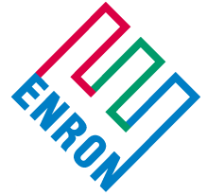

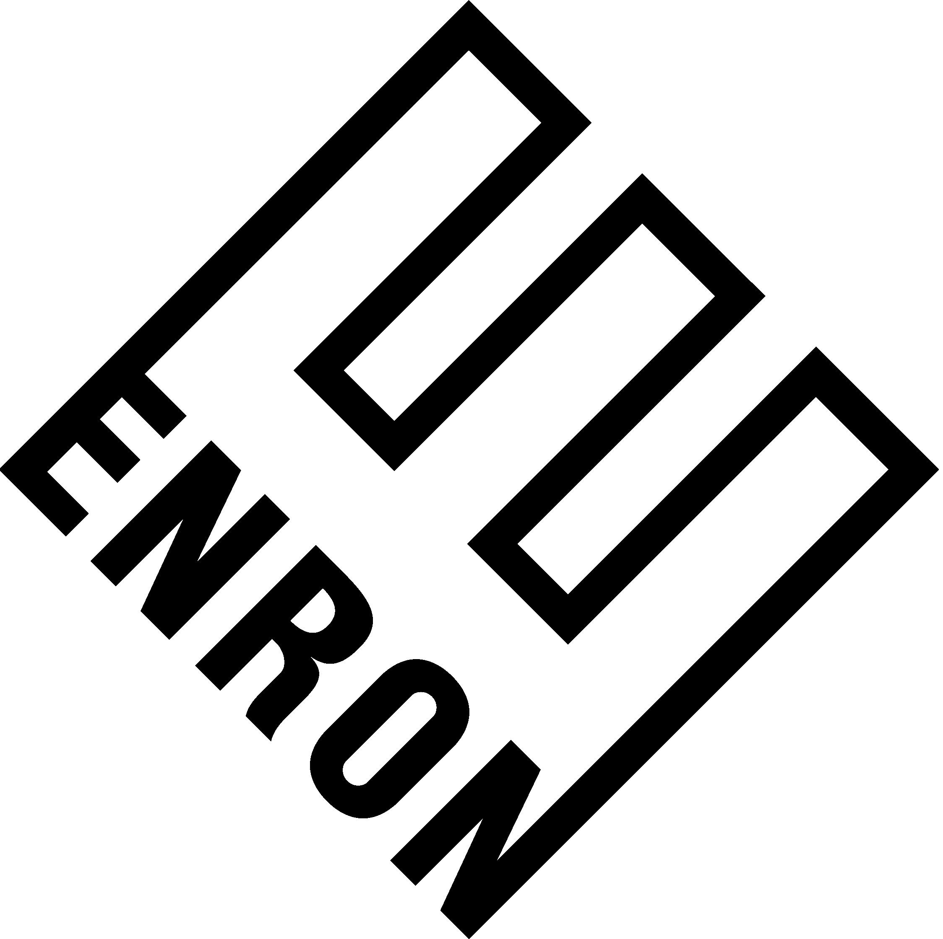

SCHEDULE 3

Specification

A: Technical Point of View

The objective is to provide Blumberg with a stream of mutually agreed upon EnronOnline quotes (quote stream) in XML format. The data will be “pushed” from EnronOnline to Blumberg via the TIBCO Rendezvous software over a set of dedicated lines linking Enron’s Houston data center and Blumberg’s New York data center. EnronOnline will publish the streams across a mutually agreeable multicast address and UDP service port. EnronOnline and Blumberg will have a pair of Rendezvous Routing Daemons (rvrds) that will bridge the Rendezvous multicast traffic across the dedicated lines.

B: Product – See Schedule 1 for definition and Agreement for applicable terms.

C: Operational Issues

Updates to the Enron Data shall be made throughout the day in a timely manner, i.e., the Enron Data shall be responsive to releases or updates made by the source of the data and updates shall be made as close to the time of such update as is commercially reasonable.

D: Quality of Service / Support

(1) Escalation procedures will be maintained and carried out according to standard operating procedures.
(2) A standard outage window will be Friday evening from 6:00pm – 11:59pm CST. All other scheduled outages will be communicated to a Blumberg contact.
(3) Enron will follow the security policies as it does for other e-commerce applications.

SCHEDULE 4

Blumberg Subsidiaries and Authorized Distributors.

