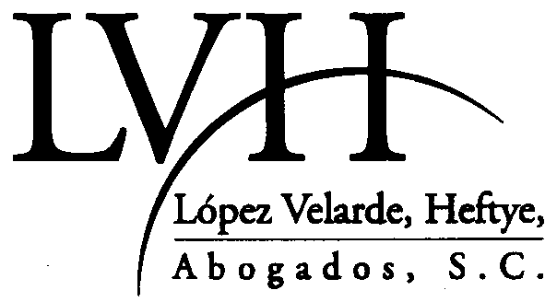

IS PLEASED TO ANNOUNCE THAT

LEON RICARDO ELIZONDO

FORMER GENERAL COUNSEL OF THE FEDERAL COMPETITION COMMISSION

M.B.A., IPADE, 1999

LL.M., UNIVERSITY OF HOUSTON, 1993

J.D., UNIVERSIDAD TECNOLÓGICA DE MÉXICO, 1990

HAS JOINED OUR FIRM AS PARTNER

AS OF MARCH 15, 2001

GUILLERMO GONZALEZ CAMARENA 1600
PISO 6, OFICINA “B”
SANTA FE, CENTRO DE CIUDAD
01210 MEXICO D.F.

TEL: (52) 50-81-14-24
FAX: (52) 50-81-14-25

relizondo@lvha.com.mx

