Young Professionals
for Aspiring Youth™
(YPAY)
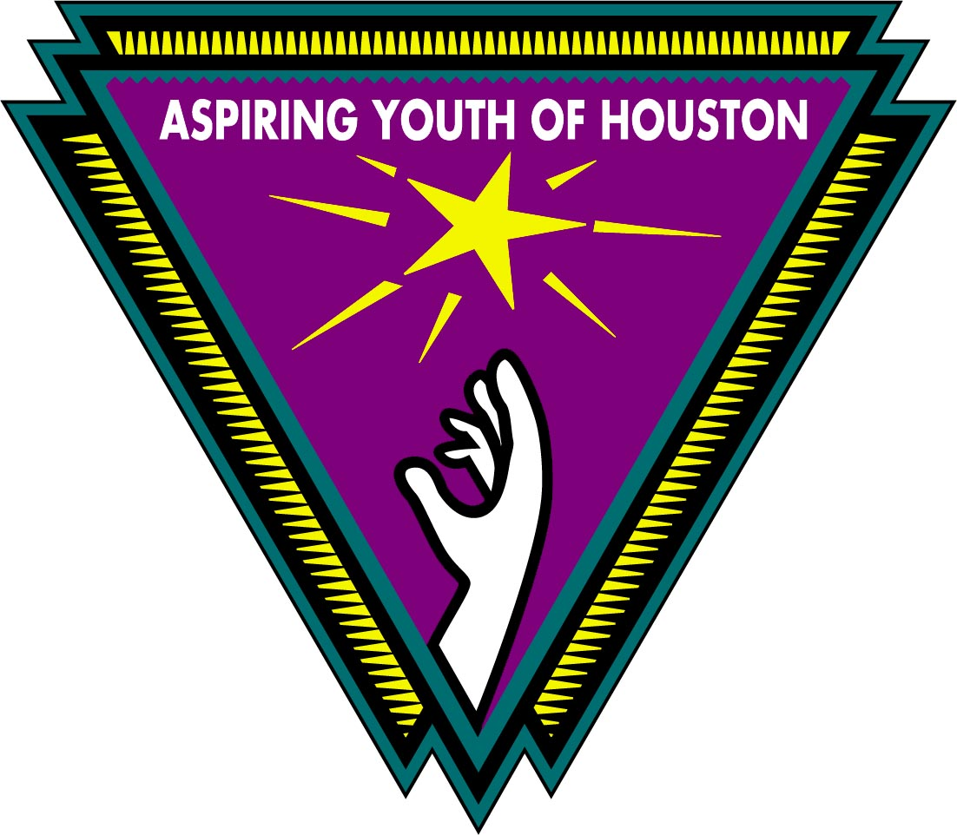

Premiere Event
at the Devin Borden Hiram Butler Art Gallery
Tuesday, April 17, 2001

Brief Presentation by
Judge Eric Andell
and two Aspiring Youth™ Students

Wine and Hors d’oeuvres served.

Devin Borden Hiram Butler Art Gallery
4520 Blossom (near Memorial and Fondren)
Date: Tuesday, April 17, 2001
Time: 6:00pm – 7:30pm
RSVP by Email (Aspireyou@aol.com)
or phone (713) 334-3330

Aspiring Youth™ of Houston is a local non-profit organization that has after-school programs for more than 750 at-risk middle school students in low-income areas of Houston. For more information on Aspiring Youth™, please visit our web site at
www.aspiringyouth.org

