You Are Invited

For Egg Nog and Holiday Cheer

At Mark’s House

On Friday evening, December 14, 2001 from 6:00 to 8:00

Hosted by Mark & Barbara

1322 Rutland Street in the Heights
(map attached)

RSVP to Keegan Farrell @ x53317

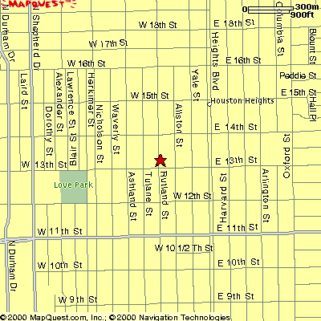
Mark’s

House
1322

Rutland
Street

