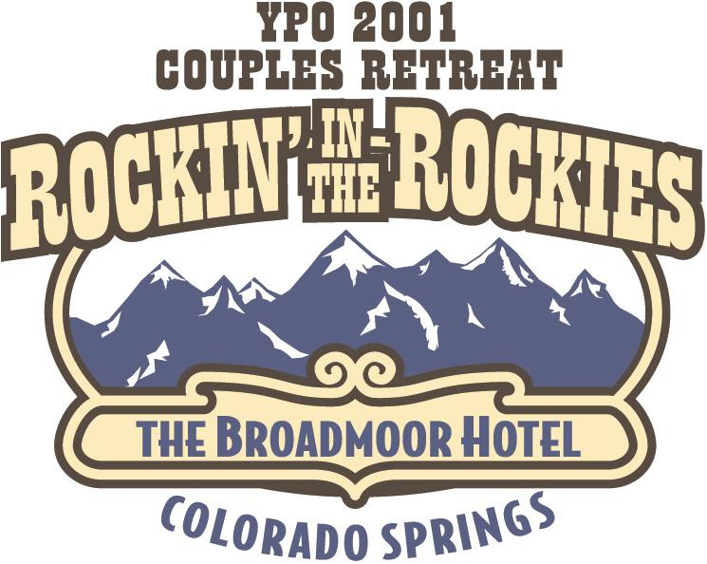

Dear Attendees,

The Couples Retreat Committee has arranged some really fun and exciting offsite activity choices for Saturday, September 15, 2001 in Colorado Springs.

Please take a look at the enclosed information and make your choices. Upon completion, make a copy of the sign up page for your records and mail the original with your payment to:

Cheryl Hester
Del Papa Distributing
6702 Broadway
Galveston, Texas 77554

If you have any questions, call Cheryl at 409-741-4407

We all look forward to ROCKIN’ IN THE ROCKIES with you!!!

Your Retreat Committee

