The Power Markets

I. GENERAL OVERVIEW
The following table provides a summary outline of certain criteria with respect to the relevant markets. The specific markets as identified by ICF Resources are TVA, a subregion of SERC, ComEd, a subregion of MAIN and Southern ECAR, a subregion of ECAR.

Key parameters | ComEd | Southern ecar | tva
Market Maturity | Robust Wholesale Market  Futures Contract (CBOT)  Active Bilateral Market | Robust Wholesale Market  Futures Contract (NYMEX)  Active Bilateral Market | Robust Wholesale Market  Futures Contract (CBOT)  Active Bilateral Market
Annual Load Growth¹ | 2.6% | 2.4% | 3.1%
Reserve Margin | 17% | 15% | 12%
Average Age of Generation ² | +23 years | +27 years | +32 years
Nuclear Generation | Largest nuclear fleet in U.S., older fleet to be retired, younger assets maintained/sold | No nuclear exposure | Existing assets to be maintained and dispatched through life of nuclear license
Environmental Compliance | Significant NOX reductions may be needed | Heavy reliance on coal may result in significant exposure to NOx regulations | TVA spending > $2.5BN on controlling emissions at 11 coal-fired plants
- Source NERC ES&D – Average for 1995-1999.
- Includes all operating units in the region.

II. INTER REGIONAL TRANSMISSION ACCESS
MAIN, ECAR and TVA are neighboring systems within the Eastern Interconnect. The map below summarizes the total transfer capability within the Eastern Interconnect.

Eastern Interconnect Total Transfer Capability (GW)
Source: NERC Summer Transmission Assessment and FERC Form 715; 1996-1998.
III. MID-AMERICA INTERCONNECTED NETWORK (“MAIN”)

A. MAIN Regional Overview
- MAIN includes utility systems covering all of Illinois, the upper peninsula of Michigan, eastern Wisconsin and much of eastern Missouri, including St. Louis. The MAIN region contains three planning sub-units: (1) Commonwealth Edison (“ComEd”), historically a single utility entity, (2) Wisconsin Upper Michigan System (“WUMS”), which includes most of the large utilities in eastern Wisconsin and the upper peninsula of Michigan, and (3) Illinois-Missouri Pool (“ILMO”), of which the largest member is Ameren.
K:\adobe\tif_april\enron\....tif,gif,jpg
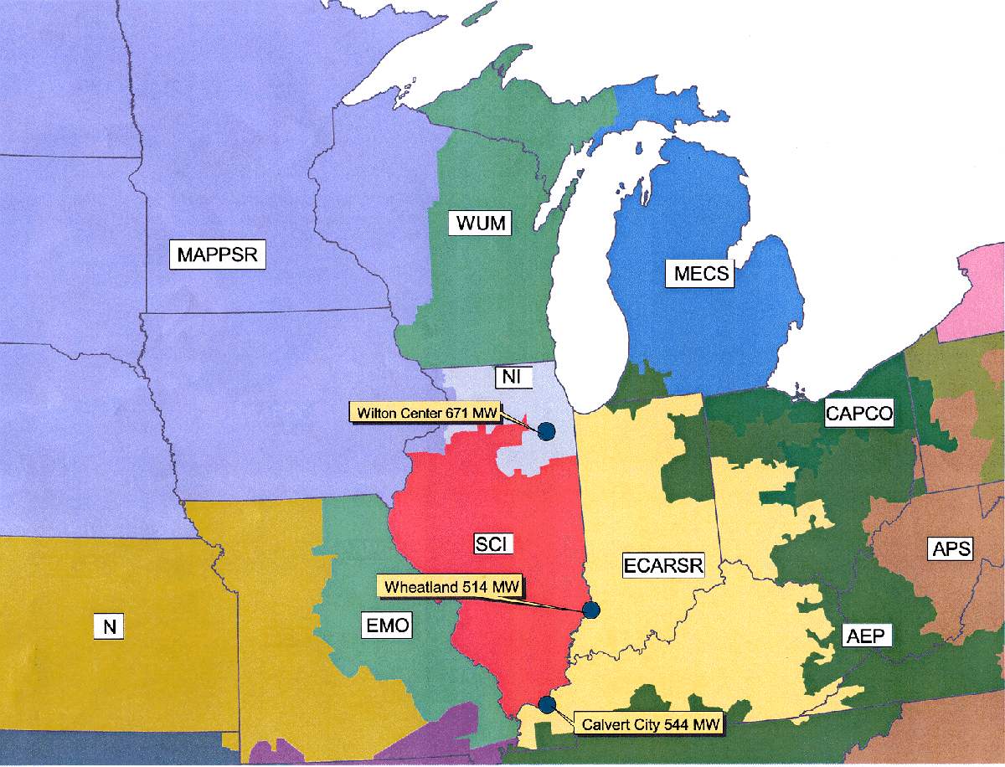

- Relative to other U.S. regions, deregulation is moderately advanced in MAIN. Illinois passed a comprehensive deregulation bill which provides for open access beginning in 1999. Asset divestitures have begun in MAIN. Commonwealth Edison, the largest utility within MAIN, has recently sold its remaining coal and oil/gas steam units to Edison Mission Energy after having sold its Kincaid and State Line coal units to Dominion Resources and Southern Company respectively.
- Wisconsin and Missouri are still considering legislation to deregulate the power industry. Retail access in Missouri is expected to begin by 2002.
- No new legislation was passed in 1999. However, the markets continue to move towards unregulated activity. For example, the merger of Dynegy and Illinova was complete as of February 2000.

MAIN Market Size
 | 1997 | 1999
Total Installed Capacity | 52 GW | 52 GW
Peak Load | 46 GW | 51 GW
Capacity Within One Wheel | 340 GW | 347 GW
Import Capability | 8 GW | 8 GW
Export Capability | 13 GW | 13 GW
Net Annual Energy | 236,143 GWh | 243,278 GWh
Average Demand | 27 GW | 28 GW
Total Wholesale Purchases¹ | 55,400 GWh | N/A
¹Source: 2000 NERC ES&D.
Wholesale Purchases were not reported after 1997.

B. MAIN Capacity Mix
MAIN is dominated by coal and nuclear generating capacity, which accounted for 81% total capacity and 96% of generation in MAIN in 1997. Generation totals beyond 1997 are not available from NERC. However, there was little change in capacity mix despite demand growth. As a result, it is likely that both coal and oil/gas steam generating levels grew from previous years. With expanded coal generation, little change in the total generation mix would be expected.
- The large nuclear concentration creates supply uncertainty especially in the near term.
(i) In the summer of 1998, MAIN experienced extreme capacity shortages in part due to a widespread shortfall in nuclear availability.
- Commonwealth Edison, has one of the largest concentrations of nuclear capacity in the U.S. and experienced significant nuclear availability problems in 1998. Units 1 and 2 of the 2,000 MW La Salle plant were off-line during the summer. The Quad Cities plant was down for much of the year and remains on the “watch list” of the U.S. Nuclear Regulatory Commission. In 1997, ComEd announced permanent retirement plans for its 2,080 MW Zion nuclear plant.
- The 1999 nuclear situation returned to more normal conditions, with LaSalle and Clinton at full availability. 2000 continues to see stability in nuclear units.
- Illinois Power Company’s Clinton nuclear plant was shut down on September 6, 1996. The unit returned to service in June 1999.On December 15, 1999, Amergen Energy Company and Illinois Power Company completed a transaction for the sale of the Clinton Power Station to Amergen.
- No nuclear units have so far applied for an operating license extension.
- The Illinois Basin, covering Southern Illinois, western Kentucky and Indiana, has historically been a major source of coal. As a consequence, numerous coal plants were built in MAIN and surrounding areas. Because this coal is generally of high-sulfur content, low-sulfur Wyoming Powder River Basin coal has penetrated the market and currently accounts for approximately half of the coal utilized in Illinois.

MAIN Capacity and Generation Mix – 1997
CAPACITY |  | GENERATION
Total Capacity = 52 GW |  | Total Generation = 217 BkWh
Note: Totals may not add due to rounding.
Source: 1998 NERC ES&D. Data for 1998 and later years is not available from NERC.

C. MAIN Transmission Overview

Inter-Regional Transmission
- The MAIN Region is highly interconnected with neighboring regions, providing significant opportunities for trading between MAIN and surrounding regions.
- The primary physical interconnections between MAIN and its neighboring systems consist of:
- Four 345 kV connections into MAPP, only one of which is in the capacity-constrained upper midwest region.
- Two 765 kV and four 345 kV connections and several sub-stations connecting the Chicago metropolitan portion of Illinois to the adjacent northwest portion of Indiana in ECAR.
- One 500 kV and two 345 kV ties connecting the MAIN portion of Missouri into Kansas and Arkansas in SPP.

Intra-Regional Transmission
The map below shows the major interconnections within MAIN.

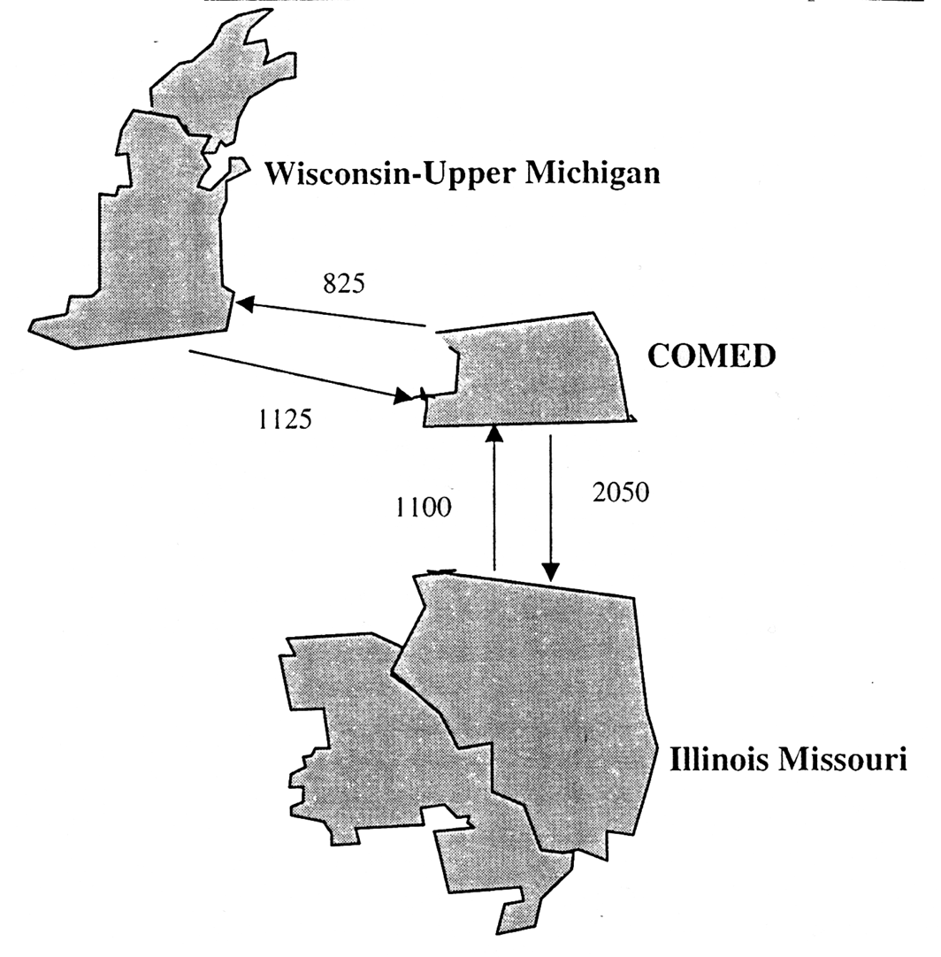

Within MAIN, transmission constraints exist going into the WUMS region.

- Other developments in the market include the potential opening of the Midwest ISO (MISO) and the Alliance RTO. Both systems would impact a large portion of the Midwest transmission grid. Further discussion is provided in Section IV of this document.

D. MAIN Historical Prices
- Energy prices in MAIN have historically been among the lowest in the country due to an abundance of low variable cost resources, namely nuclear and coal.
- The amount of low variable cost baseload capacity has been sufficient to serve load in MAIN during most hours of the year.
- As a result, the marginal source of electrical energy has typically been coal fired power plants on-peak and occasionally nuclear plants during off-peak hours.

MAIN Historical Energy Prices
(1998$/MWh)
 | 1996 | 1997 | 1998 | 1999 | 2000¹
PMW–Summer on-peak | NA | 35.5 | 117.3 | 118.2 | 169.3
PMW–Into ComEd
Average Peak | NA | 28.9 | 50.6 | 58.7 | 32.5
High | NA | 205.8 | 2,675.4 | 385.6 | 73.9
PMW–MAIN²
Average Peak | 22.7 | 26.7 | 50.4 | 58.6 | 32.7
High | 58.0 | 187.0 | 2,675.4 | 807.8 | 63.7
- 2000 prices for year to date August 14.
- In 1999, the reported price index was split into a Northern and Southern index. The values shown beyond this represent a simple average for the Summer on-peak, Average peak, and High prices.
- While Midwest peak demand growth has been strong recently, capacity expansion has not kept pace. This is attributable to both the excess capacity that followed tremendous capacity expansion in the 1980s and to the regulated structure of rate base expansion. Over the last two years, the supply/demand balance for peak hours has tightened significantly, mainly due to nuclear shutdowns and lack of new construction. This tight capacity market was evidenced by the price spikes in the summer of 1997 when power prices reached $300/MWh and by the record, dramatic price spikes in the summer of 1998 when power prices hit $7,500/MWh.
- The summer of 1999 also saw weekly price spikes upwards of $385/MWh in August. The daily high in 1999 reached $2,800 (real 1998$) as quoted in Power Markets Daily.
- Milder weather and continued capacity expansion has resulted in lower overall prices in 2000. Weekly highs have reached only $74/MWh. The daily high for 2000 reached $800/MWh (real 1998$).

MAIN Weekly Indexes – Recent Price Spikes in MAIN

IV. EAST CENTRAL AREA RELIABILITY COORDINATION AGREEMENT AREA (“ECAR”)
A. ECAR Regional Overview
- ECAR covers all or portions of Indiana, Kentucky, Michigan, Ohio, Pennsylvania, Virginia, and West Virginia.
k:\adobe\tif_april\enron\....tif,gif,jpg
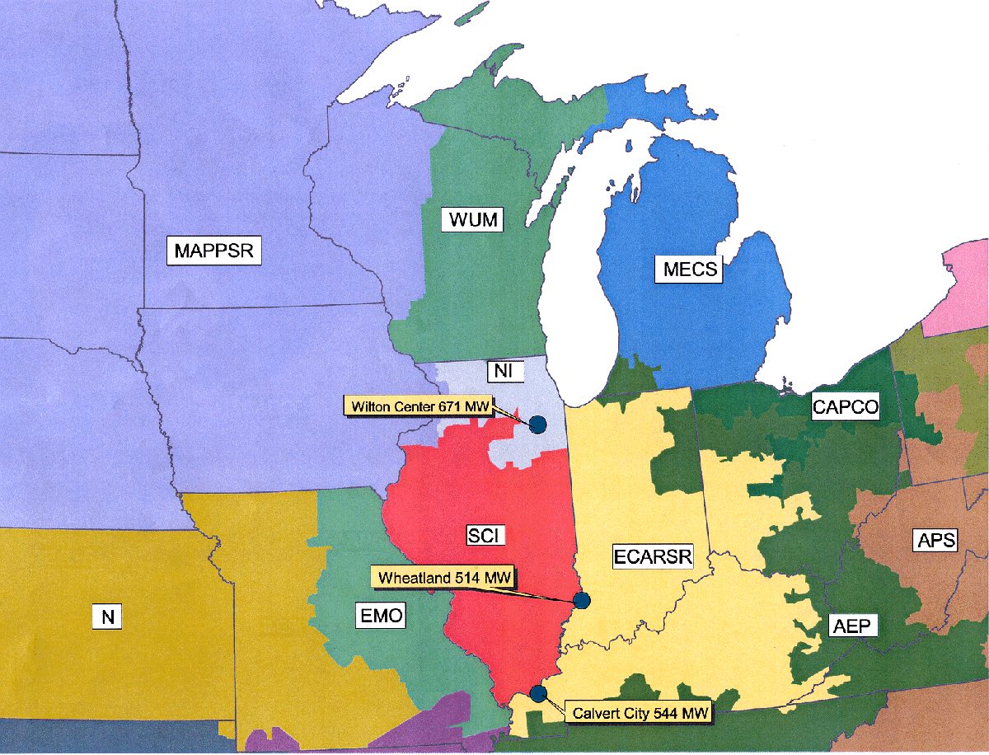

- ECAR is not a centrally dispatched or “tight” power pool. Several sub-areas of ECAR have historically operated on a tight basis. These include the American Electric Power System (“AEP”), the Allegheny Power System (“APS”), and the Michigan Electric Coordinated System (“MECS”). Although total sales for individual utilities such as AEP are significant, ECAR is not dominated by one or more utilities. Competition is further augmented by ECAR’s extensive transmission which allows for imports and exports.
- Laws concerning deregulation have been passed in Ohio, Virginia, West Virginia and Maryland. These states require full retail access by January, 2004 latest. Kentucky has decided not to pursue any legislation requiring deregulation in 2000, citing its low cost of power. A deregulation bill in the Indiana legislature was defeated in 1999 due to opposition from utilities, labor and environmental groups.
- There has not been much in the way of asset divestiture in ECAR with the exception of Duquesne in Pennsylvania and some PEPCO units in Maryland. Most of the deregulation legislation in the states in the region does not directly address divestiture. West Virginia requires all generating assets belonging to a utility to be transferred to a separate subsidiary by 2005.
- Some merger/acquisition has occurred. American Electric Power and Central and South West Corp. announced their intention to merge in December of 1997. The merger was complete summer of 2000.

ECAR Market Size
 | 1997 | 1999
Total Installed Capacity | 104 GW | 106 GW
Peak Load | 94 GW | 99 GW
Capacity Within One Wheel | 375 GW | 382 GW
Import Capability | 18 GW | 18 GW
Export Capability | 11 GW | 11 GW
Net Annual Energy | 524,414 GWh | 547,846 GWh
Average Demand | 60 GW | 63 GW
Total Wholesale Purchases¹ | 178,510 GWh | N/A
¹Source: 2000 NERC ES&D.
Wholesale Purchases were not reported after 1997.
B. ECAR Capacity Mix
- ECAR is heavily dominated by coal with some nuclear generating capacity. Combined coal and nuclear in 1997 accounted for 86% of total capacity and 95% of total generation. Overall capacity and generation mixes are unlikely to vary greatly from historical levels.

ECAR Capacity and Generation Mix – 1997
CAPACITY |  | GENERATION
Total Capacity = 104 GW |  | Total Generation = 538 BkWh
Source: NERC ES&D, 1998. Data for generation beyond 1997 is not available from NERC.
Note: Totals may not add due to rounding.
C. ECAR Transmission Overview
While there is considerable transmission capability within ECAR, the connections with the rest of the Northeast are somewhat limited.

Inter-Regional Transmission
The primary interconnections between ECAR and neighboring systems consist of:
- Two 345 kV interconnections with Ontario in MECS.
- Two 500 kV interconnections in southwestern PJM with APS in ECAR.
- Two 345 kV interconnections in northwestern PJM with Centerior in ECAR.
- Four 500 kV interconnections with VEPCO and one 500 kV interconnection with Duke in VACAR.
- Two 500 kV interconnections with TVA.
- One 765 kV and several 345 kV interconnections with MAIN (primarily at Commonwealth Edison).
Note that many ECAR companies are part of the Midwest ISO agreement discussion in Section VI.

Intra-Regional Transmission

- Southern ECAR has extensive transmission interconnections including AEP's 765 kV line, the largest in the U.S. MECS is well integrated on an internal basis but is not connected with AEP's 765 kV line.

D. ECAR Historical Prices
- Electrical energy prices in ECAR have historically been lower than neighboring regions to the East, especially the Northeast, but higher than MAPP and MAIN.
- While ECAR has significant coal capacity as part of its supply mix, delivered coal costs in this region are higher than in MAIN and MAPP. Due to ECAR’s geographic location, ECAR has relatively easy access to high cost Appalachian coal but is fairly remote from the cheaper Powder River Basin coals, which adds to delivered cost due to transportation.

ECAR Historical Energy Prices
(1998$/MWh)
 | Historical
 | 1996 | 1997 | 1998 | 1999 | 2000¹
PMW–Summer on-peak | NA | 37.7 | 150.3 | 109.8 | 43.4
PMW–ECAR
Average Daily Prices | 23.3 | 25.3 | 58.7 | 28.4 | 24.4
High | 53.2 | 244.5 | 2,099.7 | 618.1 | 47.0
PMW–Into Cinergy
Average Peak | NA | 25.0 | 58.7 | 51.3 | 32.7
High | NA | 246.4 | 2,099.7 | 1,003.1 | 77.3
1. YTD as of August 14, 2000.
- ECAR’s baseload capacity is sufficient to meet its average needs.
- Capacity becomes quite thin during peak periods.
- ECAR has become increasingly capacity short, causing higher price volatility.
- Southern ECAR experienced explosions in peak power prices in the summers of 1997 and more so in 1998. As in MAIN, these spikes help account for the high 1998 average and on peak Power Markets Week prices.
- In 1999, Southern ECAR again experienced high prices, reaching over $600/MWh for on-peak weekly prices in August.
- 2000 prices have been heavily influenced by the milder weather and have stayed at levels dictated by the costs of operating units for the most part.
- Daily prices reached $2,100/MWh in 1999 and $170/MWh to date in 2000 (real 1998$/MWh).

ECAR Weekly Indexes – Recent Price Spikes in ECAR
!Sheet1 Size: 4.10" x 6.00" Original Size: 4.50" x 5.99" Crop: .11" Top .29" Bottom

V. TENNESSEE VALLEY AUTHORITY (“TVA”)
While TVA is not an independent reliability council, it is discussed here separately from the rest of the Southeast Electric Reliability Council (“SERC”) for several reasons:
- SERC is extremely large and diverse, and it is therefore less meaningful to examine SERC as a single marketplace (e.g. TVA has significantly more hydropower generation than the rest of SERC).
- TVA has significant independence from SERC for planning and operations.
- There are transmission constraints between TVA and the rest of SERC.

A. TVA Regional Overview
- The Tennessee Valley Authority, a sub-region of the Southeast Electric Reliability Council (SERC”), encompasses a 200,000-square kilometer area including all of Tennessee, sizeable portions of northern Alabama, northern Mississippi, and southern Kentucky and small portions of Georgia, North Carolina, and Virginia.
- TVA is planned and dispatched as one system with peak loads in excess of 26 GW.
TVA is primarily a wholesaler, selling about 80 percent of its output to about 160 municipal utilities and cooperatives, and also sells directly to 60 large industrial customer and government installations.

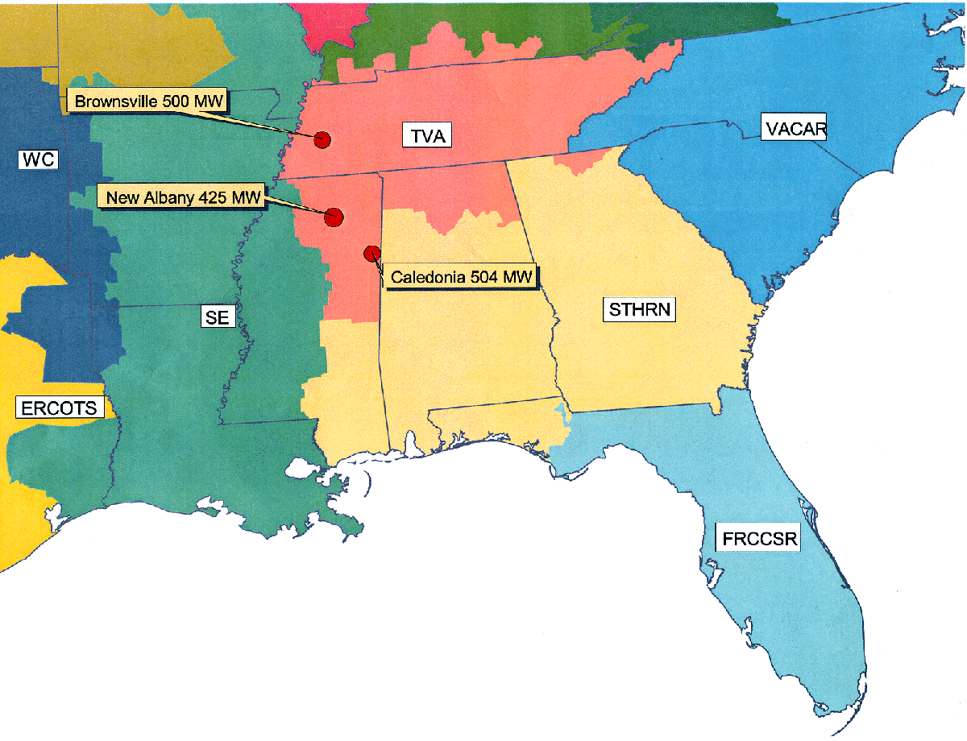

TVA Market Size
 | 1997 | 1999
Total Capacity | 30 GW | 30 GW
Peak Load | 27 GW | 28 GW
Capacity Within One Wheel | 350 GW | 357 GW
Import Capability | 18 GW | 18 GW
Export Capability | 11 GW | 11 GW
Net Annual Energy | 146,111 GWh | 155,961 GWh
Average Demand | 17 GW | 18 GW
Annual Wholesale Purchases | 4,800 GWh | N/A
Note: Wholesale Purchases were not reported after 1997.
2000 NERC ES&D.
B. TVA Capacity Mix
- The TVA capacity and generation mix is dominated by coal, which accounts for over 50% of installed capacity and approximately 60% of total generation in 1997.
- Nuclear and hydro (including pumped storage) account for roughly 22% and 21%, respectively, of the total capacity. The remaining capacity in TVA is comprised mainly of combustion turbines which are relied on for peak hours.
- TVA has more hydro than any other major U.S. sub-region in the Eastern Interconnect.

TVA Capacity and Generation Mix – 1997
CAPACITY |  | GENERATION
Total Capacity = 30 GW |  | Total Internal Generation = 160 BkWh
Note: Capacity physically located in TVA region, but counting toward other regions is not included in the capacity mix. Totals may not add due to rounding
Source: 1998 NERC ES&D. Data for generation is not available from NERC beyond 1997.

C. TVA Transmission Overview
- TVA is centrally located and has significant interconnections with other regions

PresTech K:\Adobe\April_tif\Project Finance Emron.tif
MAIN
ECAR
VACAR
SPPN
SPPW
Entergy
TVA
Southern
2269 MW
1100 MW
1013 MW
2877 MW
1988 MW
1638 MW
866 MW
2488 MW
1710 MW
1889 MW
1711 MW
3150 MW

- The primary interconnections between TVA and neighboring systems consist of ties to the following utilities:
- ECAR – AEP/Appalachian Power, Big Rivers, Kentucky Utilities, East Kentucky Power Coop, and Louisville Gas & Electric
- VACAR – Duke Power, Carolina Power & Light
- SPP – Entergy’s Arkansas Power & Light, Mississippi Power & Light
- MAIN – Central Illinois Public Service, Illinois Power and Union Electric
- Southern – Alabama Power and Georgia Power
D. TVA Historical Prices
- Electrical energy prices in all of SERC have historically been lower than neighboring regions to the North.
- TVA has relatively large total interconnections associated with its central location. Import and export capability is two thirds of average demand and some lines may be upgraded, further increasing transmission access.
- Prices jumped between the summers of 1997 and 1998 as the market has come into full balance.
- In 1999, prices were again high, reaching $2,200/MWh.
- In 2000, prices have been below levels experienced in 1998 and 1999. Daily prices have reached $145/MWh to date in 2000.

SERC Historical Energy Prices
(1998$/MWh)
 | HISTORICAL
 | 1996 | 1997 | 1998 | 1999 | 20001
PMW–Summer on-peak | N/A | 36.7 | 149.2 | 133.8 | 54.7
PMW–SERC
Average Peak | 24.0 | 26.7 | 48.6 | 39.9 | 39.0
High | 46.3 | 178.8 | 1,183.4 | 634.3 | 88.0
PMW–Into TVA
Summer On-Peak | N/A | 35.7 | 145.0 | 141.8 | 51.1
Average Peak | N/A | 27.6 | 57.9 | 51.8 | 36.4
High | N/A | 240.9 | 2,455.9 | 1,027.0 | 82.1
¹. YTD as of August 14, 2000.

SERC Weekly Indexes – Recent Price Spikes in TVA

VI. OTHER RELEVANT DEVELOPMENTS
There are several transmission related developments that can further facilitate market access for the Facilities including several steps away from pancaking of transmission rates and towards larger, integrated marketplaces.

A. Midwest ISO and Transmission Charges
- Recently, FERC conditionally approved the Midwest ISO, which includes members from MAIN, ECAR and MAPP. The implementation of the ISO would serve largely to eliminate the pancaking or rates by establishing a zonal pricing system.
- Members of the Midwest ISO include: Allegheny Power, Ameren (formerly Union Electric and Central Illinois Public Service), CILCO, Cinergy, Commonwealth Edison, Hoosier Energy Rural Electric Cooperative, Illinois Power, Louisville Gas & Electric, Wabash Valley Power, SIGECO, NSP, Alliant Energy, So. Illinois Power Cooperative, and Wisconsin Electric. A total of twelve transmission owners in the region are members of MISO. Recently, Northern State Power joined MISO expanding the organization into MAPP.
- Recently, members of MAPPCOR, the contractor that operates the Mid-Continental Power Pool (MAPP), agreed to sell its assets to MISO. The agreement will not be complete unless members representing two-thirds of the load in MAPP agree to join MISO.
- The pricing structure agreed to by the participants allows for a six year transition period, during which time the members of Midwest ISO are divided into zones existing at the time of filing the agreement. For point-to-point transmission to a customer within the ISO, the rate charged will be the zonal rate where the load is located.
- For point-to-point transmission through the ISO or for point-to-point transmission out of the ISO, the rate charged will be a single system-wide ISO rate.
- After the transition period the zonal pricing structure may be retained or a single, Midwest ISO rate adopted.
- More recently Commonwealth Edison, Mid American Energy, Interstate Power and IES Utilities have proposed forming a for-profit independent transmission company (ITC) within the jurisdiction of MISO. They have filed their plan with FERC in December 1999 and the proposal is pending review. The proposed ITC would have a governing body independent of buyers and sellers and any major rate-funded transmission expansion would need to be approved by MISO.
- Currently negotiations are underway to expand MISO to include SPP. This expansion is targeted to include both the northern and western sections of SPP.

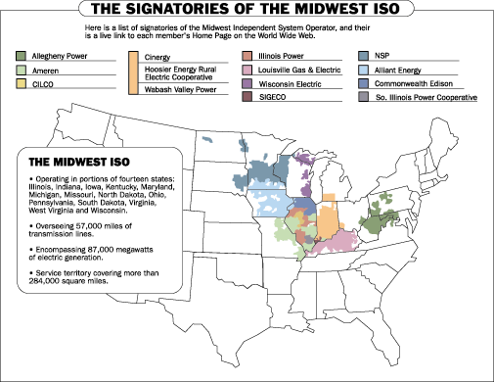
source: www.midwestiso.com

B. Alliance RTO
- A competing ISO-type regional transmission organization (“RTO”) is under development by companies in ECAR and VACAR.
- Discussions with multiple parties have been ongoing since early 1998. The Alliance is currently in Phase III.
- Currently, five companies have agreed to develop a FERC filing:
- AEP
- First Energy
- Consumers Power
- Detroit Edison
- Virginia Power
- The exact form of the RTO (full ISO or Transco) to remain flexible.
- If no one divests by day one of operations, the Alliance would function like a non-profit ISO. If one or more members sells transmission assets into the Alliance, the RTO would automatically become a transmission company.
- Members can sign an operational agreement with the Alliance relinquishing control of transmission assets, or sell or lease assets to the Alliance.
- The proposed pricing structure includes a transition period in which each member’s existing transmission system would comprise a zone.
- Customers could pay one zone rate to access a zone and then would only pay another zone rate to access the entire RTO during the transition.
- Eventually, the Alliance seeks to offer a single, grid-wide rate, perhaps in six years or when all transmission owners join.
- With FERC approval, the Alliance would also develop and propose incentive rates.

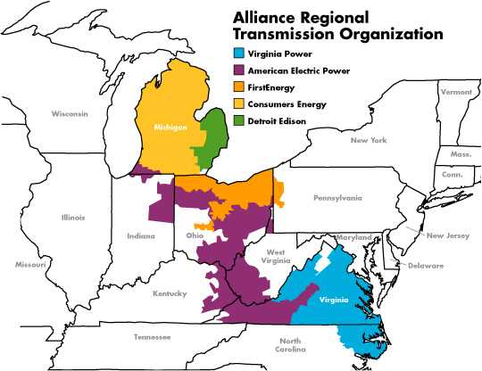
- The Alliance RTO is expected to file with FERC within the year.
source: www.alliancerto.com

