The Power Markets
I. GENERAL OVERVIEW
The following table provides a summary outline of certain criteria with respect to the relevant markets. The specific markets as identified by ICF Resources are TVA, a subregion of SERC, ComEd, a subregion of MAIN and Southern ECAR, a subregion of ECAR.

Key parameters | ComEd | Southern ecar | tva
Market Maturity | Robust Wholesale Market  Futures Contract (CBOT)  Active Bilateral Market | Robust Wholesale Market  Futures Contract (NYMEX)  Active Bilateral Market | Robust Wholesale Market  Futures Contract (CBOT)  Active Bilateral Market
Annual Load Growth | 1.5% | 1.6% | 2.4%
Planning Reserve Margin | 17% | 15% | 12%
Average Age of Generation¹ | +28 years | +26 years | +40 years
Nuclear Generation | Historically, largest nuclear fleet in U.S., older fleet to be retired, younger assets maintained/sold | Minimal nuclear exposure | Existing assets to be maintained and dispatched through life of nuclear license
Environmental Compliance | Significant NOX reductions may be needed | Heavy reliance on coal may result in significant exposure to NOx regulations | TVA spending > $2.5BN on controlling emissions at 11 coal-fired plants
(1) Average age for fossil-fuel fired generation units only.
II. INTER REGIONAL TRANSMISSION ACCESS
MAIN, ECAR and TVA are neighboring systems within the Eastern Interconnect. The map below summarizes the total transfer capability within the Eastern Interconnect.
Eastern Interconnect Total Transfer Capability (GW)

Source: NERC Summer Transmission Assessment and FERC Form 715; 1996-1998
III. MID-AMERICA INTERCONNECTED NETWORK (“MAIN”)
A. MAIN Regional Overview
- MAIN includes utility systems covering all of Illinois, the upper peninsula of Michigan, eastern Wisconsin and much of eastern Missouri, including St. Louis. The MAIN region contains three planning sub-units: (1) Commonwealth Edison (“ComEd”), formerly operated as a single utility entity, however now with asset owners including Edison Mission Energy, Southern Company, and Dominion Resources; (2) Wisconsin Upper Michigan System (“WUMS”), which includes most of the large utilities in eastern Wisconsin and the upper peninsula of Michigan; and (3) Illinois-Missouri Pool (“ILMO”), including its largest member, Ameren.
K:\adobe\tif_april\enron\....tif,gif,jpg
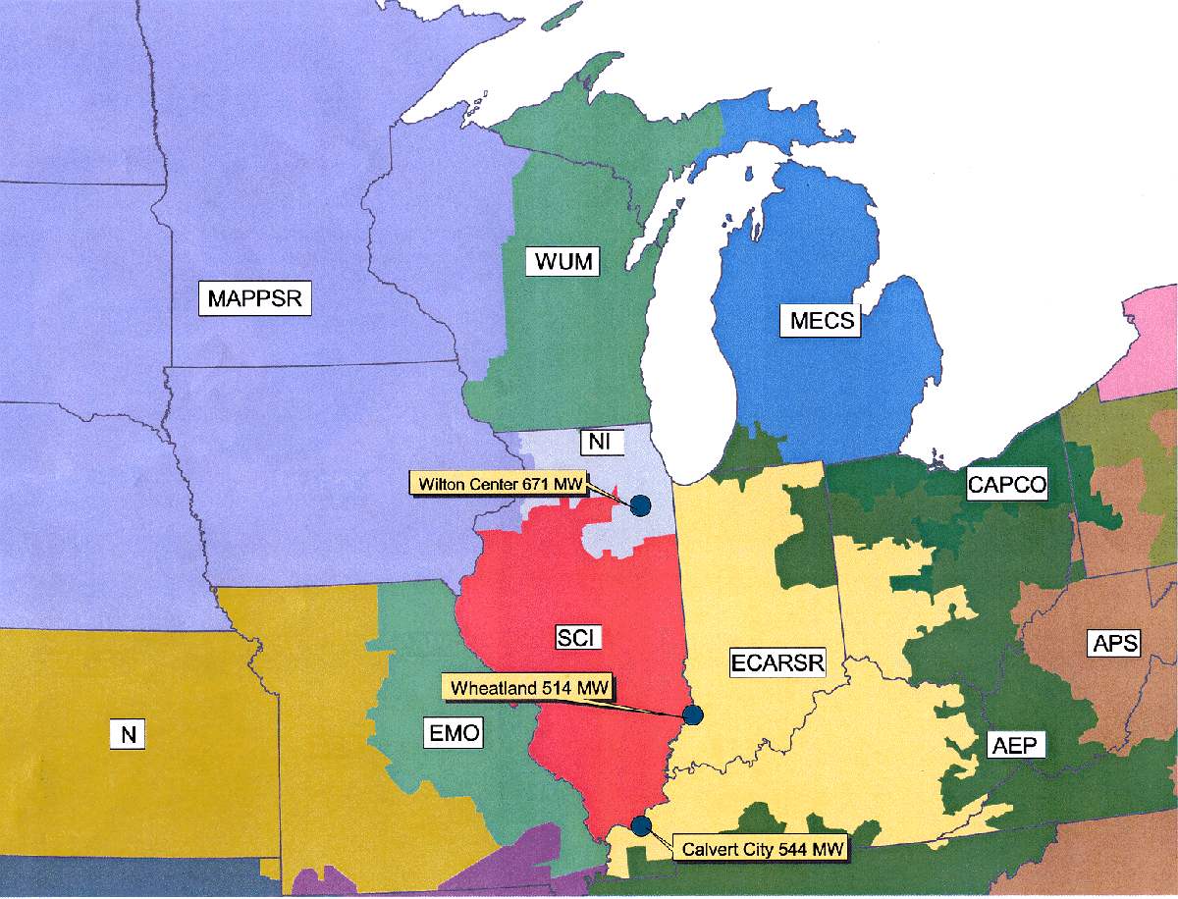

- Relative to other U.S. regions, deregulation is moderately advanced in MAIN. Illinois passed a comprehensive deregulation bill that provides for open access beginning in 1999. Asset divestitures have begun in MAIN. Commonwealth Edison, the largest utility within MAIN, has recently sold off its remaining coal and oil/gas steam units to Edison Mission Energy after having sold its Kincaid and State Line coal units to Dominion Resources and Southern Company respectively.
- Wisconsin and Missouri are still considering legislation to deregulate the power industry. Retail access in Missouri is expected to begin by 2002.
- No new legislation was passed in 1999. However, the markets continue to move towards unregulated activity. For example, the merger of Dynegy and Illinova was complete as of February 2000 and Commonwealth Edison is in the process of merging with PECO.
MAIN Market Size – 2000
Total Installed Capacity | 57 GW
Peak Load | 46 GW
Capacity Within One Wheel | 340 GW
Import Capability | 8 GW
Export Capability | 12 GW
Net Annual Energy | 235,149 GWh
Average Demand | 27 GW
Net Exports | 8,671GWh
Source: ICF Base Case Forecasts for the year 2000.

B. MAIN Capacity Mix
MAIN is dominated by coal and nuclear generating capacity. Combined, these units accounted for 81% total capacity and 96% of generation in MAIN in 1997. Generation totals beyond 1997 are not available from NERC.
- The large nuclear concentration creates supply uncertainty especially in the near term. In the summer of 1998, MAIN experienced extreme capacity shortages in part due to a widespread shortfall in nuclear availability. However, the need for capacity in MAIN extends beyond the reliability of the nuclear units. Even with the return of nuclear capacity, shortages continued in the summer of 1999:
- Commonwealth Edison has one of the largest concentrations of nuclear capacity in the U.S. and experienced significant nuclear availability problems in 1998. Units 1 and 2 of the 2,000 MW La Salle plant were off-line during the summer. The Quad Cities plant was down for much of the year and was on the “watch list” of the U.S. Nuclear Regulatory Commission. In 1997, ComEd announced permanent retirement plans for its 2,080 MW Zion nuclear plant. The 1999 nuclear situation returned to more normal conditions, with LaSalle and Clinton at full availability.
- Illinois Power Company’s Clinton nuclear plant was off-line starting September 6, 1996. On December 15, 1999, Amergen Energy Company and Illinois Power Company completed a transaction for the sale of the Clinton Power Station to Amergen. The plant is now back on-line.
- The Illinois Basin, covering Southern Illinois, western Kentucky and Indiana, has historically been a major source of coal. As a consequence, numerous coal plants were built in MAIN and surrounding areas. Because this coal is generally of high-sulfur content, low-sulfur Wyoming Powder River Basin coal has penetrated the market and currently accounts for more than half of the coal utilized in Illinois.

MAIN Capacity and Generation Mix – 2000
CAPACITY |  | GENERATION
Total Capacity = 56 GW |  | Total Generation = 244 BkWh
Note: Totals may not add due to rounding.
Source: ICF Base Case Forecasts for the year 2000.

C. MAIN Transmission Overview
Inter-Regional Transmission
- The MAIN Region is highly interconnected with neighboring regions, providing significant opportunities for trading between MAIN and surrounding regions.
- The primary physical interconnections between MAIN and its neighboring systems consist of:
- Two 765 kV and four 345 kV connections and several sub-stations connecting the Chicago metropolitan portion of Illinois to the adjacent northwest portion of Indiana in ECAR.
- Four 345 kV connections into MAPP, only one of which is in the capacity-constrained upper Midwest region.
- One 500 kV and two 345 kV ties connecting the MAIN portion of Missouri into Kansas and Arkansas in SPP.
Intra-Regional Transmission
The map below shows the major interconnections within MAIN.

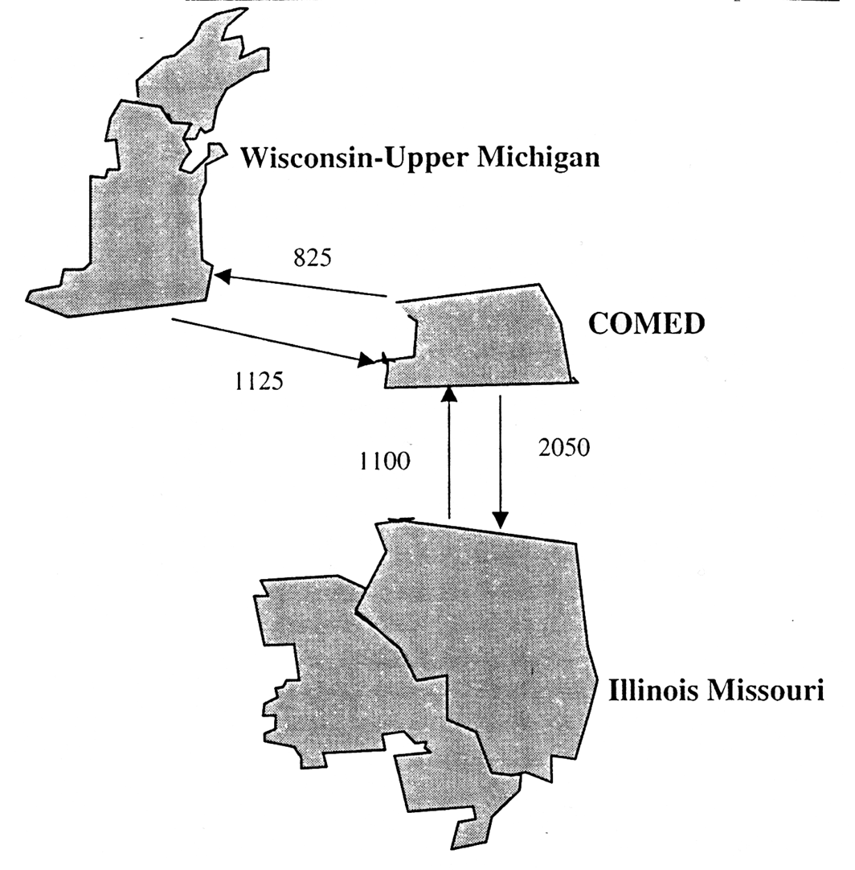
Within MAIN, transmission constraints exist going into the WUMS region.
D. MAIN Historical Prices
- Energy prices in MAIN have historically been among the lowest in the country due to an abundance of low variable cost resources, namely nuclear and coal.
- The amount of low variable cost baseload capacity has been sufficient to serve load in MAIN during most hours of the year.
- As a result, the marginal source of electrical energy has typically been coal fired power plants on-peak and occasionally nuclear plants during very deep off-peak hours.

ComEd/MAIN Historical Energy Prices
(1998$/MWh)
 | 1996 | 1997 | 1998 | 1999
PMW–Into ComEd
Average Peak¹ | NA | 28.7 | 49.8 | 57.9
High | NA | 104.3 | 690.4 | 1,365.7
Average Summer² Peak |  | 33.6 | 115.3 | 166.8
PMW–MAIN
Average Peak¹ | 22.4 | 26.2 | 49.3 | 45.0
High | 39.9 | 114.7 | 690.4 | 922.3
Average Summer² Peak | 24.8 | 34.9 | 113.9 | 104.0
Megawatt Daily – ComEd
Average Peak¹ | NA | 26.2 | 46.0 | 43.2
High | NA | 192.2 | 2,700.0 | 1,784.5
Average Summer² Peak | NA | 31.3 | 118.6 | 108.8
¹ Includes weekday hours 6 through 22.
² Includes months June, July and August.
Source: Power Market Week (PMW) weekly index and Megawatt Daily daily index.

- While Midwest peak demand growth has been strong recently, capacity expansion has not kept pace. This is attributable, in part, to both the excess capacity that followed tremendous capacity expansion in the 1980s and to the regulated structure of rate base expansion. Over the last two years, the supply/demand balance for peak hours has tightened significantly, mainly due to nuclear shutdowns and lack of new construction.
- The progressive tightening of the capacity situation in ComEd/MAIN was reflected in the difference in the price spikes in 1997 and that in 1998 and 1999. The daily price index in the summer of 1997 reached as high as $192/MWh.
- The picture changed dramatically in the summer of 1998. Outages of key nuclear units led to daily prices reaching as high as $2,800/MWh in 1998 with hourly prices being reported to be as high as $7,000/MWh.
- Capacity situation in 1999 continued to be grim as higher than expected summer demand pushed daily prices as high as $2,168/MWh. MAIN as a whole reported peak demand at approximately 5 percent higher than forecasted, while many utilities reported peaks at about 10 percent higher than forecasted. ComEd region experienced extensive outages between late July and early August.

MAIN Weekly Indexes – Recent Price Spikes in MAIN
Source: Power Markets Week.

IV. EAST CENTRAL AREA RELIABILITY COORDINATION AGREEMENT AREA (“ECAR”)
A. ECAR Regional Overview
- ECAR covers all or portions of Indiana, Kentucky, Michigan, Ohio, Pennsylvania, Virginia, Maryland, and West Virginia.
k:\adobe\tif_april\enron\....tif,gif,jpg
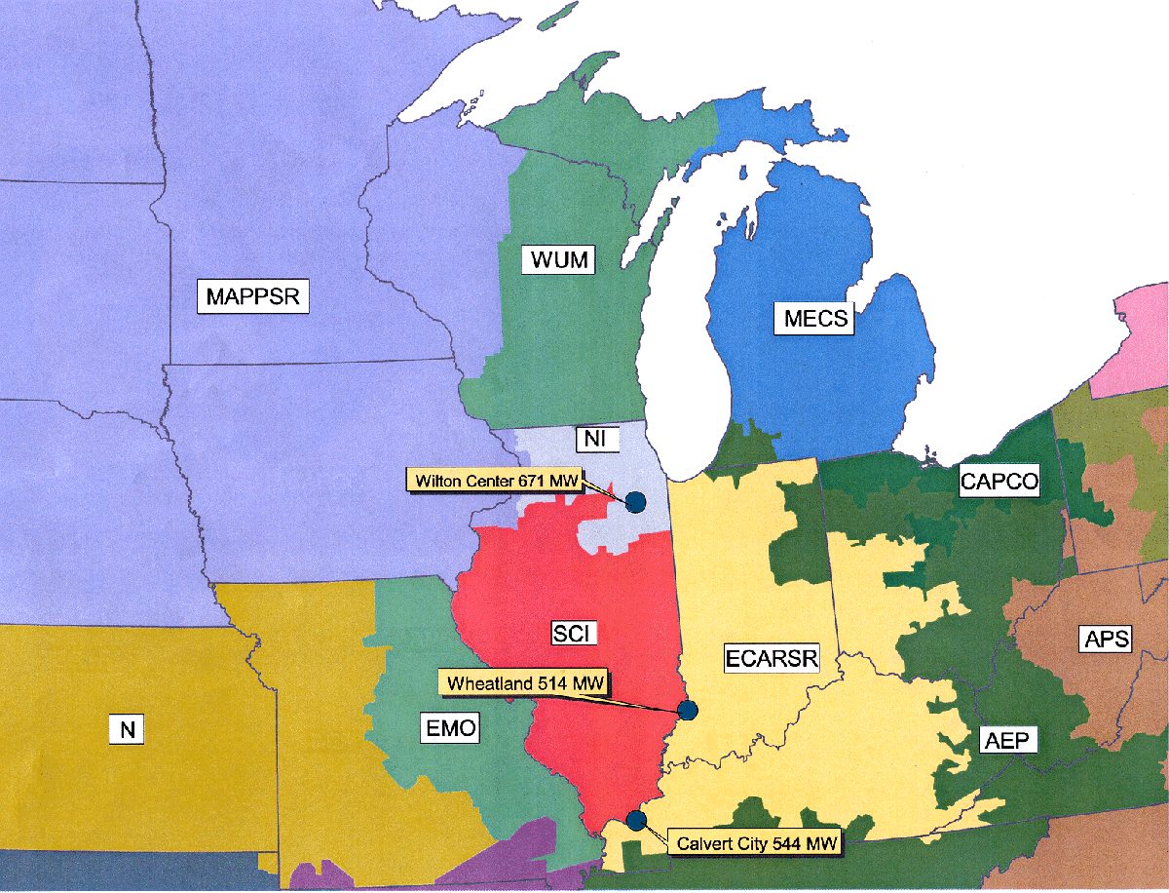

- ECAR is not a centrally dispatched or “tight” power pool. Several sub-areas of ECAR have historically operated on a tight basis. These include the American Electric Power System (“AEP”), the Allegheny Power System (“APS”), and the Michigan Electric Coordinated System (“MECS”). Although total sales for individual utilities such as AEP are significant, ECAR is not dominated by one or more utilities. Competition is further augmented by ECAR’s extensive transmission which allows for large amounts of imports and exports.
- Laws concerning deregulation have been passed in Ohio, Virginia, West Virginia and Maryland. These states require full retail access by January 2004 at the latest. Kentucky has decided not to pursue any legislation requiring deregulation in 2000, citing its low cost of power. A deregulation bill in the Indiana legislature was defeated in 1999 due to opposition from utilities, labor and environmental groups.
- There has not been much in the way of asset divestiture in ECAR with the exception of Duquesne in Pennsylvania. Most of the deregulation legislation in the states in the region does not require divestiture. Both Ohio and West Virginia require all generating assets belonging to a utility to be transferred to a separate unregulated subsidiary by 2005.

ECAR Market Size – 2000
Total Installed Capacity | 110 GW
Peak Load | 93 GW
Capacity Within One Wheel | 375 GW
Import Capability | 17 GW
Export Capability | 10 GW
Net Annual Energy for load | 569,713 GWh
Average Demand | 65 GW
Net Exports | 32,030GWh
Source ICF Base Case Forecasts for 2000

B. ECAR Capacity Mix
- ECAR is heavily dominated by coal with some nuclear generating capacity. Combined coal and nuclear in 1997 accounted for 86% of total capacity and 95% of total generation.
ECAR Capacity and Generation Mix – 2000
CAPACITY |  | GENERATION
Total Capacity = 110 GW |  | Total Generation = 602 BkWh
Source: ICF Base Case Forecast for the year 2000.
Note: Totals may not add due to rounding errors. The difference between the total generation depicted in the pie chart and the Net Energy
for load in the Table is due to net exports from ECAR.
C. ECAR Transmission Overview
While there is considerable transmission capability within ECAR, the connections with the rest of the Northeast are somewhat limited.
Inter-Regional Transmission
The primary interconnections between ECAR and neighboring systems consist of:
- Two 500 kV interconnections in southwestern PJM with APS in ECAR.
- Two 345 kV interconnections in northwestern PJM with Centerior in ECAR.
- Two 345 kV interconnections with Ontario in MECS.
- Four 500 kV interconnections with VEPCO and one 500 kV interconnection with Duke in VACAR.
- Two 500 kV interconnections with TVA.
- One 765 kV and several 345 kV interconnections with MAIN (primarily at Commonwealth Edison).
Intra-Regional Transmission

- Southern ECAR has extensive transmission interconnections including AEP's 765 kV line, the largest in the U.S. MECS is well integrated on an internal basis but is not connected with AEP's 765 kV line.

D. ECAR Historical Prices
- Electrical energy prices in ECAR have historically been lower than neighboring regions to the East, especially the Northeast, but higher than MAPP and MAIN.
- While ECAR has significant coal capacity as part of its supply mix, delivered coal costs in this region are higher than in MAIN and MAPP. Due to ECAR’s geographic location, ECAR has relatively easy access to high cost Appalachian coal but is fairly remote from the cheaper Powder River Basin coals, which adds to delivered cost due to transportation.

ECAR Historical Energy Prices
(1998$/MWh)
 | Historical
 | 1996 | 1997 | 1998 | 1999
PMW– Northern ECAR
Average Peak¹ | 23.5 | 24.8 | 56.3 | 43.5
High | 40.3 | 139.8 | 656.0 | 609.2
Average Summer² Peak | 27.3 | 37.0 | 146.1 | 108.2
PMW–Into Cinergy
Average Peak¹ | NA | 24.5 | 56.4 | 50.5
High | NA | 138.4 | 656.0 | 988.7
Average Summer² Peak | NA | 37.0 | 146.1 | 139.0
¹Includes weekday hours 6 through 22.
² Includes June, Kuly and August.
Source Power Market Week (PMW) weekly index).
- ECAR’s baseload capacity is sufficient to meet its average needs.
- Capacity becomes quite scarce during peak periods.
- ECAR has become increasingly capacity short, causing higher price volatility.
- Southern ECAR experienced explosions in peak power prices in the summers of 1997 and more so in 1998. As in MAIN, these spikes help account for the high 1998 average and on peak Power Markets Week prices.
- In 1999, Southern ECAR again experienced high prices, with the weekly index reaching as high as $600/MWh in August.
ECAR Weekly Indexes – Recent Price Spikes in ECAR

!Sheet1 Size: 4.10" x 6.00" Original Size: 4.50" x 5.99" Crop: .11" Top .29" Bottom

Source: Power Market Week.

V. TENNESSEE VALLEY AUTHORITY (“TVA”)
While TVA is not an independent reliability council, it is discussed here separately from the rest of the Southeast Electric Reliability Council (“SERC”) for several reasons:
- SERC is extremely large and diverse, and it is therefore less meaningful to examine SERC as a single marketplace (e.g. TVA has significantly more hydropower generation than the rest of SERC).
- TVA has significant independence from SERC for planning and operations.
- There are transmission constraints between TVA and the rest of SERC.
A. TVA Regional Overview
- TVA is primarily a wholesaler, selling about 80 percent of its output to about 160 municipal utilities and cooperatives, and also sells directly to 60 large industrial customer and government installations.
- TVA encompasses a 200,000-square kilometer area including all of Tennessee, sizeable portions of northern Alabama, northern Mississippi, and southern Kentucky and small portions of Georgia, North Carolina, and Virginia.
- TVA is planned and dispatched as one system with peak loads in excess of 27 GW.

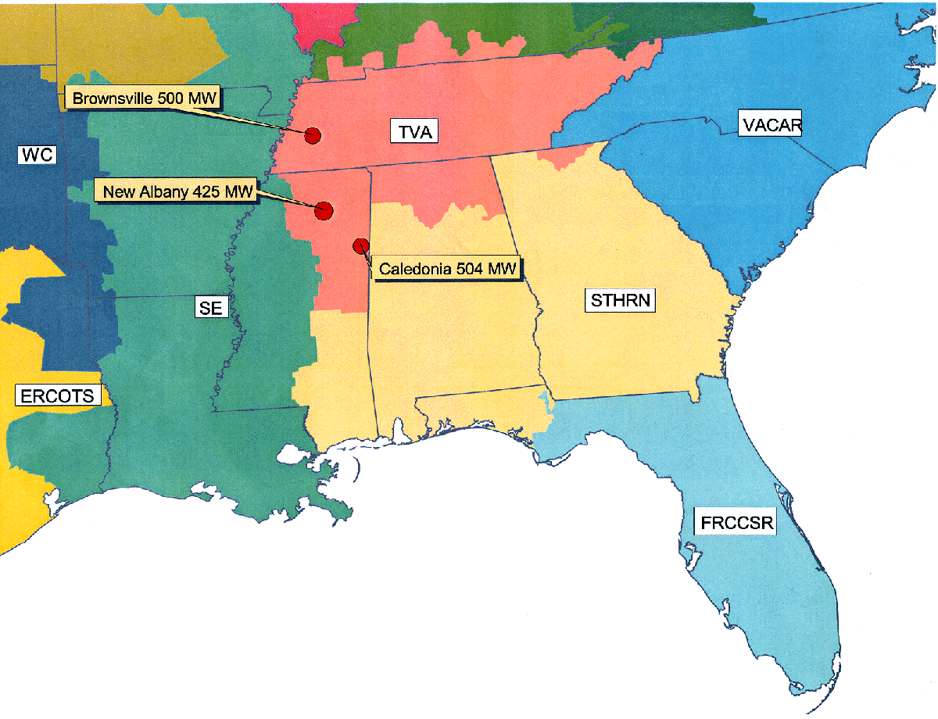
TVA Market Size – 2000
Total Capacity | 30 GW
Peak Load | 27 GW
Capacity Within One Wheel | 350 GW
Import Capability | 11 GW
Export Capability | 9 GW
Net Annual Energy | 161,604 GWh
Average Demand | 18 GW
Net Imports | 2,496 GWh
Source: ICF Base Case Forecasts for 2000.

B. TVA Capacity Mix
- The TVA capacity and generation mix is dominated by coal, which accounted for about 50% of installed capacity and approximately 65% of total generation in 1997.
- Nuclear and hydro (including pumped storage) account for roughly 22% and 21%, respectively, of the total capacity. The remaining capacity in TVA is comprised mainly of combustion turbines which are relied on for peak hours.
- TVA has more hydro than any other major U.S. sub-region in the Eastern Interconnect.
TVA Capacity and Generation Mix – 2000
CAPACITY |  | GENERATION
Total Capacity = 30 GW |  | Total Internal Generation = 159 BkWh
Note: Capacity physically located in TVA region, but counting toward other regions is not included in the capacity mix. Totals may not add due to rounding
Source: ICF Base Case Forecast for the year 2000.

C. TVA Transmission Overview
- TVA is the most centrally located power market area in the U.S. and has the greatest interconnections with other regions in the Eastern Interconnect.

PresTech K:\Adobe\April_tif\Project Finance Emron.tif

- The primary interconnections between TVA and neighboring systems consist of ties to the following utilities:
- ECAR – AEP/Appalachian Power, Big Rivers, Kentucky Utilities, East Kentucky Power Coop, and Louisville Gas & Electric
- VACAR – Duke Power, Carolina Power & Light
- ENTERGY – Arkansas Power & Light, Mississippi Power & Light
- MAIN – Central Illinois Public Service, Illinois Power and Union Electric
- Southern – Alabama Power and Georgia Power
D. TVA Historical Prices
- Electrical energy prices in all of SERC have historically been lower than neighboring regions to the North.
- TVA has relatively large total interconnections associated with its central location. Import and export capability is about two thirds of average demand and some lines may be upgraded, further increasing transmission access.
- Prices jumped between the summers of 1997 and 1998 as the market has come into full balance. In 1999, prices were again high.
- The impact of the capacity situation in MAIN and Southern ECAR is also reflected in the peak prices in TVA.

TVA/ SERC Historical Energy Prices
(1998$/MWh)
 | HISTORICAL
 | 1996 | 1997 | 1998 | 1999
PMW–Into TVA
Average Peak¹ | NA | 27.6 | 55.8 | 51.0
High | NA | 130.7 | 697.7 | 1,012.2
Average Summer² Peak | NA | 36.1 | 145.0 | 139.4
PMW–SERC
Average Peak¹ | 25.0 | 26.3 | 51.2 | 50.6
High | 37.9 | 118.7 | 636.3 | 926.5
Average Summer² Peak | 28.4 | 37.0 | 123.2 | 131.9
Megawatt Daily – TVA
Average Peak¹ | NA | 25.4 | 47.2 | 48.6
High | NA | 232.5 | 1,816.7 | 1,765.4
Average Summer² Peak | NA | 32.3 | 106.7 | 120.2
¹ Includes hours 6 through 22 weekdays.
² Inlcudes June, July and August.
Source: Power Market Week (PMW) weekly price index and Megawatt Daily daily index.
SERC Weekly Indexes – Recent Price Spikes in TVA
Source: Power Market Week

VI. OTHER RELEVANT DEVELOPMENTS
There are several transmission-related developments that can further facilitate market access for the Facilities. These include a move to a more regional ISO structure with a gradual elimination of pancaking of transmission rates and thus, a more integrated marketplace.
A. Midwest ISO and Transmission Charges
- Recently, FERC conditionally approved the Midwest ISO (“MISO”), which includes members from MAIN, ECAR and MAPP. The implementation of the ISO would serve largely to eliminate the pancaking of rates by establishing a zonal pricing system.
- Members of the MISO include: Allegheny Power, Ameren, CILCO, Cinergy, Commonwealth Edison, Hoosier Energy Rural Electric Cooperative, Illinois Power, Louisville Gas & Electric, Wabash Valley Power, SIGECO, Alliant Energy, So. Illinois Power Cooperative, and Wisconsin Electric. A total of twelve transmission owners in the region are members of MISO. Recently, Northern States Power joined MISO expanding the organization into MAPP.
- Recently, members of MAPPCOR, the contractor that operates the Mid-Continental Power Pool (MAPP), agreed to sell its assets to MISO. The agreement will not be complete unless members representing two-thirds of the load in MAPP agree to join MISO.
- The pricing structure agreed to by the participants allows for a six year transition period, during which time the members of MISO are divided into zones existing at the time of filing the agreement. For point-to-point transmission to a customer within the ISO, the rate charged will be the zonal rate where the load is located.
- For point-to-point transmission through the ISO or for point-to-point transmission out of the ISO, the rate charged will be a single system-wide ISO rate.
- After the transition period the zonal pricing structure may be retained or a single, Midwest ISO rate adopted.
- More recently Commonwealth Edison, Mid American Energy, Interstate Power and IES Utilities have proposed forming a for-profit independent transmission company (ITC) within the jurisdiction of MISO. They have filed their plan with FERC in December 1999 and the proposal is pending review. The proposed ITC would have a governing body independent of buyers and sellers and any major rate-funded transmission expansion would need to be approved by MISO.
- Currently negotiations are underway to expand MISO to include SPP. This expansion is targeted to include both the northern and western sections of SPP.

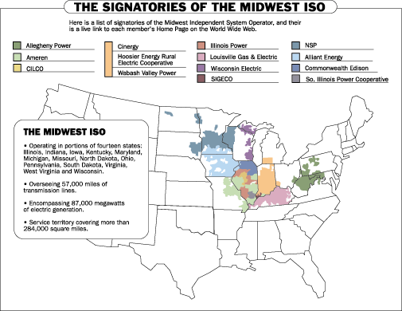
source: www.midwestiso.com
B. Alliance RTO
- A competing ISO-type regional transmission organization (“RTO”) is under development by companies in ECAR and VACAR.
- Discussions with multiple parties have been ongoing since early 1998. The Alliance is currently in Phase III.
- Currently, five companies have agreed to develop a FERC filing:
- AEP
- First Energy
- Consumers Power
- Detroit Edison
- Virginia Power
- The exact form of the RTO (full ISO or Transco) will remain flexible.
- If no one divests by day one of operations, the Alliance would function like a non-profit ISO. If one or more members sells transmission assets into the Alliance, the RTO would automatically become a transmission company.
- Members can sign an operational agreement with the Alliance relinquishing control of transmission assets, or sell or lease assets to the Alliance.
- The proposed pricing structure includes a transition period in which each member’s existing transmission system would comprise a zone.
- Customers could pay one zone rate to access a zone and then would only pay another zone rate to access the entire RTO during the transition.
- Eventually, the Alliance seeks to offer a single, grid-wide rate, perhaps in six years or when all transmission owners join.
- With FERC approval, the Alliance would also develop and propose incentive rates.

- The Alliance RTO is expected to file with FERC within the year.
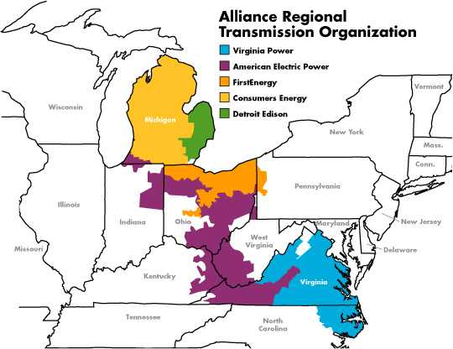
source: www.alliancerto.com

