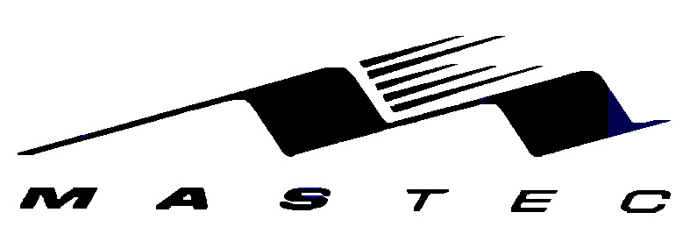

WIRE INSTRUCTIONS

MASTEC INC.

FIRST UNION NATIONAL BANK

ABA: 063-0000-21

FOR CREDIT TO: MASTEC, INC.

ACCT.# : 2153200128734

ATTN: JACKIE BORBOUSE (954) 596-6889
(954) 596-6893
jackie.borbouse@firstunion.com

/mnt/main-storage/datasets/enron-docs/doc/WireTransfer.doc

