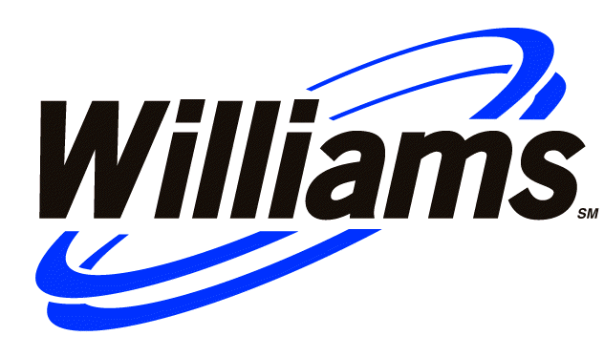
Memorandum
To: Interconnection ANOPR Generator Caucus
From: Jim Bruggeman
John Cohen
CC: Julie Simon, EPSA
Chuck Linderman, Alliance of Energy Suppliers
Date: 9/28/2025
Re: Comments on ERCOT Interconnection Agreement

Williams has reviewed the ERCOT Standard Generation Interconnection Agreement (IA) and identified a number of issues of concern reflected in the comments below. These comments focus narrowly on the language of the ERCOT IA. Though we have addressed some of these issues during the first half of the ANOPR stakeholder process, many of these issues are on the agenda to be discussed next week in Denver. Thus, we wanted to share these comments with the Generator Caucus in advance of the Denver meeting to help flag issues of concern to our caucus.

Additionally, these comments recommend specific language changes in the ERCOT IA that we hope will be helpful in transforming the ERCOT IA into a national standardized agreement.
Comments
The ERCOT IA fails to address the following:
- Maintenance standards, requirements, and obligations – who performs what activities to what equipment with what frequency?
- Future modifications – if a party needs to make a change to a certain piece of equipment where such change requires the other party to make a corresponding modification, what are the obligations to cooperate and who pays for what?
- Outage scheduling is weak to non-existent – what are the transmission outage scheduling protocols? Can a transmission owner use his ability to remove transmission lines from service to disadvantage a competitor in the energy supply market? Can the transmission owner use his responsibility for responding to transmission service calls as a way to disadvantage a competitor in the energy supply market (it happens)?
- The agreement does not address termination rights. The transmission owner should have none without an order from FERC. The generator should be able to terminate with certain notice.
- There is no discussion of liability.
- There is no discussion of indemnification.
- There are no audit rights. The generator should have audit rights to ensure proper billing, etc.
- Dispute resolution is not addressed. Does that mean each party may choose its own.
- Test energy. The utility should accept test energy and reimburse the generator for that energy at the utility’s marginal cost of production. All transmission tariff fees should be set aside.
The agreement must utilize published standards, criteria, etc. that are used to set performance requirements.
The agreement refers to numerous PUCT rules. It is difficult to tell what the document requires if these provisions are not rolled into this agreement.
Section 1.10 could be interpreted to give state commissions jurisdiction over wholesale issues.
Section 2.1 B – Any termination must be subject to FERC approval, even in the event of default. The COD within one year of scheduled is arbitrary. There may be good reasons why a project is delayed by one year particularly if it involves building a more complex generating station.
The agreement does not address the rights to salvage value of equipment.
The agreement uses “Good Utility Practice” as a standard for justifying actions. This is the pornography standard of the utility industry. “I don’t know what it is, but I know it when I see it.” It is used to justify positions that are otherwise questionable.
Section 2.3 needs to be modified to reflect obligation of utility to provide station service.
Section 4.1 – (A) Agreement needs teeth to make transmission owners liable for failure to construct transmission facilities on schedule. (B,ii) There is no legitimate reason to cap damages particularly when transmission owners are not giving generators rights to build transmission reinforcements with third party contractors. Actual losses to generator, inability to sell product at market price, should be completely compensated. The capped payments are not just compensation. (B, iv) TIF facilities may be needed for commissioning. That needs to be incorporated. (B, v) If the transmission owner can not agree on meeting an aggressive date requested, why should the generator be obliged to contract with the transmission owner, an entity that admittedly can’t do the job. Contents and quality of the TIF are ensured by published and reasonable standards that must be met by everyone. As written in (v) it is an excuse to gold plate. With reasonable standards and compliance determined by third party engineers under contract to the ISO, a fair and impartial process can be conducted.
Section 4.3 (A) The party who makes and supports the application can determine the outcome. This is a way a transmission owner can favor his own transmission projects over a generation project by possibly choosing a route for the generator’s transmission that the transmission owner can’t build. (land acquisition, etc.)
Confidential

Section 5.2 uses good utility practice as a standard for construction. Every utility I’ve ever seen has libraries full of equipment and construction standards. These standards need to be published and used for this application. Good utility practice is too ill-defined for this application. TSP needs to have obligation to provide generator with equivalent of “as built” drawings particularly as they pertain to operation of the plant.

Section 5.4 delineates no timing requirement on the notice. Timing needs to be such that generator can evaluate proposal and determine need to make changes on generator’s side of interconnection point. It also does not address issues about whether TSP can require generator to make corresponding changes at generator’s cost.

Section 5.5 (B) Add at the end, “or as reasonably requested by the generator at no cost to the generator.”

Section 5.5 (D) – see ER02-128 (Hazleton Agreement), paragraphs 5.2.2, 5.2.4, 5.2.5, 5.2.6, 5.2.7

Section 5.6 (F) needs to incorporate TSP’s maintenance standards.

Section 5.7 needs to address equipment paid for by generator but purchased and installed by TSP. Generator needs to retain some rights to that equipment even after termination of the interconnection agreement.

Section 6.1 needs to address advance notice obligations, rights to demand re-scheduling, etc.

Section 6.4 – see ER02-128 Paragraphs 6.7 & 6.8.

Section 6.7 – append “and to administer this agreement” at the end.

Section 6.9 should only be required if the technical studies performed as part of the initial interconnection request indicate a need for this equipment.

Section 7.1 – delete first line.

Section 10.1 – need to require neutral choice of law and neutral venue, Williams prefers NY law and NY courts and Southern district of NY federal court.

