3-A-V. Wheatland Plant - Knox County, Indiana

ECAR Region

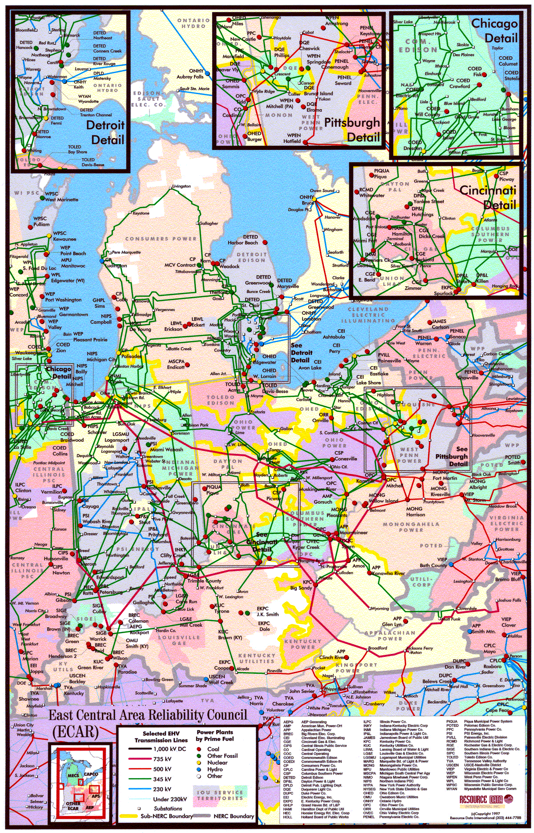

Overview – Wheatland Plant

Description: 508 MW (nominal) natural gas-fired, simple cycle power generation facility (the “Wheatland Plant”) owned by West Fork Land Development Company, L.L.C., an indirect wholly owned subsidiary of Enron North America. The Wheatland Plant consists of four Westinghouse Model 501 D5A gas turbines, each rated at approximately 127 MW (nominal).

Location: The Wheatland Plant is located on an approximate 60-acre tract of land at 480 North Hall Road in Wheatland, Indiana.

Constructor: NEPCO, an indirect wholly owned subsidiary of Enron Corp.

NERC Region: Southern ECAR

Control Area: ENWI and ENWC. The Wheatland Plant has been designated as two control areas in accordance with NERC policy. Additionally, the Wheatland Plant has an interconnect agreement with both Cinergy Services Inc. (“Cinergy”). and Indianapolis Power & Light (“IPL”). Both Cinergy and IPL allow scheduling of energy into and out of each control area, giving the Wheatland Plant the option of generating power or filling the scheduled energy delivery from the market when market economics warrant. This added flexibility ensures that the plant is reserved for operation only during periods of economic dispatch.

Power Purchase Agreement: None

Transmission: The Wheatland Plant is interconnected into two 345 kV lines, one of which is owned by Cinergy and the other is owned by IPL. With the dual interconnect, the plant has the option of dispatching into the Cinergy or IPL systems.

Fuel: The Wheatland Plant is permitted to use natural gas as its fuel source. The plant is interconnected to Midwestern Gas Transmission Company (“Midwestern Gas”), a natural gas pipeline system owned by Tennessee Gas Pipeline Company. Midwestern Gas and West Fork Land Development Company, L.L.C. each own, operate and maintain specified portions of the interconnection facilities as defined in the facilities agreement. Midwestern Gas may terminate the facilities agreement upon sixty days notice to West Fork Land Development Company, L.L.C. if:

- gas has not flowed through the interconnection facilities during the previous twelve months; or
- West Fork Land Development Company, L.L.C. has caused the interconnection facilities to be disconnected or removed.

Midwestern Gas transports and delivers natural gas to the Wheatland Plant pursuant to an interruptible gas transportation agreement. The term of the interruptible gas transportation agreement and associated transportation rate began on April 1, 2000, continues through March 31, 2008 and will continue on a month-to-month basis until terminated upon thirty days notice by either party.

Zoning: To develop the Wheatland Plant, the site was re-zoned as industrial.

Air Permit: The Wheatland Plant received its non-PSD air permit in October 1999.

Baseload Emission Information
NO_{x} Cap (Per Unit): < 25 PPM
CO (Per Unit): < 25 PPM

Commercial Ops: June 2000

Ops Hours: The Wheatland Plant is permitted to operate for approximately 902 hours per year at full load.

Heat Rate: At 90 degrees Fahrenheit and at full operation, the Wheatland Plant is able to achieve a net heat rate of approximately 11,500 Btu/kWh (HHV).

Peaking Capacity: At 90 degrees Fahrenheit and at full operation, the capacity of the plant is approximately 480 MW.

Expansion Potential: The Wheatland Plant has been designed to facilitate a future expansion or conversion to combined-cycle.

Water Usage: Approximately 450 gpm during operation.

Water Supply: Owned lake, adjacent to site.

WHEATLAND
ENWI / ENWC
G3
G2
G1
G4
B
B
B
GSU T1
GSU T2
Bus 2
Summer
Nominal
Winter
Unit MW Rating:
120
127
134
Gas Transporter:
Tennessee
Gas Daily Index:
Tenn., 500 Leg / Chicago LDC's
B = Breaker
GSU = Generator Step-up Unit
B
Bus 1
B
B
B
B
B
B
CINERGY
Gibson
CINERGY
Qualitech
AEP
Breed
DP&L
Petersburg
345 kV
B
B

