AURORA Version 5.5 New Features

Overview
AURORA SOFTWARE MODELING ENHANCEMENTS:
- Energy Storage-Resources
- Market Areas: no limit on number of areas
- Transmission: congestion pricing.
- Price Caps
- Risk Analysis
- Modeling Enhancements via VB Scripting: “Update Data” capability

GENERAL CAPABILITIES
- AURORA’s run time speed improved again.
- File transfers to EPIS
- Interface Enhancements

REPORTING ENHANCEMENTS
- Marginal Resource reporting
- Resource operations reporting
- Resource stacks detail consolidated

AURORA DATABASES
- East-Central AURORA Database -- 25 market areas modeled with 11 market areas in New York ISO.
- WSCC AURORA Database -- updated IPP resources
- ERCOT AURORA Database – updated resources
- All databases updated to use the new modeling capabilities

AURORA Software: Modeling Enhancements

Energy Storage-Resources
Energy Storage Resources – AURORA models energy storage resources, which can include pumped hydro project, batteries, superconductors, and other storage technologies. A resource is treated as a storage project if it references a fuel type that begins with “Storage.” To define the storage project characteristics, the model uses the standard resource input variables, as well as additional inputs for recharge capacity, storage limits, and project initial contents. The charging/generation cycle efficiency is defined through the resource heat rate.

At the beginning of each week during the run, AURORA determines a charging and generation schedule for each storage project for the coming week. The inputs mentioned above are used, as well as a dynamically updated hourly area price forecast for the week. Within each day across the week, the model identifies the combination of hours in which it is cost-effective to store and to generate without violation of the project storage constraints. It assures that revenue during the generation hours exceeds the cost of charging energy adjusted for cycle efficiency, plus any variable O&M costs incurred. Once the hourly schedule for the week has been determined, it is locked in and used to modify area load for the hours actually being dispatched as the simulation proceeds through the week. In any individual dispatch hour, the actual hourly cost of recharge energy or the revenue from hourly generation is based on the area price determined by the full dispatch for that hour. See Help for input specifications for storage projects.

Areas and Transmission
In determining the clearing price of the marginal resources, resources in the respective market areas are dispatched to meet regional loads subject to transmission constraints including transmission wheeling and losses to the area. With this latest release unlimited number of “Areas” may be modeled, and the transmission loading for each direction are defined as positive values.

Another new capability is the modeling of transmission congestion pricing. With this feature selected, transmission-wheeling costs will vary with transmission loading. NOTE: Results for this version may be slightly different from prior versions due to dispatch enhancements made to accommodate the congestion pricing.

Therefore, in addition to modeling incremental wheeling costs, losses and transmission link capacity limitations, AURORA can be used to forecast congestion pricing. This is a user controlled option. To select transmission congestion pricing go to the “Run Set-Up” tab, and then the “Logic” tab and select “Use Congestion Pricing.” This “Use Congestion Pricing” box controls whether AURORA will use congestion pricing on the effective link wheeling rates. Also, you may add the column "Link Congestion Year" to the Link table and set the first year you want each link to use congestion pricing (by default, pricing will be used for the link). When congestion pricing is used, link wheeling rates are determined by the following formula:

Congestion Wheeling Rate = Input Wheeling Rate times
Fraction Link Loaded ^ Exponent times 1000

By default, the Exponent is set to 70. The user can change this with the “Congestion Exponent“ box on the Logic Tab. The effect is to multiply the Input Wheeling Rates by the values from the chart below with the x-axis representing the congestion or the fraction the link is loaded. Note: a value of one occurs at about .905 with an exponent of 70.
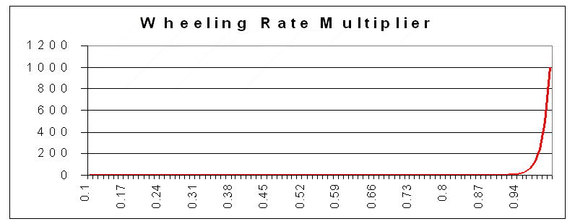

Price Caps
Provides for the input of area price caps. To use this capability, add an optional column entitled “Price Cap” to the Areas input table. If this column exists in the Areas input table, then the non-zero values will set a price cap for the area. The price cap will be artificial and will not effect resource dispatch. However, it may affect connected hub prices. Once the price cap values are in the database, implement the price caps capability by checking the Use Price Caps checkbox on the “Logic Tab” under “Run Set-Up.”

Risk Analysis
Risk Analysis – As a user you may now input the seed and iteration number on risk analysis Monte Carlo runs. This enables the user to restart a Monte Carlo Study with a seed from the last iteration ran. This is possible because the seed is displayed for each iteration in the risk results output. AURORA uses a new random number generator.

Modeling Enhancements via VB Scripting
“Update Data” capability in VB Scripting. This powerful capability provides a new way of managing database changes. AURORA has had the capability to use “Input Data” VB scripting statements in AURORA to temporarily change selected data for a particular study without changing a database. By using “Update Data” VB scripting statements, you can universally change any AURORA data element. Scripting Updates to the database now check to see if values in the database have changed since the scripting Update Data statement was generated. This capability gives the user greater control over the inputs and outputs through enhancements to VB Scripting in AURORA.

This can be used for several purposes:

- Keeping track of updates. You take any AURORA database, and use this capability to create a temporary database for a run or study. In effect this is a way of keeping a complete log of all changes from a base case database.

- Applying consistent set of changes to multiple copies of a database. This is a way a database administrator may manage a central repository of data. For example, the administrator may create a script that could be sent out to users for a coordinated update of the Company’s databases.

This capability can be used to make temporary or permanent updates to a database. The script provides you with a sequential record of all changes. Part of the power of this capability is that you can use the script to take a default or base case database, create a temporary database, or apply your proprietary changes using this Update Data capability to create a new AURORA database. In conjunction with this capability, the ability to add and delete rows of any table using VB Scripting, increases the range of changes that you are make to the database in an automated process.

VB Scripting Commands. Remember to get hourly output via VB Scripting you must use the AC.HourlyOuput command before every scripting AURORA run that needs hourly scripting output.

General Capabilities
AURORA’s run time speed has been improved again. AURORA is the fastest simulation model of its kind. Also, Resource table reads from the database are now three times faster.

You are able to send a “project file” along with a database to EPIS via the file transfer to EPIS feature. To send a database and project file, go to the File drop down menu and select “Transfer” and than select “Data Base/Project File-TO-EPIS” The current database and project file in AURORA will be the file that will be transferred. If there are blanks in the name of the database or project file name that you are attempting to send via this feature, you will get the following message: WARNING Cannot send a project with blanks in the name.

Interface Enhancements:
Enhanced double click through to referencing tables in the data editor.

When modeling features are no longer used, the features are removed from the model software. These include:
- The option to select the old dispatch logic has been removed, and only “NT dispatch” is available in AURORA
- Environmental types are no longer used even if in the database. Environmental types were superceded by the improved Emissions capability.
- The new Unit Commitment logic is used for all AURORA runs.

An AURORA presentation that provides an overview of AURORA is now available from within the Help system.

From within the AURORA Help there is a link to “Circuit Breakers” on www.epis.com. “Circuit Breakers” are perishable news links that affect the power industry that EPIS is making available on breaking news.

REPORTING ENHANCEMENTS
Marginal Resource reporting continues to improve with the addition of reporting of marginal resources at trading hubs in the hourly marginal resource output. You may see this information by selecting “Hourly Marginal Resource” on the Results Tab before you run AURORA.

You are now able to specify the resources by name to include in the resource operations report to be written to the database. (Previously all resources were written which may have written extremely large databases or even exceeded the 1 GB maximum database size on long term runs). You may get this output by selecting “Write Resource Operations” on the Results Tab before writing to the database. At the time you select this output, a dialogue box will open to allow you to identify the resources by name. If desired you may still get the output on all resources by selecting all resources in the dialogue box. An alternate way to choose resources to be included in the resource operation report and the detailed resource report is to select the resources in a new “optional” column labeled "Reporting" in the resources input table.

Resource output now includes a column "Total Output" which displays output in MWh in addition to the average MW "Output" column.

The number of output tables for resource stacks have been consolidated to one table. You are able to use filters to select resource stacks by areas of interest. You may get this output by selecting “Write Resource Stacks” on the Results Tab before writing to the database.

The default title font used in the grid display headers now appears in a normal font to improve readability of output titles.

Marginal reporting for Fuels, Resources and Groups
Fuel Output. A fuel output table is available as a standard output at the end of each AURORA run. It has monthly and annual fuel cost, fuel usage and percent marginal for each area. Specifically, for each month of the year and annual, the FUEL report displays fuel cost in $/mmBTU, fuel usage in mmBTU and the percent of time in the period the fuel was being used by marginal generation for each area. See Figure 3 for an example.

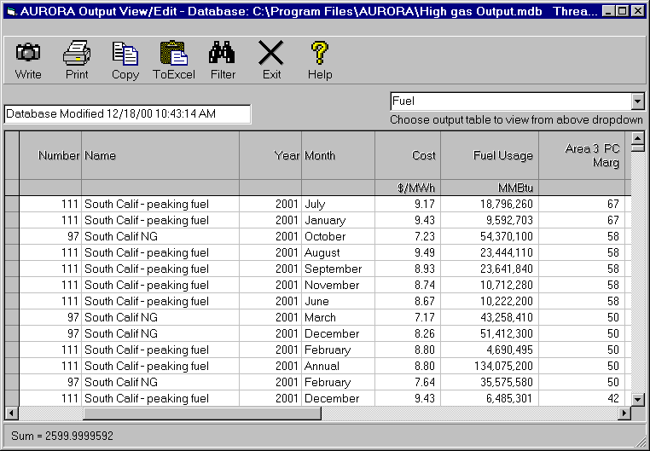
Figure 3: Standard Output of Marginal Fuel Information

Access 2000 (Reminder)
AURORA now allows input and output databases to be in Access 2000 format. EPIS and users may continue to use Access 97 format databases because both are still supported. If you are using the standard database output (not to Excel), you can define whether you want the output to be in Access 97 or Access 2000 format. Check the checkbox on the RESULTS tab to put the output in Access 2000 format.

If you are updating from a version that did not support Access 2000, remember the MS link support has changed. The references to Tables from Excel that are linked into your AURORA databases (with version 5.1.24 or earlier) will need to be deleted and re-linked. Go to the “DB Tools” button to delete and re-link MS Excel sheets.

AURORA Databases -- Modifications

East-Central AURORA Database

The following changes are reflected in the tables of the default AURORA database for East- Central:

There are now 25 market areas modeled in this database. There are 11 market areas in New York ISO (NYiso) which is up from 2 Areas in the prior database.

The 25 areas include:
ECAR, MAIN, MAPP,
MAAC-PJM-East, MAAC-PJM-West
NPCC-QC-Maritimes, NPCC-Ontario, NPCC-ISO-NE
NYISO-West, NYISO-Genesee, NYISO-Central
NYISO-North, NYISO-Mohawk Valley, NYISO-Capital
NYISO-Hudson Valley, NYISO-Millwood, NYISO-Dunwoodie
NYISO-NYC, NYISO-Long Island
SERC-South, SERC-VACAR, SERC-TVA, SERC-Entergy
FRCC, SPP

Data was implemented for Storage fuel in the Fuel Moderate table. Storage for pumped hydro is fuel #10 with a fuel type of “Storage.” Also, the Resources table data was implemented in the following data elements: Heat Rate to model efficiency, Recharge Capacity (MW), Maximum Storage (MWh), and Initial Contents (fraction)

The Resources table was updated and the resource numbers have changed. If reference resources in Portfolio Analysis, you will need to update your Portfolio Resources tables used with previous versions. Resource changes include generation listed on Hydro Quebec Annual Report for NPCC-Quebec, AURORA Area 7. This generation includes Churchill Falls, a 5428.5 MW which is an “out-of-area” hydroelectric plant located Labrador in the province of Newfoundland/Labrador.

Consistent with practice in Eastern U.S. power markets the On-Peak hour definition is 5x16 hours, Monday-Friday.

Fuel Moderate table: implemented seasonal shape for coal and nuclear default maintenance.

WSCC AURORA Database

The following changes are reflected in the tables of the default AURORA database for the WSCC:

The Resources table was updated to reflect California Energy Commission power plant database information for small IPP resources. Also, new remark columns were added to the Resources table to capture the CEC plant name, other alias names and other CEC database information.
Data was implemented for Storage fuel in the Fuel Moderate table. Storage for pumped hydro is fuel #10 with a fuel type of “Storage.” Also, the Resources table data was implemented in the following data elements: Heat Rate to model efficiency, Recharge Capacity (MW), Maximum Storage (MWh), and Initial Contents (fraction)

ERCOT AURORA Database

The following changes are reflected in the tables of the default AURORA database for ERCOT:

The Guadalupe Power Plant and Odessa Power Plant were added to Resources table.
The heat rate for North Lake 1 GT updated.

Updates In all databases:
General Information table and New Resources table was updated for cost-of-capital.

For use as a template an updated Daily Blank table was added to the default databases. This new Daily Blank table includes an optional Change Type column.

Consistent with current transmission logic the Link table transfer capacities are now positive values.

