AURORA Version 5.2 New Features

Overview
- Reporting Enhancements:
- Marginal reporting for fuels, resources and groups of resources.
- Resource stack information.
- Modeling Enhancements:
- Dual fuel modeling,
- Improved transmission modeling,
- Modeling of monthly emission rates.
- Interface Enhancements:
- Enhances user control over modeling, editing inputs, and viewing of AURORA output with greater access to hourly results.
- Greater control over the inputs and outputs through enhancements to VB Scripting in AURORA. For example, the new “update data” capability provides a means to universally change any data element.
- Database Updates:
- The databases for Central and Eastern, Texas, and Western markets have been updated to use the new modeling capabilities.

AURORA Software

REPORTING ENHANCEMENTS

Resource Stacks (Supply Stacks)
Resource stack information (Monthly and Annual) is viewable in a graphics display and available as a list of resources with the dispatch costs and order.

Graphical Display. To view the graphical display of AURORA Resource Stacks select the GRAPHICS button on the AURORA main screen. The Resource Stack information may now be viewed like price and transmission usage output. You can choose Hub or Area prices, Transmission usage or Resource Stacks. See AURORA Graphics screen below. See Figure 1 for an example of a Resource Stack for Southern California for July 2002 based on Capacity (MW).

- Resource Stacks are available in terms of Capacity (MW) or Capability (De-rated Capacity in MW).
- You may choose one or multiple areas to display (by holding the “Ctrl” key down while clicking).
- By right clicking on the graphical output, you can choose the copy command and copy the graph and its data to the clipboard for pasting into other applications.
- The toolbar gives buttons for printing or copying the data in the graph or for exiting the graphics display.

Figure 1: Graphical Display of Resource Stacks

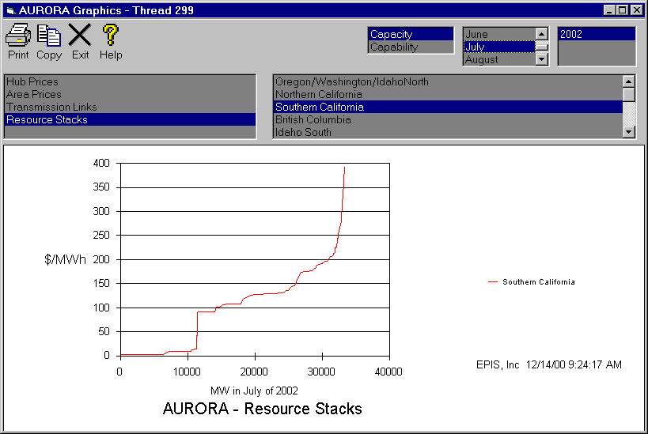
Resource Stack Information Standard Output. In addition to the graphical display, you can get the lists of resources in the area resource stacks with dispatch costs and dispatch order. Before writing the data to an output database, select standard output by checking the “Write Resource Stacks” box on the RESULTS tab. Check this box before you press the output button or pre-check this box if you are using Auto Database Write. See Figure 2 below for an example of Resource Stack output.

- When Resource Stack output is selected, AURORA provides the output tables for all the areas and months in the study. Due to the number of tables this will add to the output, you may want to only select this output option when you need the Resource Stack output. These tables are viewable as output, and are not viewable using the VIEW mode.
- By left clicking in the upright corner of an output table, you can choose the copy command and copy the data to the clipboard for pasting into other applications, or you can just push the “ToExcel” button and the data will be exported to an MS Excel Workbook.
- The toolbar has buttons for printing or filtering of data in the table display.

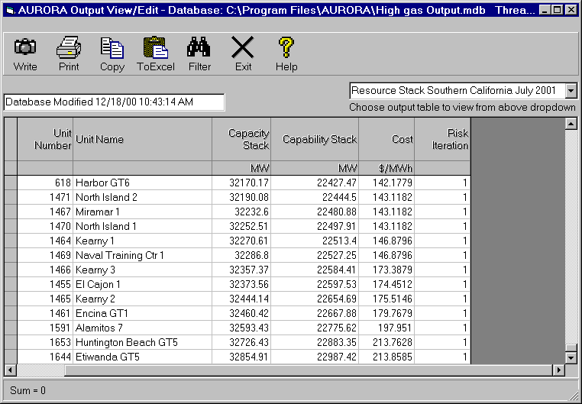
Figure 2: Standard Output of Resource Stack Information.

Marginal reporting for Fuels, Resources and Groups
Fuel Output. A fuel output table is now available as a standard output at the end of each AURORA run. It has monthly and annual fuel cost, fuel usage and percent marginal for each area. Specifically, for each month of the year and annual, the FUEL report displays fuel cost in $/mmBTU, fuel usage in mmBTU and the percent of time in the period the fuel was being used by marginal generation for each area. See Figure 3 for an example.

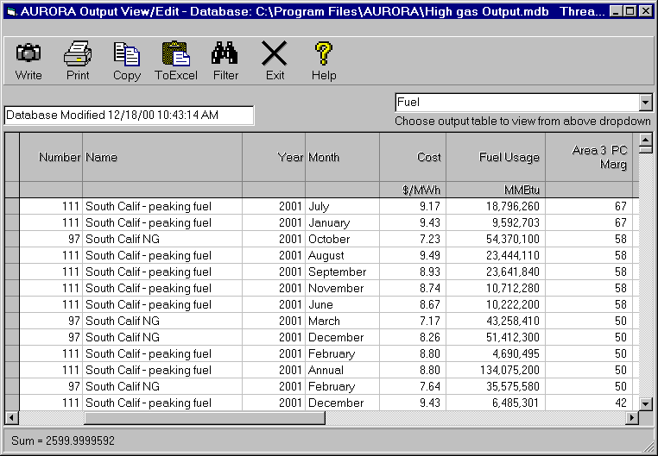
Figure 3: Standard Output of Marginal Fuel Information

Resources and Group Output
To speed review of results, consider using resource group reporting. You can define sets of resources for which you want consolidated results. In AURORA, resource groups can be defined as a combination of resources either by tagging individual resources or fuel types. Results can then be viewed for resource groups.

A powerful use of groups is to capture the percent of time resources in your defined groups are the marginal resources. This information is now displayed with the period output. Also, there are no limits on the number of resource groups you can define. The group numbers are shown in resource output and this capability works with multiple runs.

To use this capability, edit the “Resource Groups” table in the AURORA database. This table contains information on resource groups. Resource groups may be used to group output of resources for a variety of purposes. For instance, you may want a group of resources to be defined by fuel type. In this table, each group is defined with a name. A sample of the table is shown below:
Number | Name
1 | Peaking Gas
2 | Regular Gas
3 | Coal
Once you determine how you want to group the resources output, you define a specific group by designation of the group number in the “Resources” table or the “Fuel” table in a column called “Resource Group.”

Fuels
Dual Fuel Resources. You may identify resource units that use a secondary fuel. When a secondary fuel is in the resource table, AURORA automatically performs fuel switching based on the monthly price. In the resource table, the variable, “Second Fuel” specifies a secondary resource fuel type to use for the current resource. If this variable has a value greater than zero, then AURORA will check (on a monthly basis) and use the lower fuel price of the two fuels. If the secondary fuel type is being used then a flag will be displayed in the period resource tables under the VIEW button or the detailed resource report under the OUTPUT button.

Transmission
In determining the clearing price of the marginal resources, resources in the respective market areas are dispatched to meet regional loads subject to transmission constraints including transmission wheeling and losses to the area. The NT dispatch logic was refined to include the elimination of loop flows and improved loss calculations for transmission. Also, the number of areas allowed has been increased to 50, and transmission loadings are now shown separately for each direction

Hourly
AURORA now allows direct access to hourly results via VB scripting and from other applications. Due to the large volumes of data and to address memory limitations on longer runs where VB Scripting was used, AURORA was enhanced. This enhancement also significantly enhanced the speed at which hourly output is written to databases. However, to get hourly output via VB Scripting for Versions 5.1.33 and later, you must use the AC.HourlyOuput command before every scripting AURORA run that needs hourly output.

The date and hour are now written to the database for hourly output.

Also, hourly area resource capacity (along with capability) is now available for direct access from VB Scripting.

Hourly marginal resource output. You can save the status of the hourly marginal resource by selecting the “Hourly Marginal Resource” check box on Results tab in a project file. By checking this box you get a report that displays hourly marginal resources and number by area. Specifically, the following is displayed: the hour in the month, the hour in the week, the hour in the day, the year in the run, the month, the week of the month and by area the Marginal Resource Name and Marginal Resource Number

Monthly Output
To allow quick sorting by month, a numeric month column now appears with monthly output that is written to the database.

Enhanced control of editing and viewing output
The following are enhanced controls to help you view and edit data in AURORA databases.
- Enhanced the filtering capabilities for the edit, output and view grids by adding the ability to filter on values which are not equal to what is input.
- Added “filter” to the right click button in the "View", "Output" and "Edit" screens.
- Added the ability to view “Unit Capacity as it changes monthly.
- Added a change column type to the database right click functions.
- Added output of net load (area load net of imports and exports)
- Separates resource output to supply and demand side in the period area or area price output tables (view or output buttons).

Modeling Enhancements via VB Scripting
“Update Data” capability in VB Scripting. This powerful capability provides a new way of managing database changes. AURORA has had the capability to use “Input Data” VB scripting statements in AURORA to temporarily change selected data for a particular study without changing a database. Now with the addition of “Update Data” VB scripting statements, you can universally change any AURORA data element. This can be used for several purposes:

- Keeping track of updates. You take any AURORA database, and use this capability to create a temporary database for a run or study. In effect this is a way of keeping a complete log of all changes from a base case database.

- Applying consistent set of changes to multiple copies of a database. This is a way a database administrator may manage a central repository of data. For example, the administrator may create a script that could be sent out to users for a coordinated update of the Company’s databases.

This capability can be used to make temporary or permanent updates to a database. The script provides you with a sequential record of all changes. Part of the power of this capability is that you can use the script to take a default or base case database, create a temporary database, or apply your proprietary changes using this Update Data capability to create a new AURORA database. Therefore, in the future when a new default database is released, you can review your proprietary changes in light of the default database, and than update the default database using your VB scripting file. In conjunction with this capability, the ability to add and delete rows of any table using VB Scripting, increases the range of changes that you are make to the database in an automated process.

New VB Scripting Commands. Besides the standard visual basic scripting statements and functions that are available, many AURORA functions can be performed through scripting by using the special AURORA statements.

You now have available a number of new VB Scripting Commands. You can insert a command via the AURORA scripting menu or you can manual type it. Please see the AURORA Help for a complete list of AURORA commands.

The following is a partial list of the new things you can do with VB Scripting:
- Get direct access to certain data: hourly area resource capacity (along with capability), get dispatch hours, set fuel cost and fuel usage (along with Area Price), the run pause at a date, hourly results, etc.
- Remember to get hourly output via VB Scripting (for Versions 5.1.33 and later) you must use the AC.HourlyOuput command before every scripting AURORA run that needs hourly output.
This release also adds error checking for open clipboard in scripting.
Plus, an improved version of Microsoft VB Scripting documentation is accessible from within AURORA.

Access 2000
The AURORA input and output databases have been upgraded to Access 2000 but AURORA is still backward compatible with Access 1997. Therefore, AURORA now allows input and output databases to be in Access 2000 format. You may continue to use Access 97 format databases because they are still supported. If you are using the standard database output (not to Excel), you can define whether you want the output to be in Access 97 or Access 2000 format. Check the checkbox on the RESULTS tab to put the output in Access 2000 format.

USE CAUTION when updating to this new version. The link support in Access 2000 has changed. The references to Tables from Excel that are linked into your AURORA databases (with version 5.1.24 or earlier) will need to be deleted and re-linked. Go to the “DB Tools” button to delete and re-link MS Excel sheets.

EMISSIONS MODELING
AURORA models the affect of emissions on power markets. Various emission types may be modeled, such as air emissions: SO2, NOX, and CO2. AURORA will forecast the market price changes that occur in the power markets due to changes in emission assumptions. Also, AURORA will forecast future new resource mix at different emissions levels. AURORA’s environmental modeling capability provides for:
- Unlimited number of emission types.
- Ability to identify a resource emission rate by emission type
- Ability to input annual or monthly emission rate data.
- Ability to specify emission price and limit for each emission type.

The costs and limits can be expressed in terms of annual or monthly values.

You specify whether emission results are used in resource value computations by checking under “Use Emissions”, the “in value computation” box on the Assumptions tab. Results for emissions are emission amounts and costs that are shown for the period for each emission type. These results are available in output tables or sheets: Hour Resource, Annual Resource Output, Period Resources and Resource Group. Results for emission cost by resources are shown as “cost ($000) of emissions” for all types for each plant. These results are available in the output known as the “Resource Operations Report.”

AURORA Databases -- Modifications

General Comment on Databases
The new databases distributed with V5.2 are for use with AURORA V5.0.1 or later. The new databases are not backward compatible with versions of the AURORA model prior to V5.0. However, in almost all cases the previous versions of the databases will still run on AURORA V5.2.

East_Central AURORA Database Changes

The following changes are reflected in the tables of the default AURORA database for East_ Central:

- "Fuel Moderate" table:
  - Changed real fuel escalations to reflect EIA gas forecast.
  - To model higher gas prices, increased cost of curtailment resources.
  - Revised data for "Non-Cycling" (percent) for unit commitment logic. Uranium (nuclear) = 1, lowest price-tier for natural gas = 5.
  - "Min Up Time" and "Min Down Time" were revised: Uranium (nuclear) 96 Min Up Time, 24 Min down Time; Coal 48 Min Up Time, 18 Min Down Time; Natural gas 24 Min Up Time, 12 Min Down Time
- "Resources" table:
  - Modified fuel mappings for coal plants.
  - Revised resources and their fuel types based on NY ISO resource information.
  - Separated maintenance rate out of the forced outage rates for resources.
  - Increased the capacity associated with curtailment resources.
- "New Resources" table: added a column for "Maintenance Rate"
- Removed the "Environmental Types" column from all databases. This data element is no longer used because the AURORA emissions logic.
- "General Information" table: removed "Trans Length Factor" column. The Transmission Length factor is no longer used.

ERCOT Database Changes

The following changes are reflected in the tables of the default AURORA database for ERCOT:

- "Fuel Moderate" table:
  - Changed real fuel escalations to reflect EIA gas forecast.
  - To model higher gas prices, increased cost of curtailment resources.
  - The higher range-tiers for natural gas pricing were redefined
  - Revised data for "Non-Cycling" (percent) for unit commitment logic. Uranium (nuclear) = 1, lowest price-tier for natural gas = 5; ERCOT Coal (lowest level) = 1
  - "Min Up Time" and "Min Down Time" were revised: Uranium (nuclear) 96 Min Up Time, 24 Min down Time; Coal 48 Min Up Time, 18 Min Down Time; Natural gas 24 Min Up Time, 12 Min Down Time
- "Resources" table:
  - Natural gas fuel selections were re-assigned. The large natural gas units below 11,000 heat-rate were assigned the low-price tier (fuel 113).
  - Separated maintenance rate out of the forced outage rates for resources.
  - Increased the capacity associated with curtailment resources.
- "New Resources" table: added column for "Maintenance Rate"
- Removed "Environmental Types" column from all databases. No longer used because there is new emissions logic.
- "General Information" table: removed "Trans Length Factor" column. The Transmission Length factor is no longer used.

WSCC AURORA Database Changes

The following changes are reflected in the tables of the default AURORA database for the WSCC:

- "Fuel Moderate" table:
  - Updated fuel forecast to reflect higher gas prices at Henry Hub and in California.
  - Changed real fuel escalations to reflect EIA gas forecast.
  - To model higher gas prices, increased cost of curtailment resources.
  - Revised data for "Non-Cycling" (percent) for unit commitment logic: Uranium (nuclear) = 1; lowest price-tier for natural gas = 5.
  - "Min Up Time" and "Min Down Time" were revised: Uranium (nuclear) 96 Min Up Time, 24 Min down Time; Coal 48 Min Up Time, 18 Min Down Time; Natural gas 24 Min Up Time, 12 Min Down Time.
- "Resources" table:
  - Included sample data for "Bidding Factor" and "Bidding Shape" to reflect recent experience with daily forecasting. The sample bidding data was added to the "Annual Alpha Vectors" and "Monthly Shape Factors" tables. Each user must tune bidding factors based on their judgment.
  - Revised California resources to have North California resources use North California fuel and South California resources use South California fuel.
  - Adjusted fuel selection to adopt pricing tiers for nominal natural gas price, peaking and high peaking fuels for Area 5, Idaho South. This change affected Simplot Cogeneration unit only.
  - Separated maintenance rate out of the forced outage rates for resources.
  - Increased the capacity associated with curtailment resources.
- "New Resources" table: added column for "Maintenance Rate"
- “Annual Vectors: table: modified annual and yearly maximum for new resources for use in capacity expansion modeling.
- Removed "Environmental Types" column from all databases. No longer used because there is new emissions logic.
- "General Information" table: removed "Trans Length Factor" column. The Transmission Length factor is no longer used.
- Transmission "Link" table:
  - To reflect new Merchant Eldorado transmission line (referred to as "Merchant (E-W)" and "Merchant (W-E)" on the CAISO web site), added 645 MW in each direction between Area 3 (Southern California) to Area 10 (Arizona/Nevada South).

Data Documentation
More information on the data documentation is available in the AURORA On-line Help.

