West Palm Beach Voters

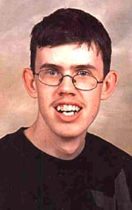
Hi there...this is me. Mom said I got all the good looks and no brains. I love being a babe hound. Girls make spit roll down my chin. I have a stomach problem and fart a lot. I voted for Gore/Buchanan!!

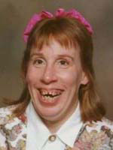
This is my mom. She has lots of boyfriends. One of them has a job. She says with a little luck I could be a garbage man one day. She voted for Gore/Buchanan.


This is my brother Hank. He is in jail right now. When he gets out he is not allowed to be around animals and kitchen appliances. Had he not been in jail he would have voted for Gore/Buchanan.


My grandma lives with us in our trailer. She smells real bad. She likes to hang out in bars and drink beer. Grandma has sores all over and they leak yellow stuff on the furniture. The flies are terrible. She got a ride to the polls and voted for Gore/Buchanan.

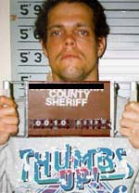
My mom says she is almost positive this is my dad. He lives in a Federal Penitentiary in Montana. When he gets out in 55 years we are going fishing. He voted for Gore/Buchanan in Montana.

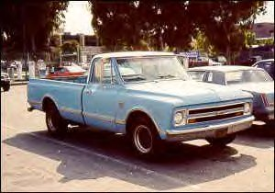
This is the shuttle van that takes voters to go vote for Gore/Buchanan.

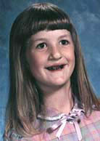
My younger sister Jill lost all her teeth. She was licking an eggbeater after mom made a cake and my cousin Jimmy turned it on by accident. She says Gore and Buchanan are cute.

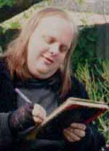
We are proud of my older brother Barney. He is only 27 and all ready in the 4th grade. He wants to be a Doctor and can write his own name. He voted all by himself for Gore/Buchanan.

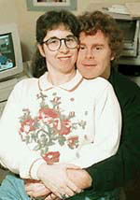
My half brother Jim Bob and his wife. She is a hottie. They raise Possum in their back yard. They are not allowed to have children. But they are allowed and did vote for Gore/Buchanan.


This is my older sister Sue Ellen. She has 15 kids and they all look different. We depend on her welfare check to get by. She has a disease that makes her itch. She and all 15 of her kids voted for Gore/Buchanan.

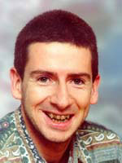
Jethro is my 1st cousin. He runs a tomato stand down by the highway. He once went 53 days without taking a bath. He bathed before he voted for Gore/Buchanan.


This is Buck. He is my second cousin. He is pretty smart. Buck is going to be a dentist some day. He does all the work on our teeth. He’s going to be a dentist and he voted for Bush/Cheney.


This is my sister’s boyfriend for now. His name is Larry. He fixes lawn mowers in the city. My sister says he has a hairy butt. He punched his ballot twice for president and it was voided.

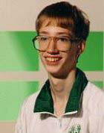
This is Michael. He used to be my best friend but got killed by a bus on the interstate. I still wear his underwear. Someone used his name and ID and voted for Gore/Buchanan.

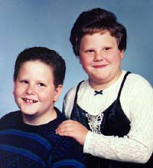
These are 2 kids we throw stuff at. There used to be 3 of them. Mom says we can't throw heavy stuff any more. They would have voted for Gore/Buchanan if they were old enough.

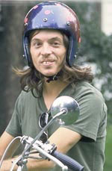
Jake holds the park record. He once jumped over 7 trailers. Jake crashed a lot and talks real slow now. His doctor told him to wear a helmet. He wore his helmet when he voted for Gore/Buchanan.

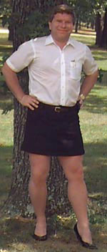
My uncle Marky is still having problems. He doesn't know what he wants in life anymore. He is a Vietnam War hero and now sells perfume at a department store. He thinks he’s prettier than Tipper but still voted for Gore/ Buchanan.

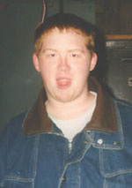
This is my stepbrother Phil. He had a hunting accident years ago. The bullet is lodged just over his right ear. It's hard to understand him sometimes and he always stinks like rotten cheese. He got to vote first for Gore/Buchanan because he stunk so badly in line.
THE END

