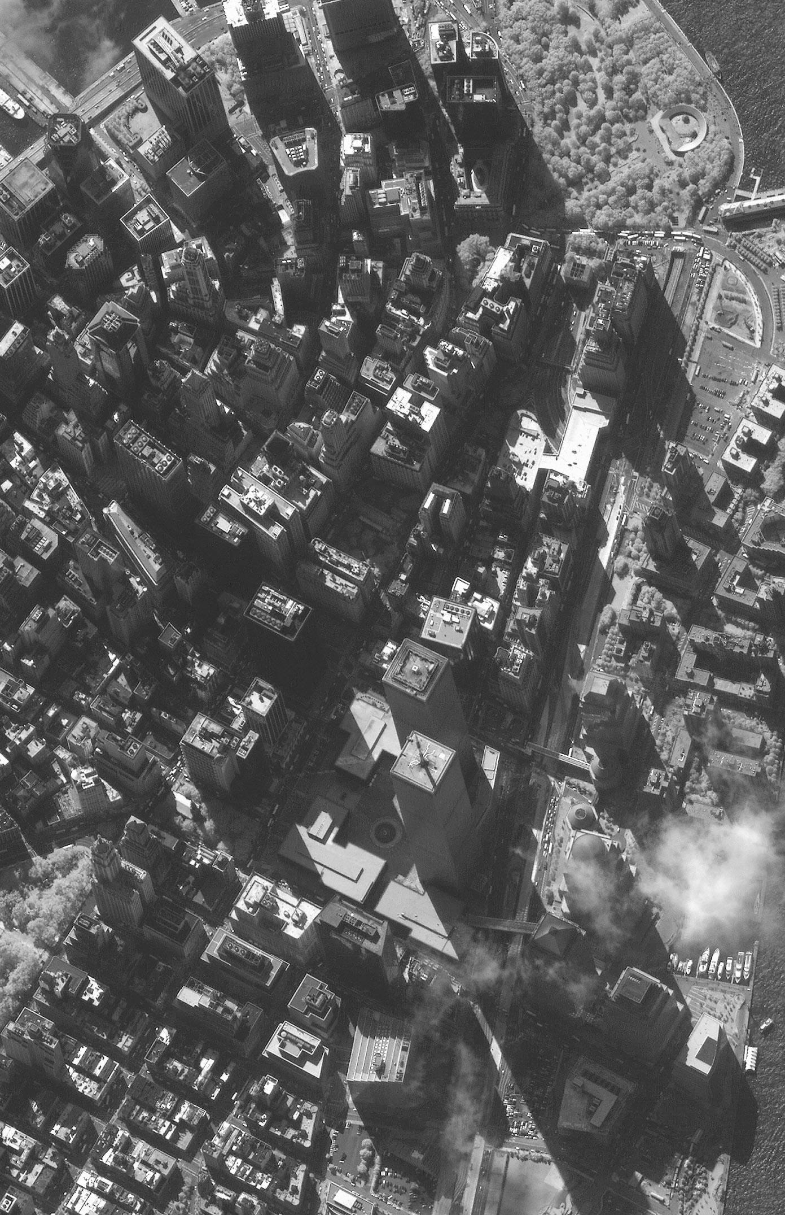
Millenium [sic]
Hotel
WTC1
“North Tower”
WTC2
“South Tower”
WTC3
Marriott Hotel
Most roof-top television news cameras have been trained on West Street at this now-collapsed two-story “sky bridge.”
WTC4
WTC5
WTC6
WTC7
Writing on the morning of Friday 14 September 2001, with the possible exception of 130 Liberty Street, none of the buildings identified by a red, dash-bordered callout box remains standing.
My office was on the
9th floor on this northern face of 130 Liberty Street
One Liberty Plaza

Holocaust Museum
Copyright © 2001 Jeffrey Polsky

