Tuesday, December 26, 2000
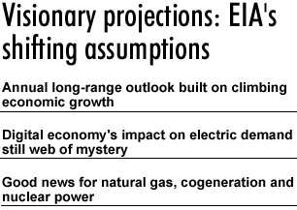
By Dave Todd
dtodd@ftenergy.com
What a difference a year makes. Just ask the U.S. Department of Energy's Energy Information Administration (EIA), which on Dec. 21 presented its customary Yuletide offering: Annual Energy Outlook 2001. The report details the agency's latest rolling guess as to how America's energy requirements and capabilities — as well as the very structure of the energy industry — could evolve over the next 20 years.
Surprised by strong growth
The year 2001 look ahead from DOE's forecasting unit (EIA enjoys an element of statutory independence with respect to its analyses even in relation to its own department) is striking in several respects. Chief among them, perhaps, is that the report reflects its authors' evident surprise at just how much some previous assumptions about the coming two decades have had to be altered, or set aside, due to substantial upward projections for long-term U.S. economic growth.
An early glimpse of this retooling was offered in EIA's preview of the report in late November. The advance screening revealed an anticipated annual average growth rate for the period 1999-2020 of 3 percent, up from the 2.1 percent postulated in last year's outlook. But the extent to which the agency sees the landscape shifting because of this and other key numbers is striking. For example, anticipated annual growth in electricity demand is expected to grow on average by 1.8 percent for the period, up from last year's 1.3 percent estimate.
"We just really feel that given the way things have been going for a number of years, a growth rate in the low two's is pretty low," said Susan Holte, director of the demand and integration division within EIA's Integrated Analysis and Forecasting Office. In part, its sunnier new projection can be attributed to recent definitional changes in the way the country's gross domestic product is measured through National Income and Product Accounts calculations critical to those making macroeconomic forecasts. In that regard, the most notable change is that business and government expenditures for computer software are now factored into the equation as investments rather than intermediate purchases, which precluded them from being counted in final GDP statistics.
"But part of it (upward changes in energy demand), frankly, is just a more optimistic scenario for long-run economic growth," Holte told Energy Insight Today.
So how is this likely to manifest itself? Part of the answer lies in new insights into energy consumption patterns arising out of changing trends in how middle-class and more prosperous Americans choose to live. One striking example: Houses in the United States are getting bigger.
"For the first time this year, there was enough (data) about housing to come up with some sort of statistically significant estimate about it," Holte said. "So when a new house is added in 2010, the model is going to be a little larger than for a house that is added in 2005."
Taking advantage of available data
The EIA has the advantage, for the first time, of being able to draw on hard numbers for the square footage of every category of new housing stock in every U.S. Bureau of the Census division nationwide. Armed with this information, it says that projected use of delivered energy per household is estimated to be 6 percent higher by 2020 than was forecast last year, despite expected gains in energy efficiency resulting in lower home energy costs per square foot.
More broadly, for the economy as a whole, "over the last few years we (EIA) have been rather significantly underestimating the growth of electricity demand," Holte said. "This year we did a reevaluation of a lot of what are called the miscellaneous uses of energy — that's your computers, your office equipment, your telecommunications equipment. We've rather significantly goosed that up." (see table 1)
Murky terrain, more definition needed
Still, it's clear this category is very murky terrain. EIA lacks reliable data as to what the millions of computers and computer-based devices in American businesses and homes, along with all the back-up systems required to make them function, contribute to overall electricity demand. Estimates ranging from 3 percent to as much as 8 percent have been bandied about in the past year.
The lack of hard information in this area has led to EIA making it a high priority to bring definition to the matter. Indeed, agency administrator Jay Hakes testified last February before a congressional subcommittee on national economic growth-related issues about the need for better numbers relating to the impact of computer-based devices on electric load demand. The EIA has launched a series of studies to try to come up with a comprehensive picture, but according to Holte, it is unable at this point to declare whether the Internet economy is going to make the country more energy efficient or less energy efficient by the time the electricity required to serve it is factored in. Such information is critical, she said, to determine the need for new electric transmission capacity in areas of the country that already are constrained or under threat of being so.
On another score, EIA officials — while careful to point out that their analyses are "policy neutral" — say the latest long-range growth prediction for the American economy factored into their modeling indicates a bigger challenge during the next 20 years to reduce greenhouse gas emissions derived from energy use. This, despite a more rapid decline in industrial energy intensity and higher reliance on nuclear generation than previously forecast. Using present assumptions, carbon dioxide emissions from energy use are expected to increase at an average rate of 1.4 percent a year, from 1,511 metric tons carbon equivalent in 1999, to 2,041 metric tons carbon equivalent in 2020.
Nuclear power a significant winner
Speaking of nuclear power, it emerges as a significant winner in the latest look ahead to 2020, despite predictions that not a single new nuclear unit will go into service over the coming two decades anywhere in the U.S. Far from delivering gloomy news, EIA contends that plant-life extensions are becoming increasingly attractive for nuclear generation owners and operators. The most important EIA finding: middle-aged nuclear plants in America continue to prove themselves robust competitors to potential alternative energy source replacements.
"The average nuclear capacity factor in 1999 was 85 percent, the highest annual average ever in the United States," the EIA outlook states. "The average annual capacity factor generally increases (throughout the forecast) to a maximum of about 90 percent."
Holte added that while "it's not economical in our estimation to be constructing new (nuclear) plants," given that retirements are occurring at a slower rate "we're just more optimistic about the costs of refurbishing and relicensing plants.
"And this year, I'm not talking short-term but in the (20-year) forecast, natural gas prices are higher than last year," Holte continued. "So when the decision's being made: 'Do I shut down a nuclear plant or keep it going', you have more cases where the decision is going to be made to refurbish the nuclear plant."
Natural gas, however, is the fuel source that predominates the EIA's projections, and in a manner that has in no way been diminished by current skyrocketing prices that are sending shivers through much of the nation's economy.
Cogeneration potential revised upward
The potential for cogeneration in the industrial sector also has been revised upward in the latest annual assessment, with a near doubling by 2020 of last year's projected installation of new capacity.
Cogeneration is expected to more than double from today's level to more than 22 GW by 2020, most of it gas fired. However, economic choices could become problematic, the difference between the delivered prices of electricity and natural gas in the industrial sector being a key component of determining how or whether to go with cogeneration systems. The report predicts a narrowing difference between electricity and natural gas prices over the forecast period that might diminish the incentive to invest in cogeneration systems. (see table 2)
And while electricity supplied to industry through distributed generation is expected to increase by more than 50 percent over the forecast period, in 2020 it still is expected to represent less than 1 percent of electricity requirements for the country, reaching about 6 GW in 2010 and 13 GW in 2020. There is, however, considerable uncertainty about prices that would be paid for power from distributed generators when electricity generation services are opened to competition. EIA's best guess is that no distributed generation base-load capacity will be built through 2020. (see table 3)
Coal may be a loser
One relative loser in this picture would seem to be coal. EIA is bearish about its future power generation growth prospects, projecting that a mere 22 GW out of a projected 393 GW of domestic U.S. generation capacity in 2020 will be coal-fired, despite a predicted 25 percent drop in mine-mouth coal prices over the next two decades, measured in constant dollars. As for new, low-polluting or zero-emission coal technologies, the EIA is, so to speak, from the great coal state of Missouri as analysts argue that commercialization prospects are not yet on their horizon.
While coal will certainly continue to have low operating costs and fuel supply cost requirements, it is unlikely to preclude natural gas from capturing, in Holte's words, "practically all of the new generation capacity" likely to be built. So while coal consumption for generation will continue to grow in absolute terms, its market share seems destined to start falling off noticeably in the next few years.

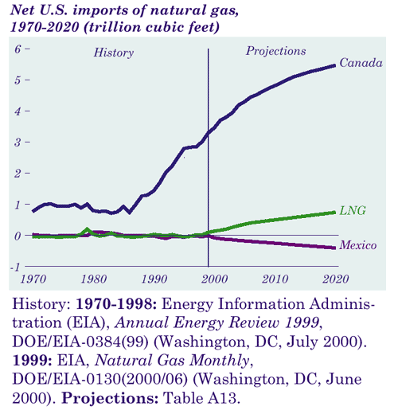
Table 1

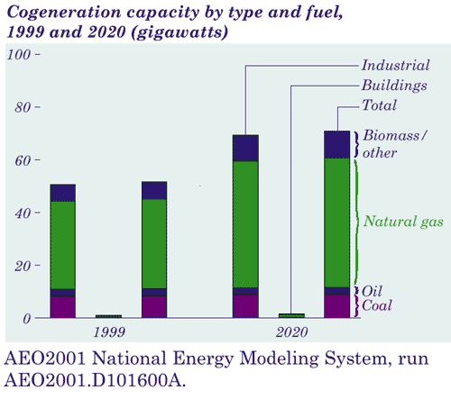

Table 2

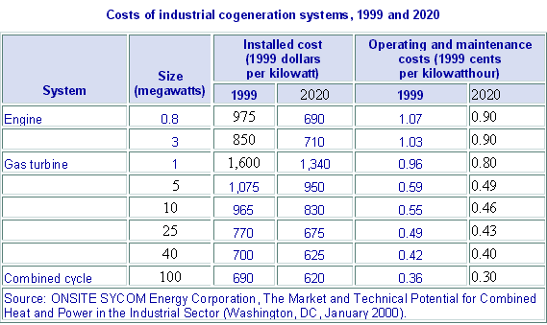

Table 3

