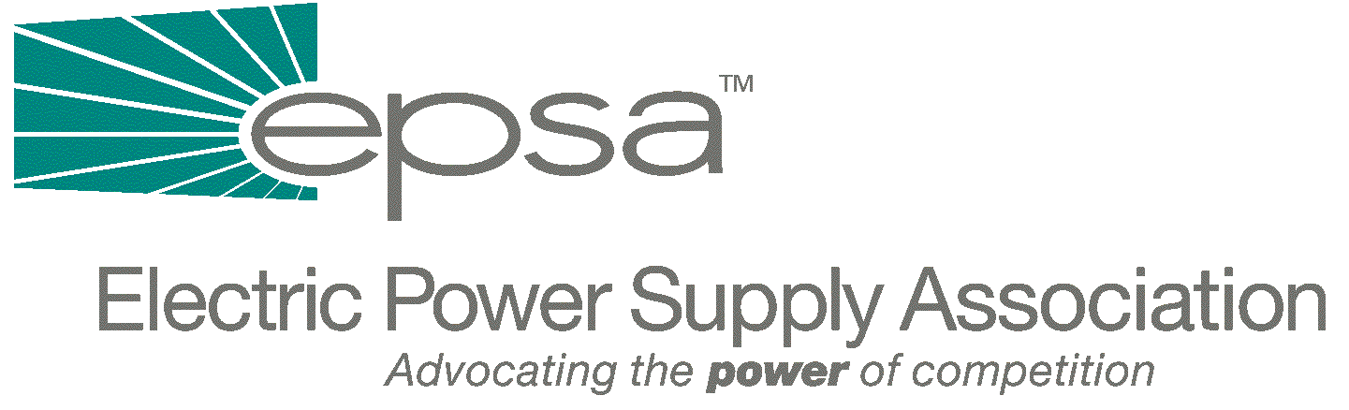
1401 H Street, NW
Suite 760
Washington, DC 20005
202/789-7200
202/789-7201 fax

www.epsa.org

Memorandum
TO: | Regulatory Affairs Committee  Power Marketers Working Group
FROM: | Don Santa, Regulatory Affairs Committee Chair  Joe Hartsoe, Power Marketers Working Group Chair  Mark Bennett, Senior Manager of Policy
DATE: | September 28, 2025
RE: | Report on FERC RTO Workshop in Las Vegas, NV

The third of five FERC-facilitated Regional Transmission Organization (RTO) workshops under Order No. 2000 was held on March 23rd and 24th in Las Vegas, Nevada. As explained in prior memoranda, the workshops are intended to expedite the formation of RTOs by jumpstarting a collaborative process involving transmission owners, market participants, consumer groups and government officials. In his introductory remarks for the initial plenary session, Dan Larcamp, Director of FERC’s Office of Markets, Tariffs and Rates, reminded the participants that FERC’s goals for the workshop were to share information, identify impediments to RTO formation and agree on a post-workshop collaborative process.

During the first day of the workshop, there were presentations on RTO functions in the Western Interconnection (WI) and views on the RTO’s role from the power marketing perspective. There followed reports on the status of RTO formation in the West by the Northwest RTO Group, Desert Star, the California ISO, the Rocky Mountain Area and Mountain West ISA. The reports were followed by stakeholder responses. On the second day of the workshop, attendees participated in four concurrent sessions on four specific RTO proposals relating to the California ISO, the Northwest RTO Group, Desert Star and the Rocky Mountain Area. The workshop concluded with a final plenary session on next steps.

A central theme of this workshop was the difference between the Western and Eastern Interconnections. A speaker for the “seams team” of the Committee on Regional Electric Power Cooperation (REPC), an organization of Western state and provincial regulators and energy offices, stated that the WI already represents a workable, integrated wholesale power market. Compared to the Eastern Interconnection, the west loads and resources are integrated over greater distances, population is widely spaced and there is a greater reliance on hydro resources. Also, the WI has a path rating system that mitigates the problems associated with a commercial contract system that is not flow-based.

It was observed, however, that the WI has some problems that could inhibit the development of competitive power markets, including pancaked rates for about 30 control areas. Also, despite a scheme for commercial integration of phase-shifters, the WI lacks a market mechanism to deal with system loop flow. There is also concern that four to eight RTOs could emerge in the WI, without the participation of all control areas.

Nonetheless, there was optimism that, if correctly designed and implemented, multiple RTOs could “come close” to the efficiencies of a single RTO. To accomplish this, the REPC proposed establishing clear goals for the WMIC, including congestion clearing mechanisms with related firm transmission rights to make RTO boundaries transparent, compatible scheduling and operating protocols, an expanded role for market participants in ancillary service markets and reciprocity agreements between RTOs to eliminate pancaked access fees.

In addition to the REPC presentation, other principles and issues were identified by “RTO Filing Utilities” (a collection of eight utilities and the BPA) and the National Wind Coordinating Committee. Presentations were also made by the Western Systems Coordinating Council, the Committee for Regional Power Cooperation and the Western Interconnection Coordination Forum. The RTO Filing Utilities called for “an efficient decision-making process that fully considers broad regional input”.

The RTO Filing Utilities proposed that the public collaborative process they intend to establish would address 20 issues, including recovery of fixed transmission costs and losses, congestion pricing, price reciprocity and other seams issues, transmission planning and expansion, market monitoring, RTO performance incentives and liability. They also proposed 14 principles that should be observed in resolving these issues, including reliability, customer benefits, open architecture, non-discriminatory treatment and public involvement.

In reports back to the final plenary session, the California ISO stated that it met most of Order 2000’s characteristics and functions, but needed to develop congestion management, OASIS redesign, long-term planning procedures and improve the stakeholder process. The Rocky Mountain group intends to obtain resource commitments, identify and remove institutional barrier and enhance stakeholder participation. Desert Star recognized the urgency of meeting immediate needs relating to cost-shifting, minimizing transmission uplift costs to consumers and obtaining funding through a fair and impartial process. Desert Star expects the WMIC to address seams issues and noted that different state retail competitive structures and private use restrictions on public entities must be considered. They expect to file this summer and be operational by December.

The Western Interconnection Organization (WIO) intends to adopt its by-laws and certificate of incorporation by June, conduct workshops in September, present a proposal to the WICF in October and begin implementation after FERC approval in early 2001.

The next FERC RTO workshop will be held in Kansas City on March 29th and 30th. EPSA will host a “pre-meeting” dinner at 5:00 p.m. on Tuesday, March 28th. If you have any questions or comments about the Las Vegas workshop, or the upcoming workshop in Kansas City, please contact Mark Bennett or Julie Simon at EPSA (202-789-7200 or mbennett@epsa.org or jsimon@epsa.org).

This presentation included comments from the Western Market Interface Committee (WMIC), which is expected to be the market interface committee of the Western Interconnection Organization when it is formed.

