Livelink Guide Sheet

Livelink is a knowledge repository that is used to house large volumes of information, encourage collaboration and track tasks. In this case, its use pertains to the Merger Transition and Integration process. It will store Q&As segmented by various categories – Benefits, Compensation & Bonuses, HR Activities, Layoffs & Severance, PRC, Retirees, Stocks & Options and Worklife that HR users can extract to assist their client groups.

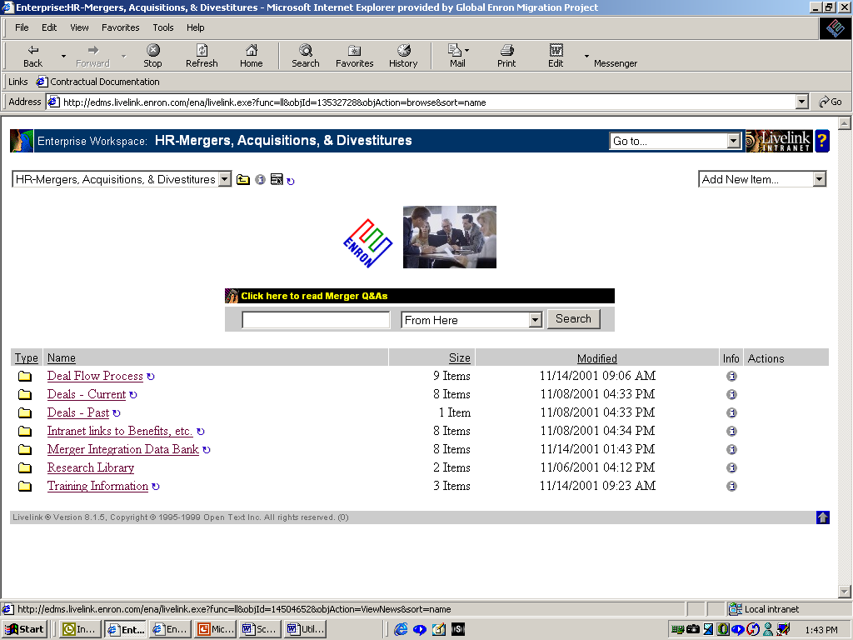
1. Accessing Livelink
- After logging on, open the application.
  - Start->Programs->Internet Explorer
- Copy the below web address in the address line of your browser:
http://edms.livelink.enron.com/ena/livelink.exe?func=ll&objId=13532728&objAction=browse&sort=name

- Click on Favorites
- Click “Add to Favorites…”
- Name as “Merger Integration Data Bank”
- Click on the folder Merger Integration Data Bank
- The screen at right appears

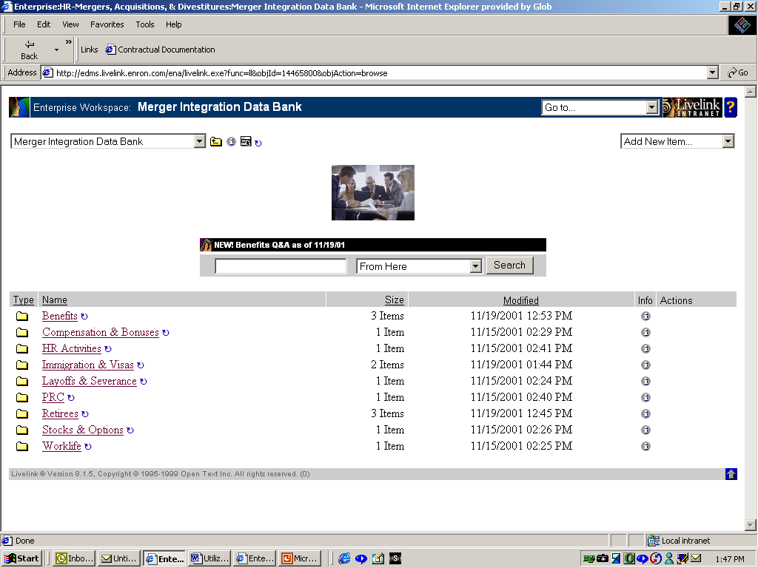
2. Q&A Categories
- Click on the link Merger Integration Data Bank
- Within this folder are several categories: -
  - Benefits
  - Compensation & Bonuses
  - HR Activities
  - Immigration & Visas
  - Layoffs & Severance
  - PRC
  - Retirees
  - Stocks & Options
  - Worklife

3. Viewing the Q&As
- Open the folder of your interest by clicking on its name.
- Select the document you wish to view.
PLEASE PAY SPECIAL ATTENTION TO THE NEWS FLASHES SCROLLING IN THE MIDDLE OF THE SCREEN.

4. Printing documents
- Click on the document
- From the menu, select: File->Print->Ok

For further assistance to effectively use Livelink,
please contact Simone Lewis @ 713-853-1645.

Menu Item | Contains…
Benefits | Information relating to medical, dental, vision, educational assistance, spending accounts and vacation.
Compensation & Bonuses | Information relative to bonuses, salaries, etc.
HR Activities | Information relative to staffing, posting of jobs, relocation, hiring freezes, offers, retention and activities affecting employment.
Immigration & Visas | Information relating to the actions to take in event of layoffs or the merger.
Layoffs & Severance | Information on timelines, policies, calculations and processes.
PRC | Questions on the Year-End process.
Retirees | Information on the retirement program.
Stocks & Options | Ratios, calculations, vesting periods & option schedules.
Worklife | Questions on Metro, Clickathome, United Way participation, etc.

