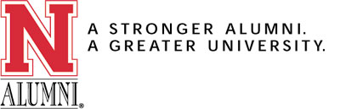
TYPE OF MEMBERSHIP:
Annual Individual $35
Annual Couple $45
Recent Graduate $15 (graduated within past year)
Life Individual $500
Life Individual Installment $105 per year for 5 years
Life Couple $600
Life Couple Installment $130 per year for 5 years
Life Senior Individual $300 (65 years of age or older)
Life Senior Couple $350 (65 years of age or older)

PERSONAL INFORMATION

Name: ________________________________________________________________________________
Maiden Name: _________________________________________________________________________
Address: ______________________________________________________________________________
City: _________________________________________________________________________________
State: __________________________________________ Zip: _______________________________
Email: ________________________________________________________________________________
Social Security Number: _________________________________________________________________
Are you a University of Nebraska graduate? Yes No
UNL Degree: __________________________________ College: ________________________________
Class Year: ____________________________________________________________________________
College activities (honor societies, athletics, etc.): ______________________________________________
______________________________________________________________________________________
Is Spouse an Alum? : Yes No
Spouse's Name: _________________________________________________________________________
Spouse's Maiden Name: __________________________________________________________________
Spouse's College: _______________________________________________________________________
Spouse's Social Security Number: __________________________________________________________
Chapter Code (optional): ORE
Reason for joining: ______________________________________________________________________
______________________________________________________________________________________

Enclosed a check made payable to the Nebraska Alumni Association and mail it to: Nebraska Alumni Association, Wick Alumni Center, 1520 R Street, P.O. Box 880216,Lincoln, NE, 68588-0216. For questions about membership, please contact Donna Ruff at (402) 472-2841.

