AAA POWER Inc.
#32 Arbour Lake Pl NW
Calgary, AB T3G 3W9
Ph (403) 241-1756
Ph (403) 651- 6357
Fax (403) 241-1756
Email: whitej@cadvision.com
August 15, 2001

Enron Corporation

1400 Smith St.

Houston TX 77002

Gentlemen:

We understand that you are interested in receiving certain proprietary and confidential technical and business information (“Information”), which we possess, concerning the University of California Sulfur Recovery Process (“UCSRP”), for the purposes (“Purposes”) of evaluating your interest in working with us in the development and commercialization of the UCSRP. We have exclusive rights to commercial development and licensing of the UCSRProcess, which Process has been invented and patented by Professor Scott Lynn and the University of California, Department of Chemical Engineering. The UCSRProcess continues to be further developed by Professor Lynn and AAA Power Inc.

We are willing to furnish, directly or indirectly, Information to you, provided you agree with us as follows:

1. You will not disclose Information to any third party, except under confidentiality terms approved in advance by us.

2. You will use Information only for said Purposes.

3. The restrictions of Paragraphs 1 and 2 shall not apply to any information which:

a. is, or becomes through no fault of yours, published information generally known in the sulfur recovery industry; or

b. was possessed by you in written form prior to disclosure by us; or

c. is obtained by you from a third party without restriction on disclosure.

Please indicate your agreement by signing in the place provided below. Please return one signed original to us and retain the other enclosed original for your records.

Sincerely, Agreed:

AAA POWER INC. Enron Corporation

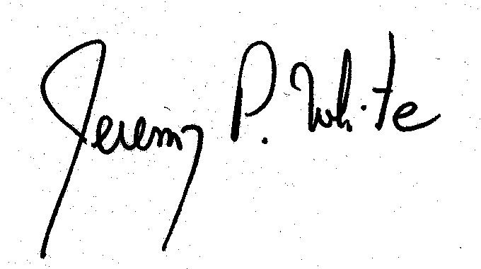
By By
Title President /CEO____________________ Title ________________________________

Date August 15, 2001 Date

