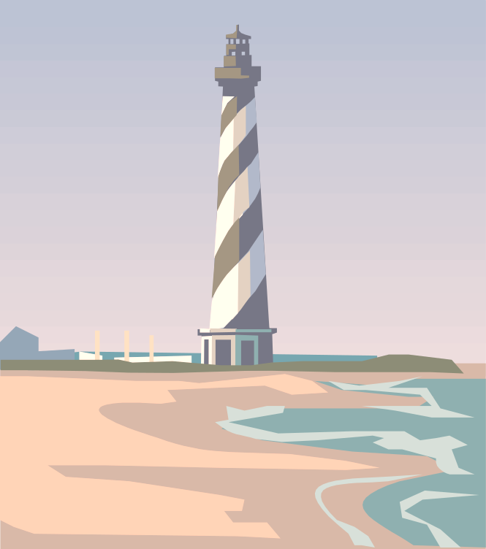

Transwestern Pipeline Company
2001 Customer Update
November 2001

Business Agenda

Thursday, November 8, 2001

Meeting Location– Salon B
8:15 AM Sunrise Breakfast Buffet
9:00 AM Customer Service Update Shelley Corman
9:45 AM Scheduling/Accounting Update Lynn Blair
10:15 AM Pipeline Enhancements for New Business Opportunities Kim Watson
10:45 AM TW Customer Performance Feedback Session
12:00 PM Adjournment
12:30 PM Enjoy an afternoon cruise of the Kemah/Galveston Bay on the “Star Gazer” while visiting with Transwestern representatives
4:00 PM Return to South Shore Harbour

Friday, November 9,2001

Meeting Location- Lalique
8:00 AM Bake Shop Continental Breakfast
9:00 AM Individual TMS & Flowing Gas Online Training Session
- Nominations
- Confirmations
- Invoices On-Line
3:00 PM Adjournment

Casual dress is recommended

