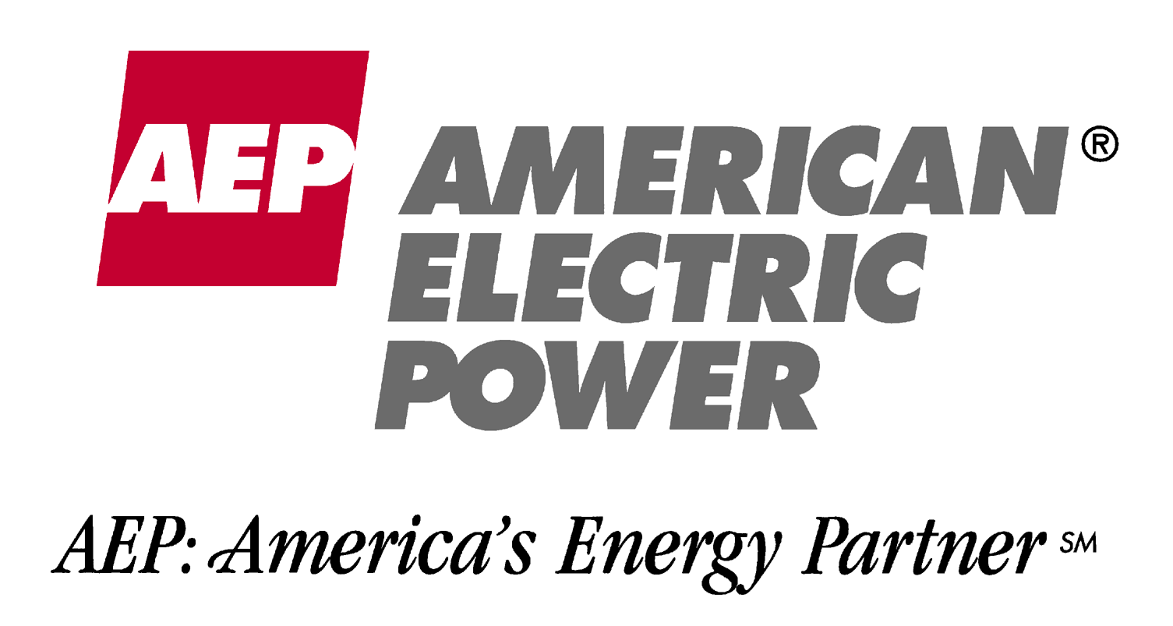
April 20, 2001

Ms. Michelle Lokay
Transwestern Pipeline Company
P.O. Box 1188
Houston, TX 77251-1188

Dear Michelle,

American Electric Power Energy Services, Inc., “AEP Energy Services”, is pleased to provide the following bid for firm transportation service on Transwestern’s mainline.

Receipt Point | Delivery Point | MMBtu/d | Term | Price/MMbtu | Fuel
Central Pool | Socal Needles | 20,000 | 6/1/2002 or “as soon as possible”  through 5/31/2004 | $.63 | 5%
Central Pool | PG&E Topock | 10,000 | 6/1/2002 or “as soon as possible”  through 5/31/2003 | $.63 | 5%

Again, I appreciate the opportunity to submit the above bid. If I can assist you in any other way please feel free to contact me at (614) 324-4526.

Sincerely,

Ray Hamman
Energy Trader

