Transmission Ticker

Requirements & Dependencies:

- Borland Database Engine
- Ticker Server

Purpose:

Query reservations and view new reservations that come into OASIS meeting the selection criteria.

Uses:
Main Window [Diag 1]
- Launching will bring up the main window with a listing of public available views and that of your own.
- Subscribe to it by double clicking on it – this will bring up a ticker view for that view.
- To see how the view is defined, click on the View Definition button.
- Pressing Create New View wil let you define your own view, which you can specify as proivate or publicly shared.

Defining New Views [Diag 2]
- Diag 2 refers to the View Screen which is brought up when you are viewing the definition of an existing view or when you are creating a new view.
- The example diag 2 defines a ticker view to show what EPMI has confirmed or accepted for the next eight hours. Notice how the effective range is set as a relative range starting at hour 0 (right now) and continuing for the next 8 hours. This creates a rolling window of time that is continually moving forward.

Ticker Window [Diag 3]
- After subscribing to a view (by double clicking on the view name or hitting the Subscribe to View button), you will see a widnow come up with all the reservations that meet the criteria defined in the view.
Note: Use caution when selecting your criteria. It’s very easy to get a view with 5000+ records that can cause a delay.
- As new records are posted to the OASIS sites that meet your criteria, they will show up on the ticker window highlighted in yellow for approx 30 seconds and then fading back to white
- You can pick which columns you wish to view by left clicking on any column heading. There are 65 available columns (including the buyer and seller comments). The ticker can then be sent to Excel by right clicking anywhere on the grid and selecting the Send To Excel option. This is handy for doing sorting, grouping and doing analysis.

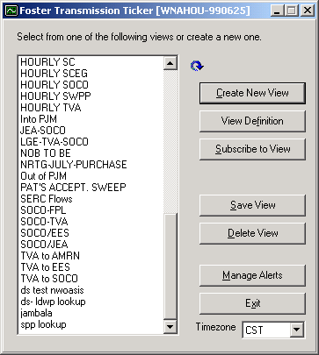
Diag 1

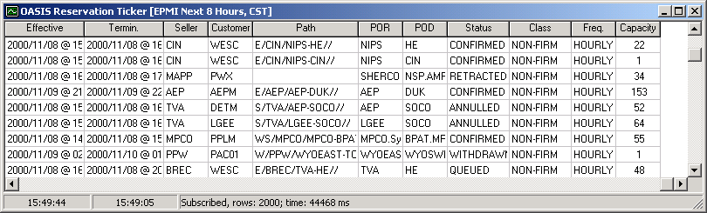
Diag 3

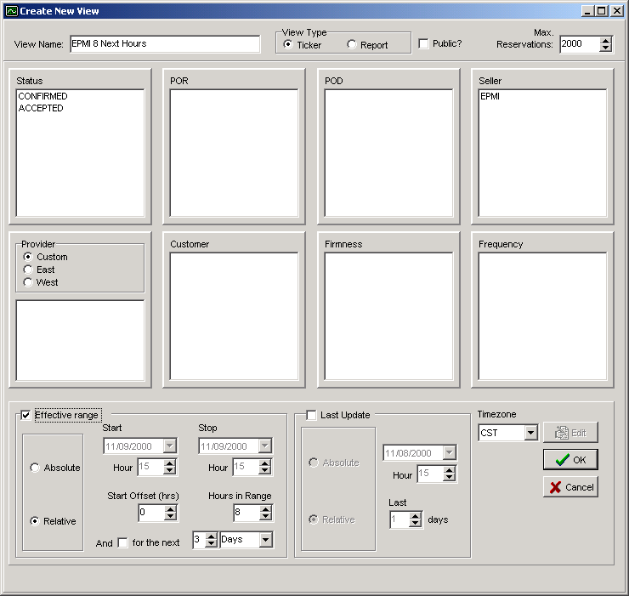
Diag 2

