Transmission Offering Client

Requirements & Dependencies:

- Borland Database Engine
- Netscape
- TradeAgent
- RetrieverServer

Uses:

- Upon launching application, selection criteria will load displaying all possible criteria parameters.
- Example of viewing select criteria for Transmission Availability from Southern OASIS (SOCO) [Refer to Diag 1]
- Click on the Add button; after sending and receiving the submission to SOCO’s website, which is done automatically; the results will be diplayed on the main form situated behind the Selection Criteria form. [Refer to Diag2] To remove the selection criteria simply click on the Done button.
- The Available Transmission Capacity (ATC) displayed on the main form is broken down and grouped by path and then by date [Refer to Diag2]
- To remove this newly created SOCO view from the main form, select the view by clicking on the gray margin containing the path information, and click on the Minus (-) button.
- To create another view, click on the Plus (+) button and that will aunch up the Selection Criteria form
- For purchasing an offering, select the specificoffering entry within the panel for SOCO, and click on the Dollar ($) button, fill out the Capacity and Price and click on the Start button to purchase [Refer to Diag3]
- To confirm and/or withdraw an offer, click on the Confirm/Withdraw icon on the main Transmission Offerings window and enter the Assignment Reference #.

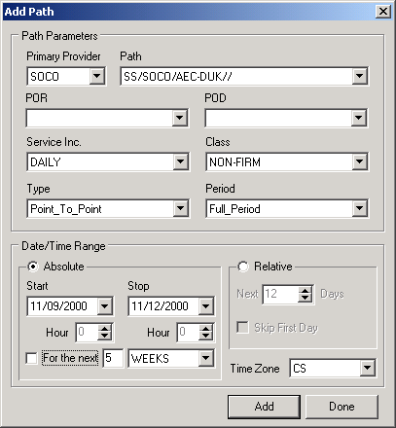
Diag 1
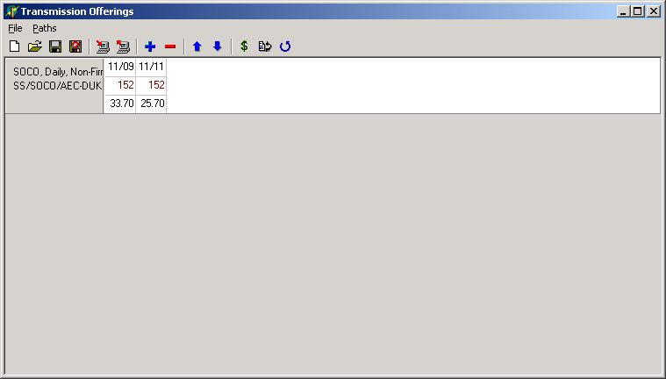
Diag 2

