The U.S. transmission grid is a fragmented system with limited ability to move power between regions. Most transmission lines in the United States were built decades ago to move power over short distances from power plants to end-use customers. While inter-regional connections do exist, these lines were built mainly for reliability purposes. The grid was never designed to transfer large quantities of power easily around the country.

The physics of transferring power across a transmission line causes it to consume reactive power, with increased transfers resulting in increased voltage drop across the line. When heavy power transfers occur across a transmission system interface and transmission lines are heavily loaded, voltage in the area of the interface can become depressed if sufficient reactive supplies are not available to the system. When transfers of power follow a consistent directional pattern, it is relatively easy to plan and justify cost for the required reactive support for the transfers.

Significant reactive support was added on the bulk system to enable higher transfers from ECAR to MAAC and the VACAR Subregion of SERC in the early 1990s. However, under open access, transactions are being done in large numbers across long distances, and often in directions that were not anticipated when the transmission system was planned and built. Also, the direction and amount of transfers has become much more volatile, changing daily, and sometimes hourly. Consequently, planning reactive support enhancements for improving transfer capability is now extremely difficult.

New flow patterns result in an increasing number of facilities being identified as limits to transfers, and transmission loading relief (TLR) procedures have been required in areas not previously subject to overloads to maintain the transmission facilities within operating limits. Transmission facility overloads or operation at levels near security limits do not necessarily translate into an unreliable or unsecure transmission system; this may instead be an indication that the transmission system is fully utilized and will not support any further economic transfers of energy. There are several steps or classifications of NERC TLR, ranging from Level 0 to 6. Curtailments of transactions do not occur until Level 3 (non-firm) and Level 5 (firm).

Number of TLR Events in the Past Four Years as Reported to NERC
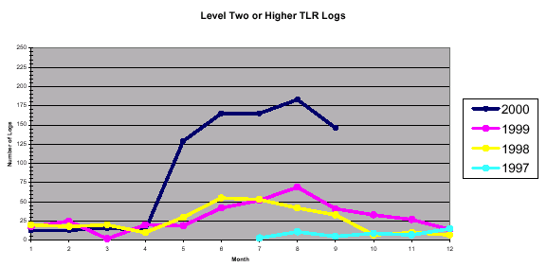

The chart below compares the import and export capability of major U.S. power markets with the total installed capacity base of those markets. On average, regional import capability represents about 13% of a market’s total installed capacity base. Regional export capability averages about 11%. It is important to note that these estimates assume optimal system conditions.

Interregional Power Transfer Capability (Assumes Optimal System Conditions)

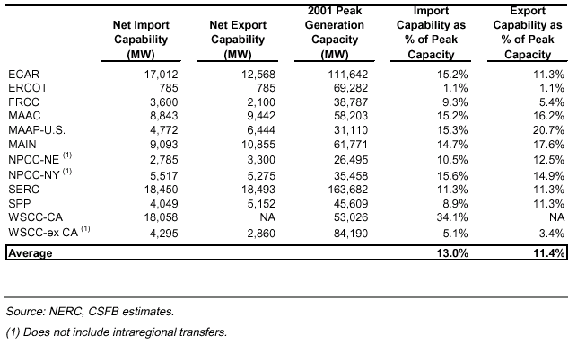

Further contributing to the fragmentation of the grid, existing technologies to direct power flows are very inefficient and sometimes extremely ineffective. For example, the current system relies on mechanical devices to control the movement of power from power plants to load centers.

Source: NERC, Reliability Assessment 2000-2009, The Reliability of Bulk Electric System in North America, October 2000; Credit Suisse/First Boston, Power Generation – A Regional Analysis of Supply and Demand in the US Power Market, September 5 2001

