THE ENRON TRAVEL CLUB presents
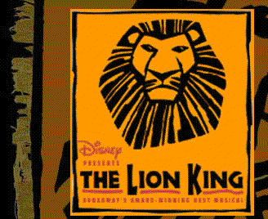

THE LION KING tells the epic adventures of a young lion cub named Simba as he struggles to accept the responsibilities of adulthood and his destined role as king.
The performers utilize an array of masks and puppet techniques to portray the story's 13 principle characters and dozens of other animals. The audience is able to see the actor's face, as well as the mask or puppet. The production has wholly original design and is not an attempt to recreate the animated "look" of the feature film.
THE LION KING features 13 songs, five of which were presented in the animated film. The score encompasses the sounds and rhythms of the African culture, along with the appeal of popular music.
THE LION KING is a musical story that appeals to audiences young and old - a tale of the responsibilities of growing up.

Date: Friday, August 23, 2002

Time: 8:00 PM

Place: Jones Hall - Seating -- Grand Tier/Boxes

Price: $68.25 per ticket for ETC Members -- $78.25 for Non-Members

Coordinator: Margaret Doucette

x5-7892

ECN 3855-A

We only have a very limited number of tickets for this event!!! Please book now!!!!!
Thank you

