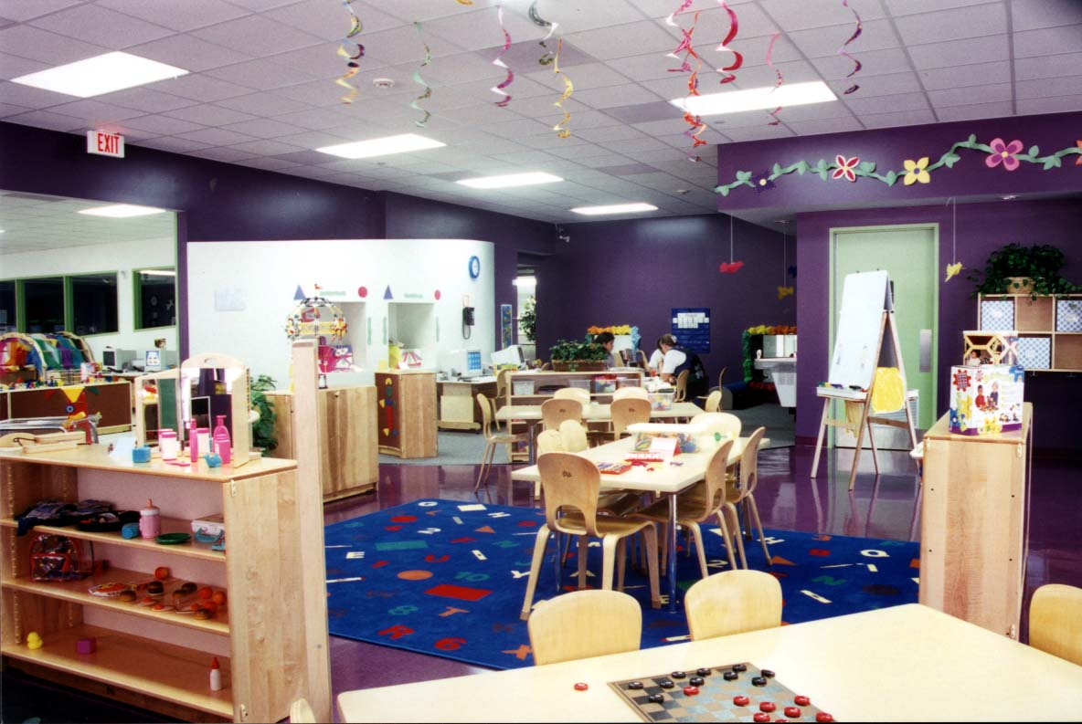
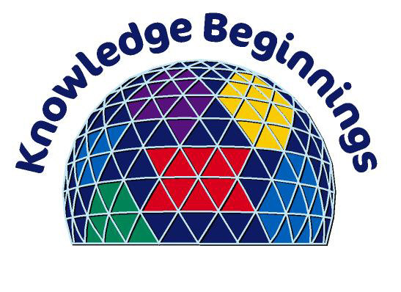
Thank you Enron, for a Great Year!

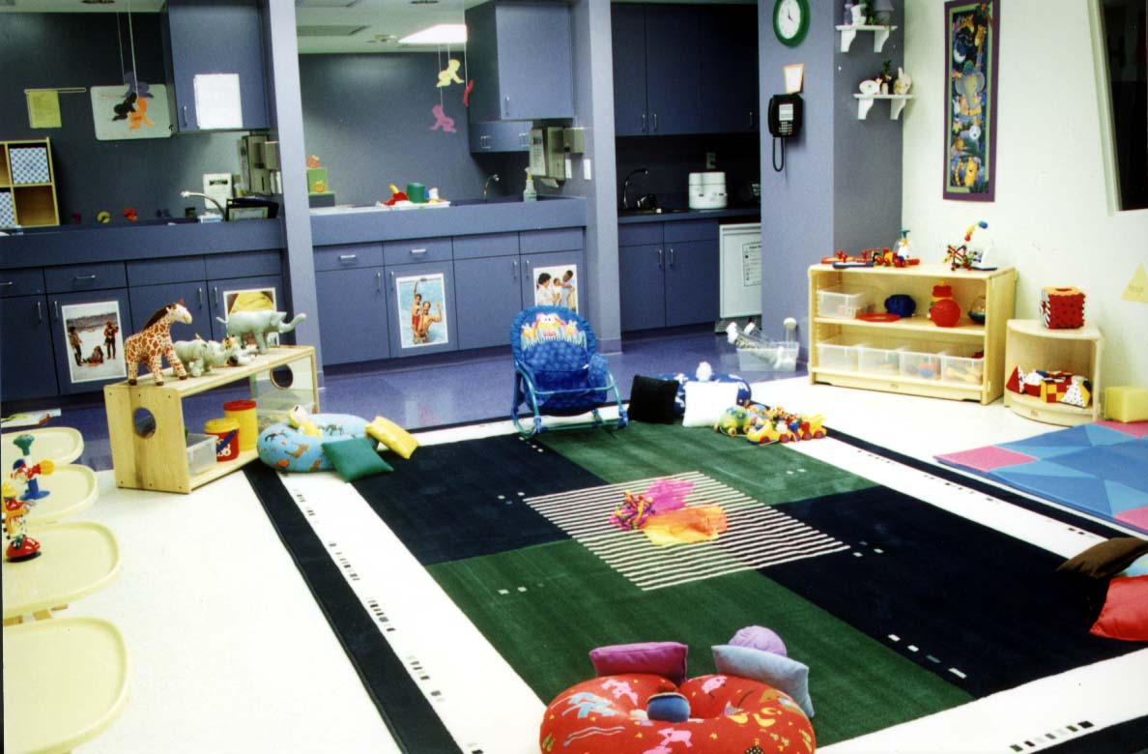
Knowledge Beginnings Downtown Backup Childcare Center would like to gratefully thank Enron for a successful 2000.

On Friday, December 15, 2000, we would like to invite you to use this center as a day on us. We will open the school that day for Enron children only. Usage of the center will not count as an annual day and you may use as many spaces as needed.

You must register before 12-14-2000 to use this day. Reservations will be accepted on a first come first serve basis. You may register in person, by phone or by E-mail. For more information, Please call (713) 759 – 1915 or e-mail us at kb2125@klcorp.com.

Don’t miss the fun!

