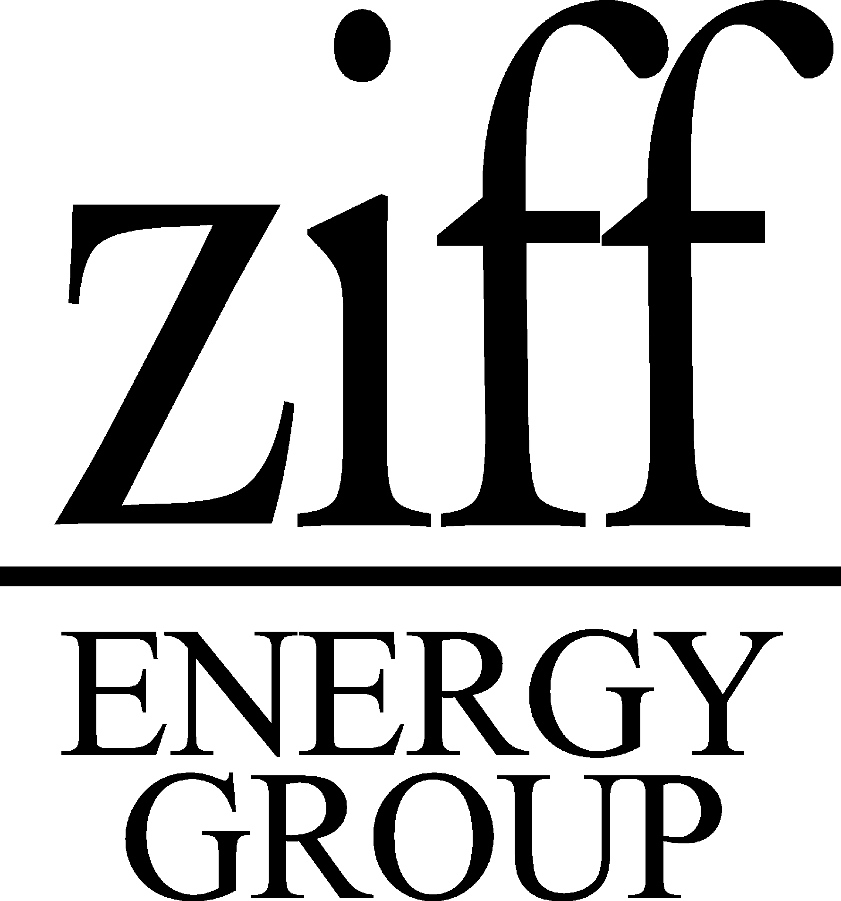

North American Gas Strategies ConferenceS

RECENT ATTENDEE COMMENTS

“This is the only conference around with a true North American focus that integrates both U.S. and Canadian issues.”
James Spann, CEO, Energy Spectrum Capital

"Good overview of gas supply & demand issues. Learned the latest knowledge on the main drivers."
David Litchfield, Managing Director, Duke Energy

“This is the best. Continually recommend this conference to others.”
Ed Porter, Vice President, Northern Projects, Enbridge Inc.

“…one of the best organized, most informative conferences around.”
Mike Fielding, Manager, Strategic Planning, Williams Gas Pipeline Co.

“Splendid selection of highly respected speakers.”
Kevin O’Toole, Western Hub Properties, LLC

"Met many new industry leaders. High quality attendance."
Larry Hinks, Marketing Manager, Elf Exploration

"Extremely well organized conference.”
Gary Thomas, Executive Vice President, North America Operations, Enron Oil & Gas Company

"More forward looking - tends to be at a more strategic level than many of the other conferences."
Craig Frew, President, Iroquois Gas Transmission System

"Gained a better perspective on industry dynamics.”
“Met peers/players outside 'normal' circle of contacts."
Paul Gucwa, U.S. Exploration Manager, Marathon Oil Co.

“Great size conference – big enough to have a good industry cross-section, small enough for effective networking. Good coverage of supply issues.”
Andrew Slaughter, Senior Staff Analyst, Shell E&P

“As always, top notch production. The color copies with adjacent notes page are a keeper.”
Bonita Leonard, Consultant, El Paso Energy / Tennessee Gas Pipeline

“Depth and quality of the presentation is outstanding. Great handouts and very, very well organized.”
Wayne Sartore, Vice President, Northern Projects, Enbridge Inc.

“The conference was well organized and there was a great level of emphasis on quality of speakers.”
Trevor Mihalik, CFO, Bridgeline Holdings

"Ziff conferences are great."
Mike Lang, Account Manager, Tennessee Gas

"Opportunity to hear views on a variety of industry topics from a broad
spectrum of key industry players."
K. A. Kennedy, Director Energy, USG Corporation

