AGREEMENT TO INTERCONNECT AND OPERATE
NATURAL GAS PIPELINE FACILITIES

THIS AGREEMENT TO INTERCONNECT AND OPERATE NATURAL GAS PIPELINE FACILITIES ("Agreement"), is entered into and made effective this ___ day of June, 2000, by and between, CORAL ENERGY RESOURCES, LP ("CORAL"), and HOUSTON PIPE LINE COMPANY, a Delaware corporation, ("HPL"). (CORAL and HPL are sometimes referred to individually as "Party" and collectively as "Parties").

WITNESSETH:

WHEREAS, CORAL owns and operates a 24-inch pipeline and related facilities (the "CORAL Pipeline") located in Texas; and
WHEREAS, HPL owns and operates an intrastate natural gas pipeline and related facilities located in Texas (the "HPL Pipeline"); and
WHEREAS, CORAL and HPL desire to install, own, and operate a natural gas meter station located on the CORAL Pipeline on the __________Survey, A-____, in Kleberg County, Texas to deliver natural gas from the CORAL Pipeline to the HPL Pipeline.

NOW, THEREFORE, in consideration of the premises and the mutual covenants and agreements herein contained, the parties agree as follows:

1. Interconnect. The interconnect shall consist of a 3-inch orifice meter, a chart recorder and instrumentation, a sampler, regulation and over-pressure protection (“OPP”), control valves and associated equipment, tap valve and riser and approximately 800 feet of crossover pipelines required for the physical delivery of natural gas from the HPL Pipeline to the CORAL Pipeline (the "Interconnect"). The Interconnect shall consist of the CORAL Facilities and the HPL Facilities, as defined below. The layout of the Interconnect between the CORAL Pipeline and the HPL Pipeline shall be as set forth on Exhibit "A".

(i) HPL Ownership. HPL shall own that portion of the Interconnect located on HPL’s side of the insulating flange designated as the point of custody transfer as defined in Section 5(i) below which shall include a 4” tap valve and riser on the 8-inch HPL Pipeline, HPL’s chart recorder for check measurement, instrumentation, regulation, OPP, control valves and associated equipment, and associated piping up to the insulating flange designated as the point of custody transfer as defined in Section 5(i) below as shown on Exhibit “A” attached (the "HPL Facilities").

(ii) CORAL Ownership. CORAL shall own the 3-inch orifice meter, chart recorder or flow computer for custody transfer measurement, sampler and piping and pipe related facilities located on CORAL’s side of the insulating flange designated as the point of custody transfer as defined in Section 5(i) below (collectively the "CORAL Facilities").

2. Engineering, Design and Construction. The HPL Facilities shall be designed, installed, and constructed by HPL or its designee in accordance with Engineering Standards as adopted by Enron Operations Corp., as the same may be amended or supplemented from time to time (the “Standards”). The CORAL Facilities shall be designed, installed and constructed by CORAL in accordance with the Standards. The Parties may conduct onsite inspections of the other Party's portion of the Interconnect during and after construction. Upon request by a Party, the other Party shall provide the following: (i) the welder’s test for buttwelds and branch welds; (ii) the fabrication and radiographic inspection; (iii) hydrostatic testing documentation; (iv) OPP documentation, as applicable; and (v) as-built drawings and information. The Parties shall arrange a mutually agreeable schedule for the tie-in of the Interconnect with the HPL Pipeline and the CORAL Pipeline, which shall in no event occur later than ______________, 2000.

3. Reimbursement of Costs. HPL shall reimburse CORAL for reasonable costs incurred by CORAL for the design, installation, procurement, and construction of the CORAL Facilities, which in no event shall exceed $27,000.00. Such cost does not include separation, regulation or site fencing which HPL shall provide at it sole cost if HPL deems such equipment necessary in its sole discretion. CORAL shall invoice HPL for such costs and HPL shall pay such invoice within 30 days of HPL’s receipt thereof.

4. Easements and Permits. HPL or its designee shall obtain all clearances, permits, licenses, authorizations, easements and other land rights that may be needed for the construction, installation, maintenance, and operation of the HPL Facilities and CORAL Facilities. The Parties and/or their designees shall have access to each other's facilities at all reasonable times.

5. Operation. HPL shall operate and maintain or cause the operation and maintenance of the HPL Facilities in accordance with the Standards and with sound and prudent natural gas pipeline industry practice and shall be fully responsible for the operation and maintenance thereof and for all cost, expense and risk associated therewith. CORAL shall operate and maintain the CORAL Facilities in accordance with sound and prudent natural gas industry practice and shall be fully responsible for the routine operation and maintenance thereof and for all cost and expense associated therewith. Each party shall be responsible for its own electric power and phone service, required for the Interconnect.

(i) Delivery Point. Custody of the gas shall transfer at the insulating flange located between the CORAL Facilities and the HPL Facilities, as more specifically set forth on Exhibit "A" hereto.

(ii) Quality Specifications and Measurement. All gas delivered to the Interconnect shall be measured in accordance with and shall conform to the standards provided in any applicable sales or transport agreement. Either Party shall at all times have the right to refuse delivery of gas not meeting the quality standards set forth in any applicable sales or transport agreement. Operation of the CORAL Facilities by CORAL or its designee shall include operation of the orifice meter (the "Meter") and CORAL shall give HPL twenty-four hour operational notice to HPL prior to any testing or calibrating of the Meters. HPL shall have the right to be present during testing or calibrating of the Meters; provided, if the CORAL has given such notice to HPL and HPL is not present at the time specified, then CORAL may proceed with the tests as though HPL were present, and the results therefrom shall be deemed correct and accurate. The Meter shall be used to perform custody transfer measurement of the gas.

(iii) Pressure Control. HPL or its designee shall operate the pressure control portion of the HPL Facilities to ensure that gas deliveries are equal to nominations, plus or minus tolerances generally acceptable in the intrastate natural gas pipeline industry.

(iv) Samples and BTU Content. A proportional to flow gas sampler installed as part of the CORAL Facilities shall be used to ascertain the heating content of the gas stream.

(v) MAOP. CORAL shall deliver gas to the HPL Facilities at pressure sufficient to effectuate deliveries into the HPL Pipeline, which shall in no event exceed the maximum allowable operating pressure (“MAOP”) of the HPL Pipeline.

(vi) Noncompliance. Should either Party fail to comply with any provision of this Agreement with regard to gas quality, flow control, pressure and pulsation control or any other provision which could impact the operation and safety of the HPL Pipeline, the CORAL Pipeline or the Interconnect, the impacted Party shall have the right to immediately suspend the flow of gas through the Interconnect. Such Party shall notify the other Party of such suspension as soon as reasonably possible.

(vii) Odorization. It is understood and agreed that any gas delivered and received though the Interconnect will not be odorized.

6. No Obligation. Neither the installation of the Interconnect nor the Parties execution of this Agreement shall require a Party to receive or deliver gas through the Interconnect absent an applicable transportation, purchase or sales agreement.

7. Compliance with Laws. The Interconnect shall be constructed, installed, operated and maintained in compliance with all valid laws, orders, directives, rules and regulations of governmental authorities having jurisdiction.

8. Inspection and Retention of Records. Each Party shall have the right at all reasonable times to audit the records of the other Party which are pertinent to the Agreement; provided, however, that each Party shall adequately protect the confidentiality of proprietary information. If any such examinations reveal any inaccuracy in any billing theretofore made, the necessary adjustments in such billing and payment shall be made within thirty (30) days after final determination thereof; provided, that no adjustments for any billing or payment shall be made for any inaccuracy claimed after the lapse of twenty-four (24) months from the rendition of the invoice(s) relating thereto. All of the records including, measurement, safety, operational, accounting records and accounts referred to herein shall be maintained according to generally accepted accounting and industry principles employed in the business of the purchase, transportation and sales of gas or in accordance with any laws, rules or regulations which are or may become applicable, and such records and accounts will be available for inspection at times mutually agreeable to the Parties hereto.

9. Term. This Agreement shall be effective as of the date first above written and shall remain in full force and effect for an initial term of five years and month to month thereafter. Either Party may terminate this Agreement at the end of the initial five-year term or at the end of any month thereafter with thirty days prior written notice to the other Party.

10. Indemnity. Each Party agrees to indemnify, defend and hold harmless the other Parties and their respective parents and other affiliates, successors, assigns, legal representatives, officers, directors, shareholders, agents and employees (the “Indemnified Party”) from and against all claims, causes of action, damages, suits, judgments, and liabilities of every kind, including all expenses of litigation, court costs and attorneys and expert witness fees, injuries to or sickness or death of any person, loss or damage to any property (including, without limitation, claims resulting from the presence, disposal or release of any material, and for the clean-up or remediation of contamination and/or environmental damage), civil or criminal fines or penalties or similar payments, or other losses not enumerated above, caused by, arising out of, or in any way incident to, in connection with, or related to (i) the breach by such Party (or any of such Party’s employees, agents, representatives, contractors or subcontractors) of any portion of that Party’s obligations, covenants, representations, or warranties contained in this Agreement, or (ii) any act or omission by such Party (or any of such Party’s employees, agents, representatives, contractors or subcontractors) with regard to this Agreement or any activities conducted by such Party (or any of such Party’s employees, agents, representatives, contractors or subcontractors) pursuant to this Agreement. IT IS THE INTENT OF THE PARTIES THAT THIS INDEMNITY AND THE LIABILITY ASSUMED UNDER IT BE WITHOUT REGARD TO THE CAUSE OR CAUSES THEREOF, INCLUDING, WITHOUT LIMITATION, THE NEGLIGENCE OF ANY INDEMNIFIED PARTY, WHETHER SUCH NEGLIGENCE BE SOLE, JOINT OR CONCURRENT, OR ACTIVE OR PASSIVE; PROVIDED, NO PARTY SHALL BE LIABLE IN RESPECT OF ANY CLAIM TO THE EXTENT SAME RESULTED FROM THE GROSS NEGLIGENCE, WILLFUL MISCONDUCT OR BAD FAITH OF THE INDEMNIFIED PARTY.

11. Limitation of Consequential Damage Recovery. EXCEPT AS EXPRESSLY PROVIDED HEREIN, NO PARTY SHALL BE LIABLE TO ANY OTHER PARTY FOR ANY LOST OR PROSPECTIVE PROFITS OR ANY SPECIAL, PUNITIVE, EXEMPLARY, CONSEQUENTIAL, INCIDENTAL OR INDIRECT LOSSES OR DAMAGES (IN TORT, CONTRACT OR OTHERWISE) UNDER OR IN RESPECT OF THIS AGREEMENT OR FOR ANY FAILURE OF PERFORMANCE RELATED HERETO HOWSOEVER CAUSED.

12. Notices. All notices and other communications between the Parties, unless otherwise specifically provided, shall be in writing and deemed to have been duly given when delivered in person or deposited with the United States Postal Service, First Class, with postage prepaid, addressed as follows:
HPL: CORAL:
Houston Pipe Line Company Coral Energy Resources, LP
1400 Smith St. _________________________
Houston, Texas 77002-7361 _________________________
Attention: Natural Gas Assets Facsimile Number: (___) _________
Facsimile Number: (713) 646-8416 Phone Number: (___) ____________

Gas Control:(713) 750-7080 Operational Notices:
Coral Energy Resources, LP
________________________
________________________
Facsimile Number: (___) _________
Phone Number: (___) ____________

13. Laws. THIS AGREEMENT SHALL BE GOVERNED BY AND CONSTRUED IN ACCORDANCE WITH THE LAWS OF THE STATE OF TEXAS.
14. Arbitration. Any dispute relating to this Agreement shall be resolved by binding arbitration pursuant to the Commercial Arbitration Rules of the American Arbitration Association ("AAA") and all such proceedings shall be subject to the Federal Arbitration Act. Each Party shall select one arbitrator and the two arbitrators shall select a third arbitrator who has not previously been employed by either Party and does not have a direct or indirect interest in either Party or the subject matter of the arbitration. While the third arbitrator shall be neutral, the two party-appointed arbitrators are not required to be neutral, and it shall not be grounds for removal of either of the two party-appointed arbitrators or for vacating the arbitrators' award that either of such arbitrators has past or present relationships with the party that appointed such arbitrator. Only damages allowed pursuant to this Assignment may be awarded and the arbitrator shall have no authority to award treble, consequential, incidental, indirect, exemplary or punitive, lost profits or other business interruption damages of any type under any circumstances regardless of whether such damages may be available under Texas law.

15. Binding Agreement and Assignments. Once executed by the Parties, this Agreement shall be binding upon and inure to the benefit of the Parties and their permitted successors and assigns. Except to the extent expressly allowed hereinafter, a Party may not sell, assign or otherwise transfer, in whole or in part, any interest in this Agreement without the prior written consent of the other Parties to this Agreement, which consent shall not be unreasonably withheld; provided that, a Party may sell, assign or transfer partially or wholly its interest in this Agreement to an affiliate without consent of the other Parties. Any sale, assignment or transfer in violation of the foregoing provisions shall be void.

16. Force Majeure. In the event any Party is rendered unable, wholly or in part, by Force Majeure to carry out its obligations, other than payment, it is agreed that upon such Party's giving notice of such Force Majeure to the other party, the obligations of the Party giving such notice, to the extent affected by such event, shall be suspended from the inception and during the continuance of the Force Majeure. "Force Majeure" means an event not anticipated as of the date hereof, which is not within the reasonable control of the Party, or in the case of third party obligations or facilities, the third party, claiming suspension, and which by the exercise of due diligence such party, or third party, is unable to overcome or obtain or cause to be obtained a commercially reasonable substitute performance therefor.

17. Miscellaneous. The division of this Agreement into articles, sections and subsections, and the insertion of headings and table of contents, if any, are for convenience of reference only, and shall not affect the construction or interpretation hereof. To the extent of any conflict between the terms and provisions of the portion of this Agreement that precedes the signature lines (the "Body of the Agreement") and any Exhibit or Appendix attached hereto, the Body of the Agreement shall control. This Agreement was prepared jointly by the Parties hereto. This Agreement was prepared with each of the Parties having access to their own counsel, and the Parties waive any claim they may have now or in the future based on this Agreement not having been prepared jointly by the Parties. If one or more of the provisions of this Agreement are determined to be invalid, illegal or unenforceable by a court of competent jurisdiction, the affected Parties hereunder shall promptly meet and attempt in good faith to agree on how to adjust the remaining provisions of this Agreement to place the affected Parties in the same economic position they would have been in had such provision(s) remained in effect. If the affected Parties are unable to agree on such adjustments, then any materially affected Party may terminate this Agreement upon reasonable notice to the other Parties. This Agreement together with the Exhibits attached hereto set forth the entire agreement among the Parties relating to the subject matter hereof and supersedes and replaces all previous discussions, undertakings and agreements regarding the subject matter of this Agreement. Except as otherwise expressly provided, this Agreement shall not be amended other than by written agreement of the Parties. The failure of any Party to insist upon strict performance of any provision hereof shall not constitute a waiver of, or estoppel against asserting, the right to require such performance in the future, nor shall a waiver or estoppel in any one instance constitute a waiver or estoppel with respect to a later breach of a similar nature or otherwise.

18. Counterparts. This Agreement may be executed in any number of counterparts, each of which when so executed shall be deemed to be an originally executed copy.
IN WITNESS WHEREOF, the parties hereto have executed this Agreement as of the date first above written.

CORAL ENERGY RESOURCES, LP HOUSTON PIPE LINE COMPANY

By: By:
Stephen C. Schneider
Title: Title: Vice President
Date: Date:

EXHIBIT "A"

TO THE AGREEMENT TO INTERCONNECT AND OPERATE
NATURAL GAS PIPELINE FACILITIES BETWEEN HPL AND CORAL
DATED JUNE __, 2000

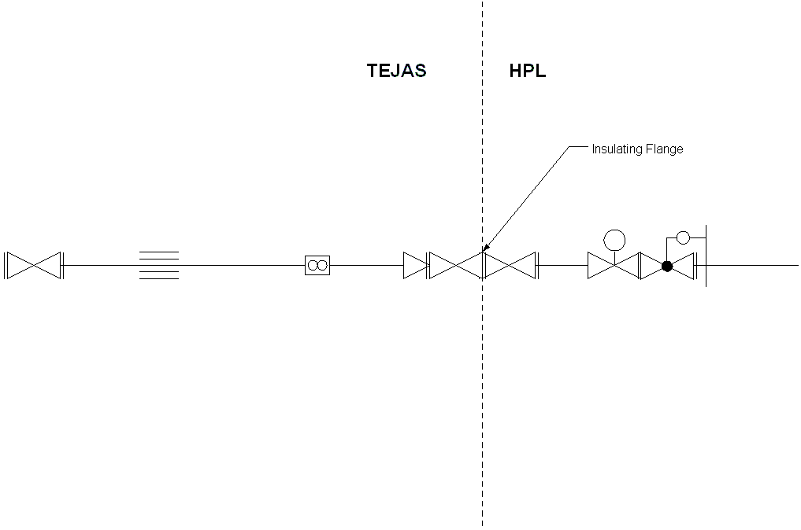
FLOW DIRECTION

