Technology for Country Folk

LOG ON:  Making a wood stove hot | 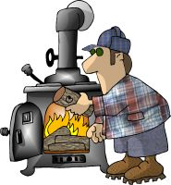
LOG OFF:  Too much wood on fire | 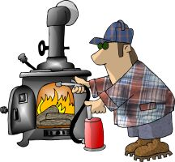
MONITOR:  Keep'n an eye on the wood stove | 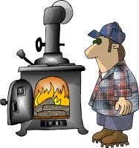
DOWN LOAD:  Gitten the farwood off'n the truck | 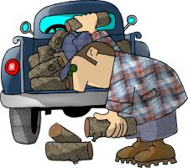
MEGA HERTZ:  When yer not keerfull gitten the farwood | 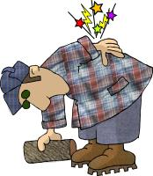
FLOPPY DISC:  Whatcha git from tryin to tote too much farwood | 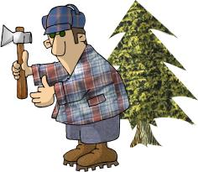
RAM:  That thar thang what splits the farwood | 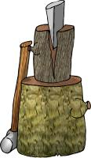
HARD DRIVE:  Gitten home in the winter time | 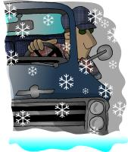
WINDOWS:  Whut to shut when its cold outside | 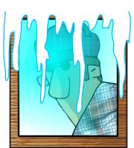
SCREEN:  Whut to shut when its black fly season | 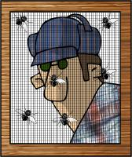
BYTE:  Whut dem dang flys do | 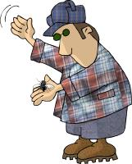
CHIP:  Munchies fer the TV | 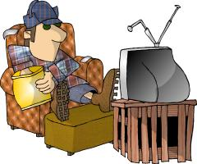
MICRO CHIP:  Whut's in the bottom of the munchie bag | 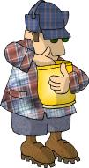
MODEM:  Whatcha do to the hay fields | 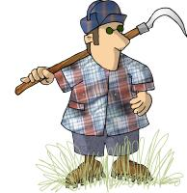
DOT MATRIX:  Ole Dan Matrix's wife | 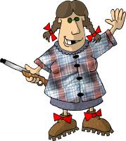
LAP TOP:  Whar the kitty sleeps | 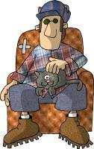
KEYBOARD:  Whar you hang the dang truck keys | 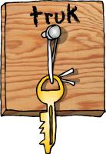
SOFTWARE:  Dem dang plastic forks and knifes | 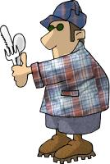
MOUSE:  What eats the grain in the barn | 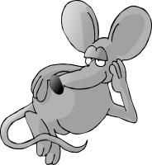
MOUSE PAD:  That's hippie talk fer where the mouse lives | 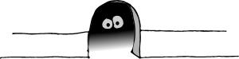
MAINFRAME:  Holds up the barn roof | 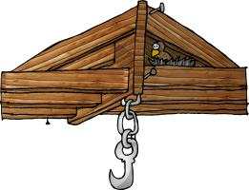
PORT:  Fancy flatlander wine | 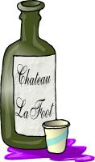
ENTER:  Notherner talk fer "C'Mon in y'all" | 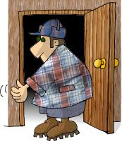
CLICK:  Whut you hear when you cock yer gun | 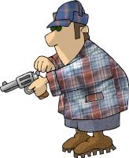
DOUBLE CLICK:  When you cock the double barrel | 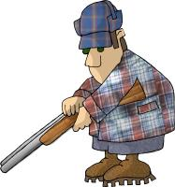
REBOOT:  Whut you have to do right before bedtime, when you have to go to the outhouse | 